Appendix A: An overview per disease of the distribution and source of the input parameters and a graphical representation of the output of the model

Table of Contents

Peripheral arterial disease (Fontaine III/IV) 3

Aortic valve insufficiency or stenosis 4

Renal cellular carcinoma, stage II/III 5

Abdominal aneurysma of the aorta 6

Arrythmias (Wolf-Parkinson White, AV-nodal re-entry tachycardia, Flutter) 7

Mitral valve regurgitation or stenosis 8

Aortic valve stenosis 9

Cholangeocarcinoma 10

End-stage renal disease 11

Non-small cell lung carcinoma 12

Coloncarcinoma with liver metastases 13

Renal cell carcinoma, stage I 14

End-stage liver disease 15

End-stage heart failure 16

Laryngeal carcinoma 17

Aortic valve insufficiency 18

Abdominal aneurysm of the aorta 19

Adults with untreated atrial septum defect 20

Penis carcinoma 21

Pancreas carcinoma 22

Instable angina pectoris - CABG 23

Instable angina pectoris - PCI 24

Hepatocellular carcinoma 25

Colon carcinoma with peritoneal metastases 26

Ovarium carcinoma 27

Oral carcinoma 28

High-risk endometrium carcinoma 29

Upper urinary tract carcinoma 30

Muscle invasive bladder cancer 31

Resectable mammacarcinoma 32

Empyema 33

High-grade glioma 34

Symptomatic carotid artery plaques 35

Cervical cancer 36

Low-grade glioma 37

Low-risk endometrium carcinoma 38

Fontaine II peripheral artery disease 39

Resectable mammacarcinoma 40

COPD with substantial emphysema 41

Recurrent pneumothorax 42

Mild salivary gland carcinoma 43

Thyriod carcinoma 44

End-stage renal disease 45

## Peripheral arterial disease (Fontaine III/IV)

### Surgical procedure: Bypass surgery

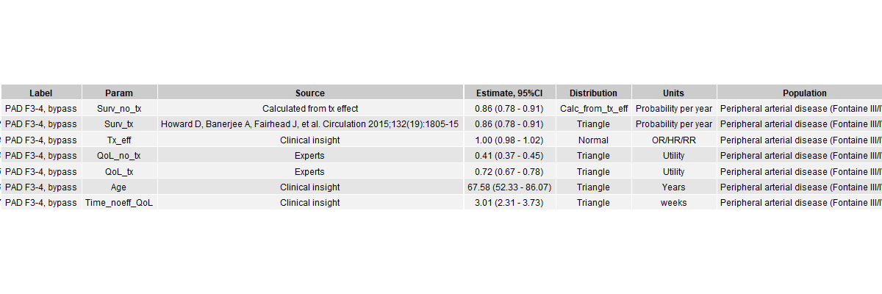

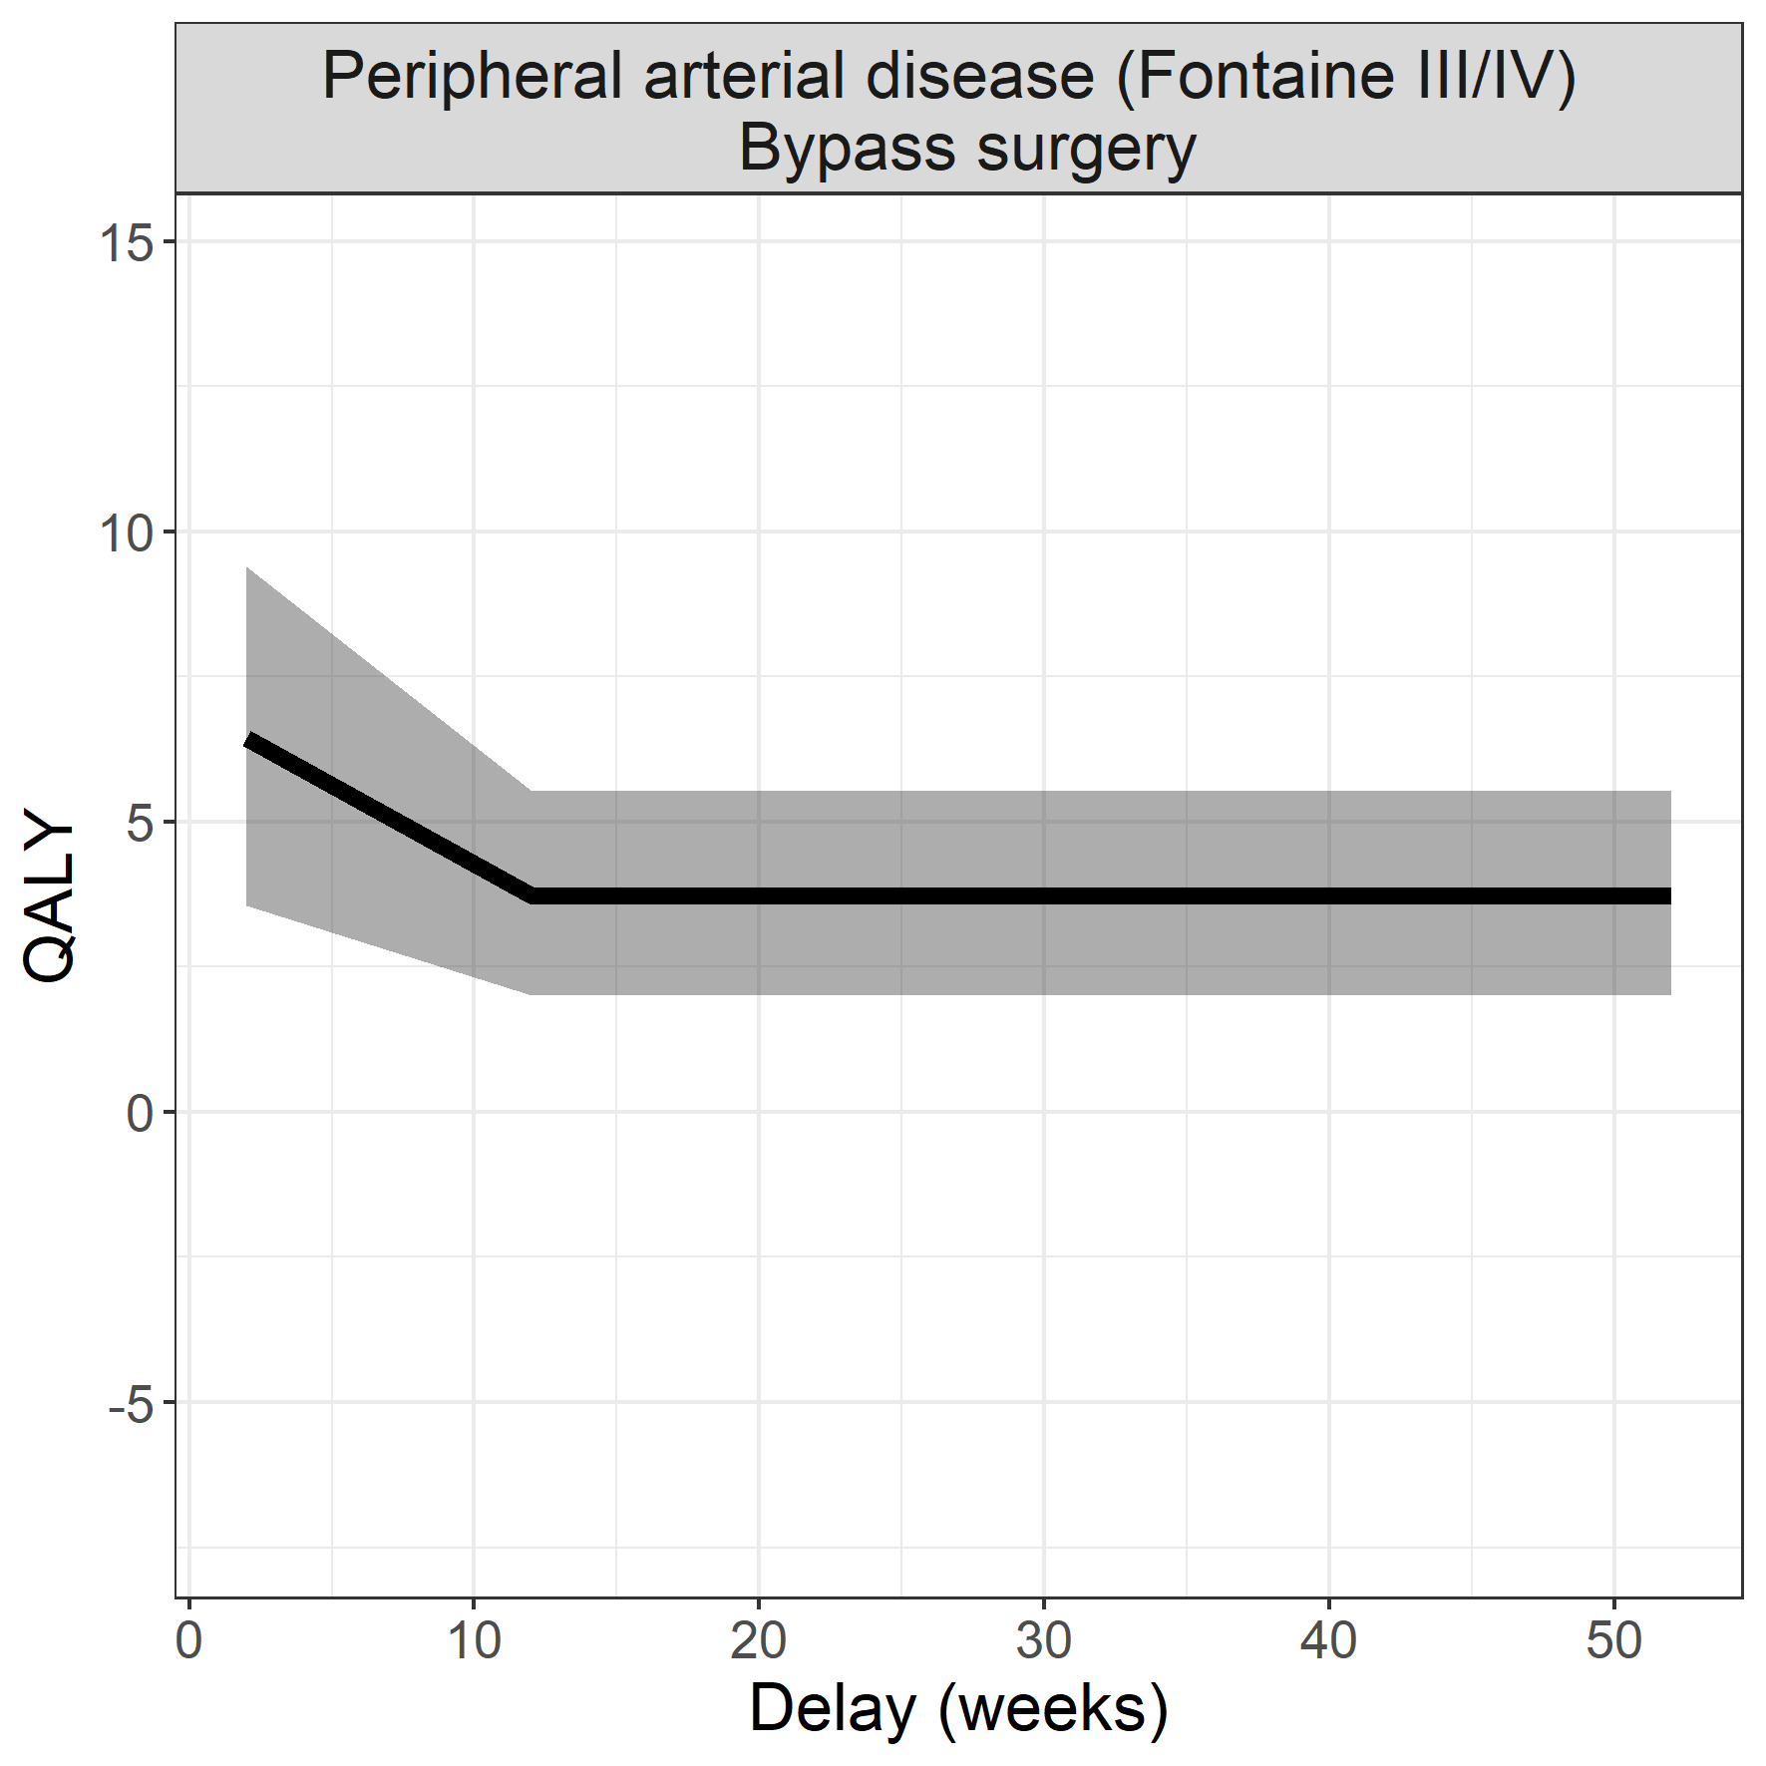

## Aortic valve insufficiency or stenosis

### Surgical procedure: Aortic valve replacement (transaortic valve implantation)

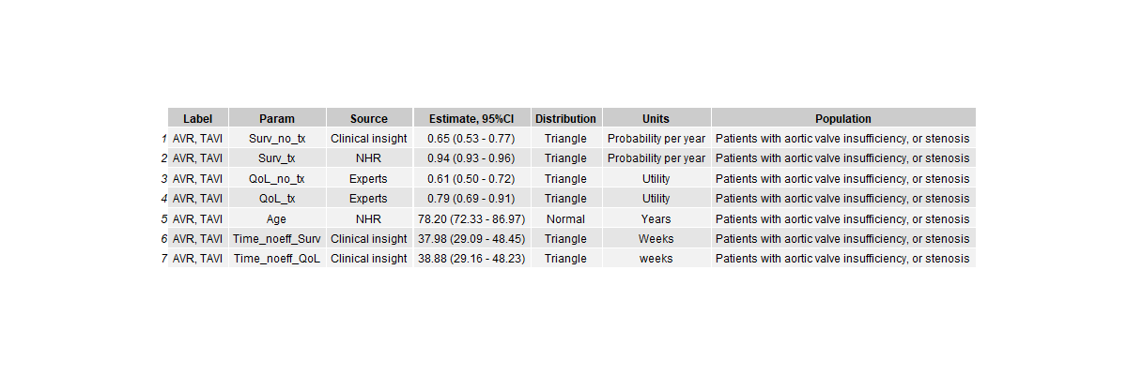

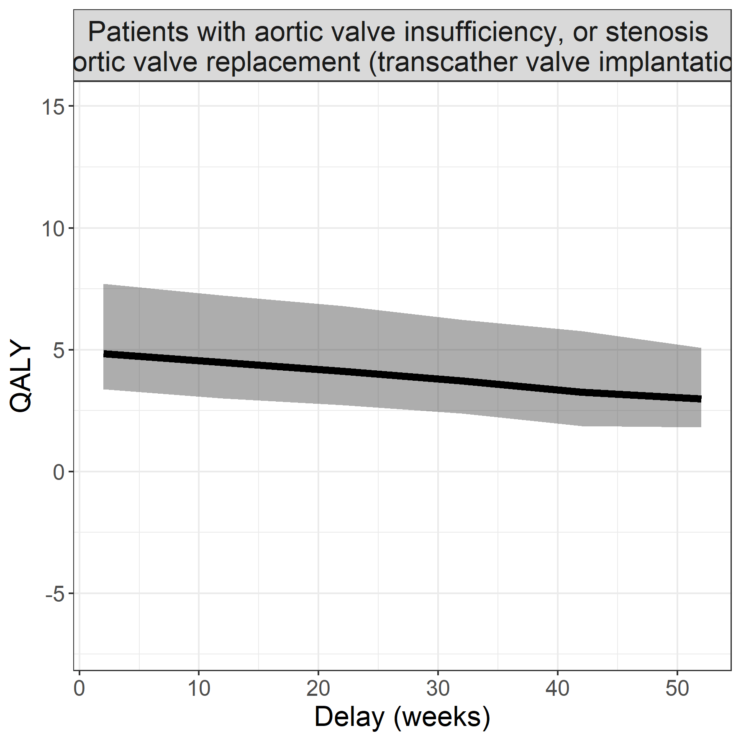

## Renal cellular carcinoma, stage II/III

### Surgical procedure: Total nefrectomy

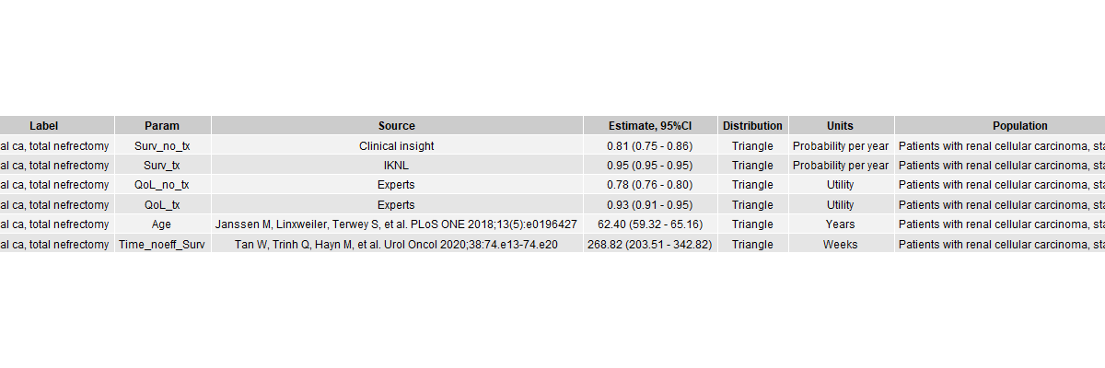

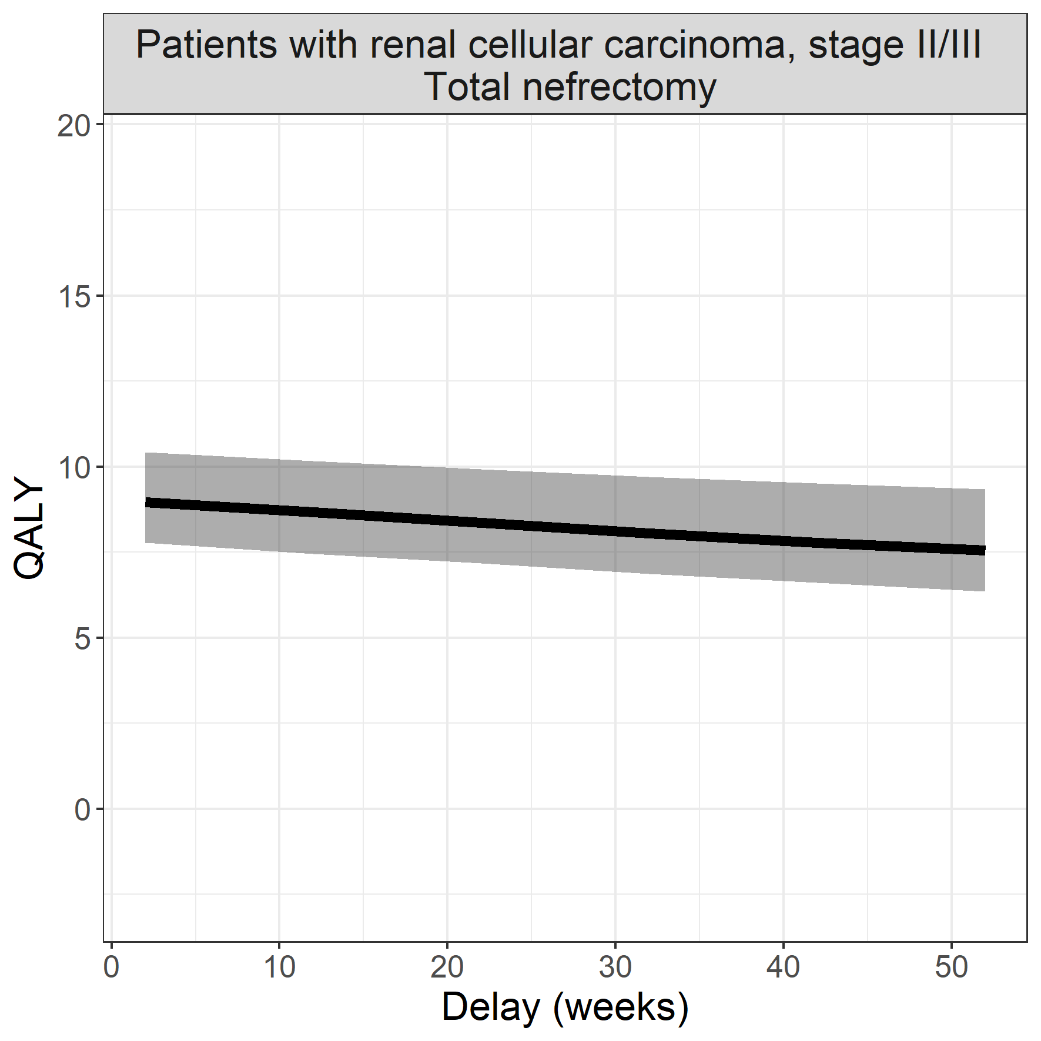

## Abdominal aneurysma of the aorta

### Surgical procedure: transabdominal repair

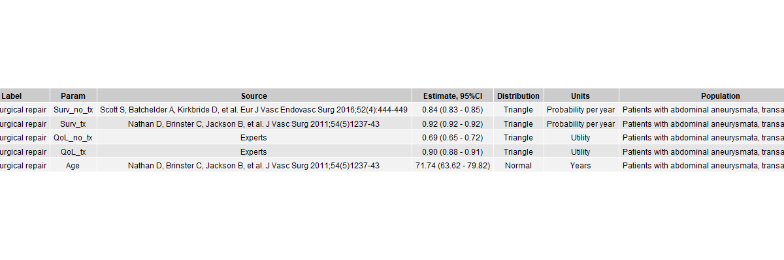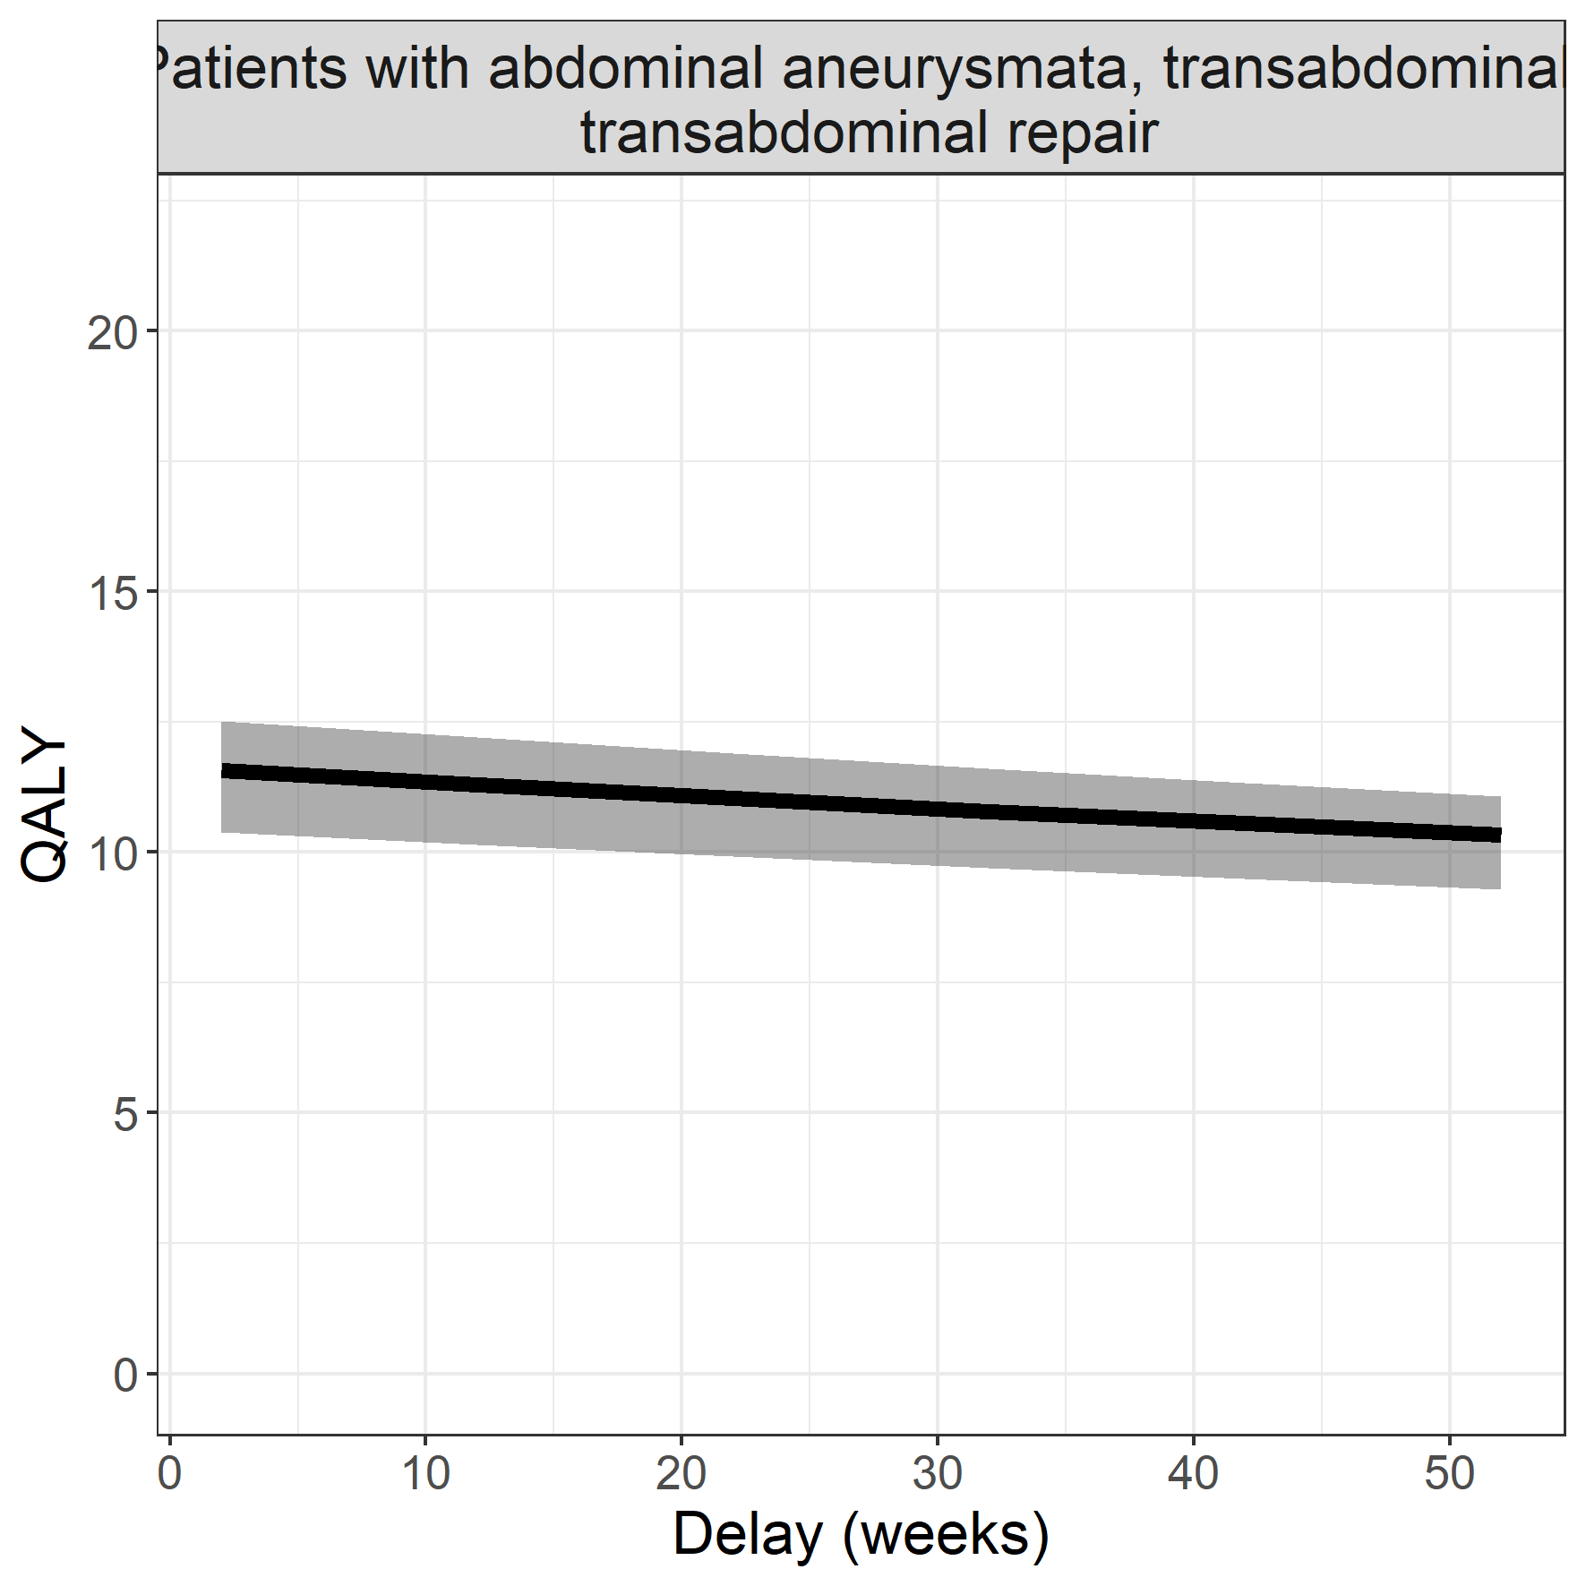

## Arrythmias (Wolf-Parkinson White, AV-nodal re-entry tachycardia, Flutter)

### Surgical procedure: pacemaker

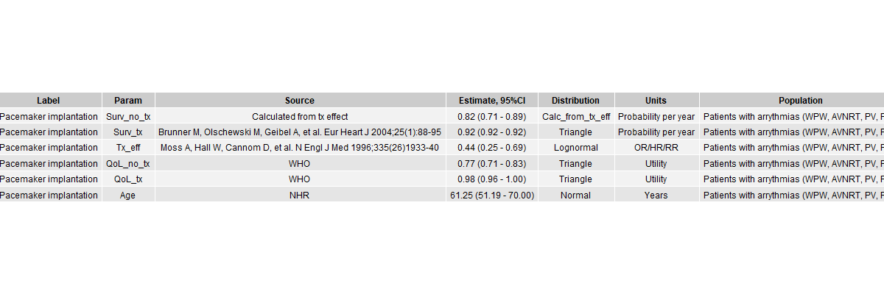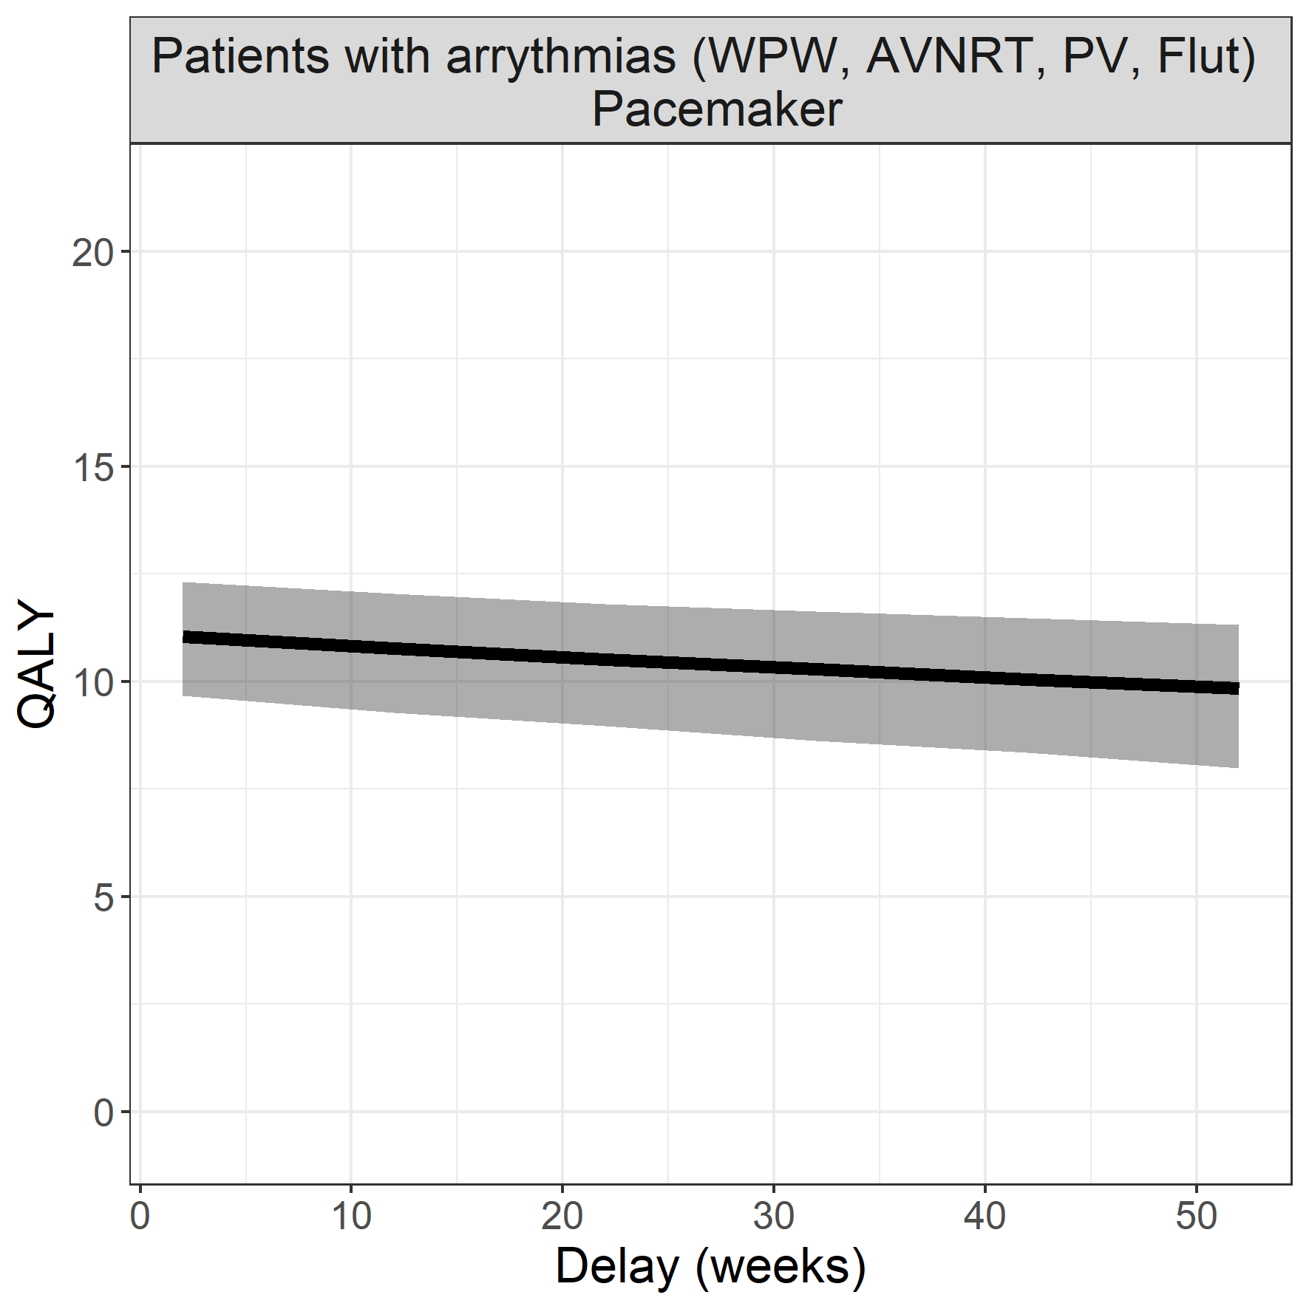

## Mitral valve regurgitation or stenosis

### Surgical procedure: mitral valve replacement (thoracotomy)

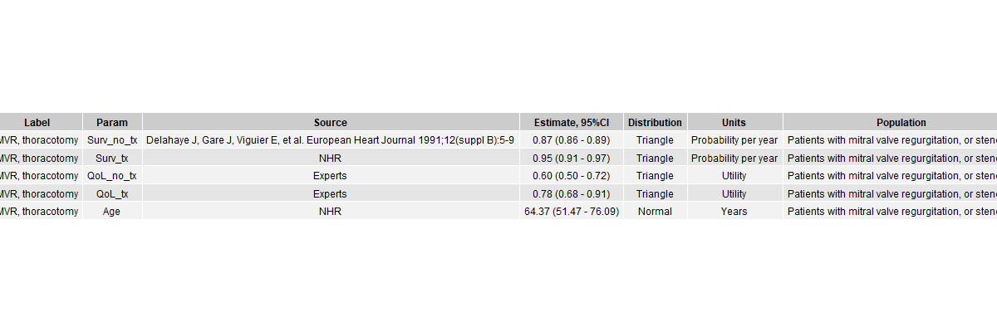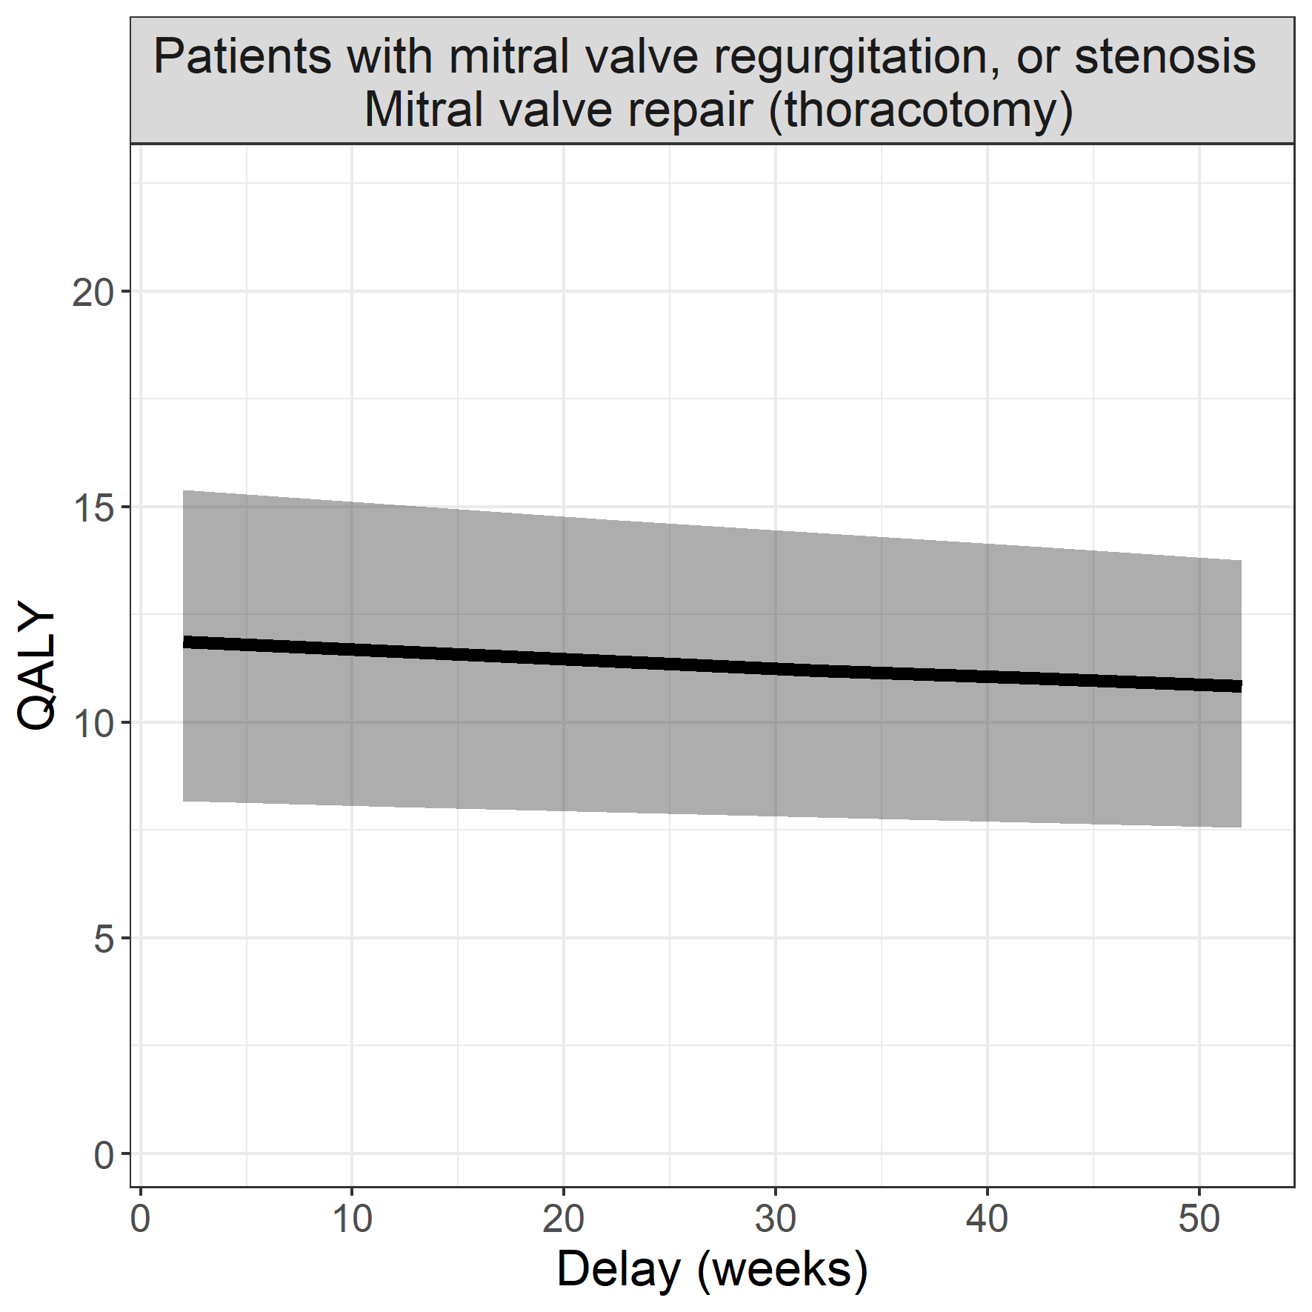

## Aortic valve stenosis

### Surgical procedure: aortic valve replacement (thoracotomy)

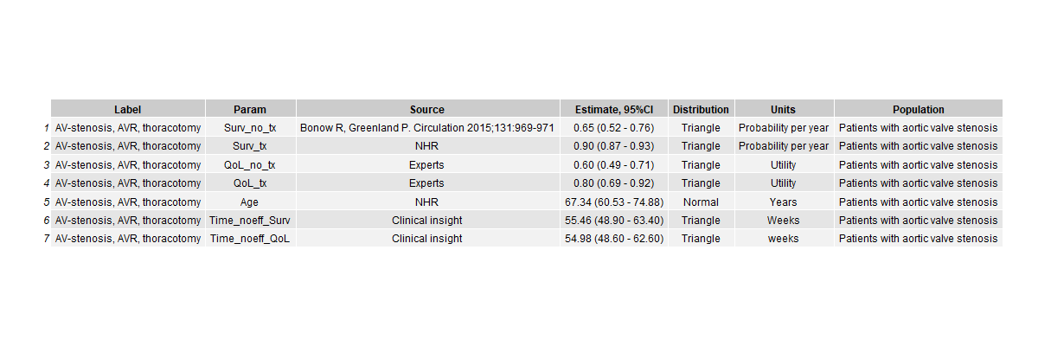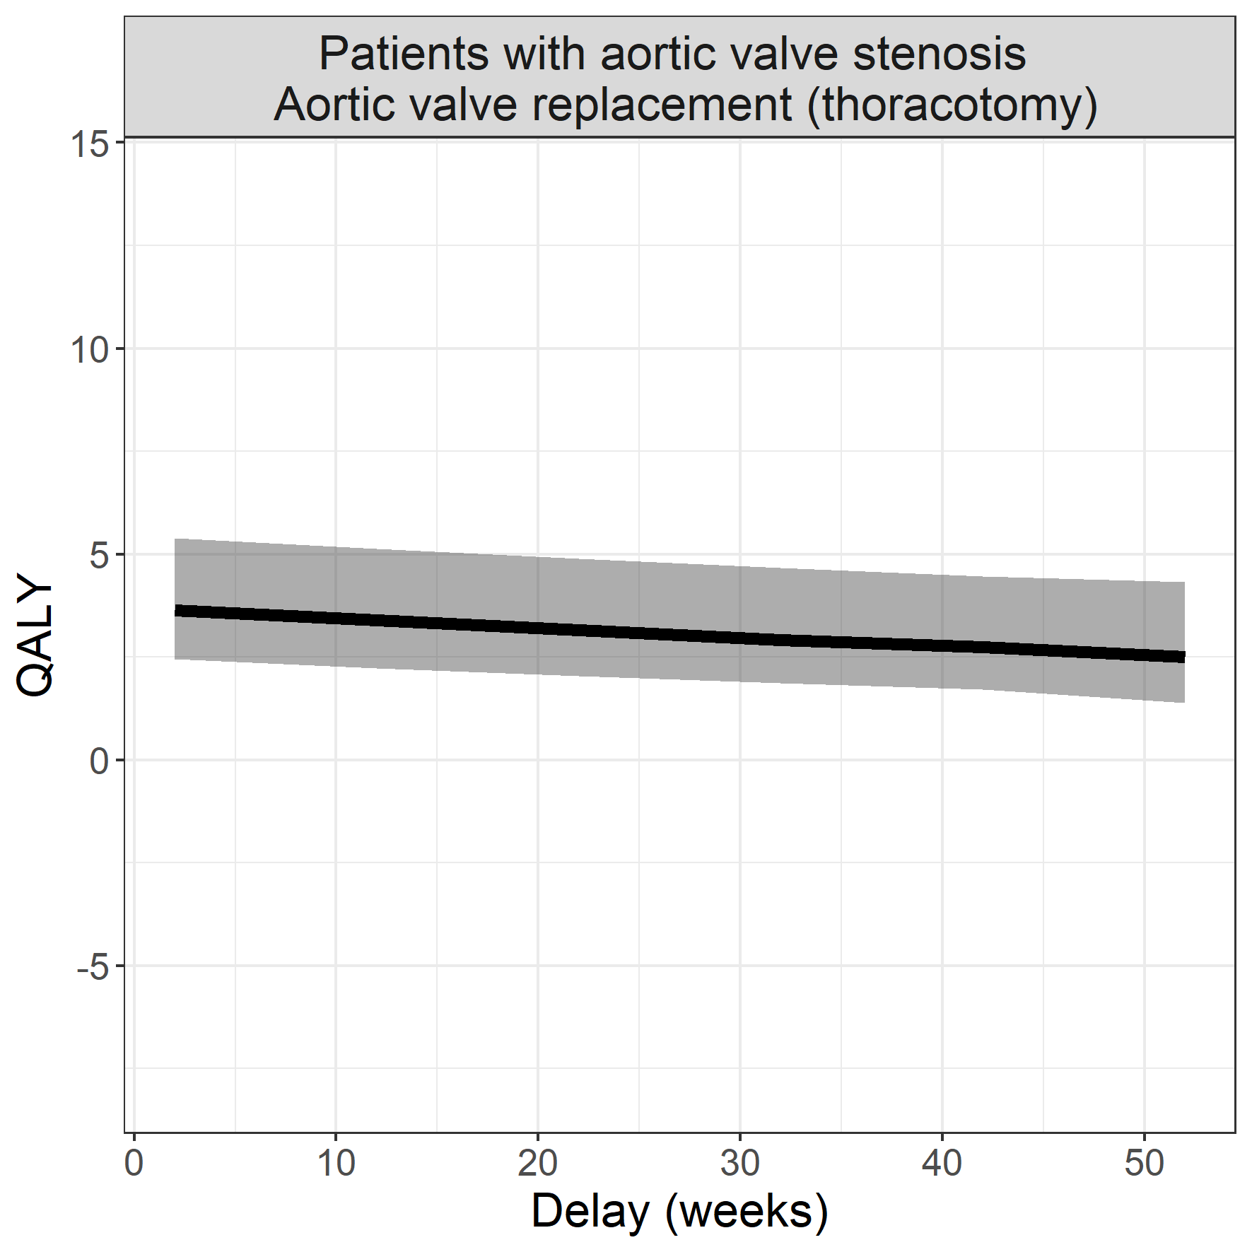

## Cholangeocarcinoma

### Surgical procedure: surgical resection

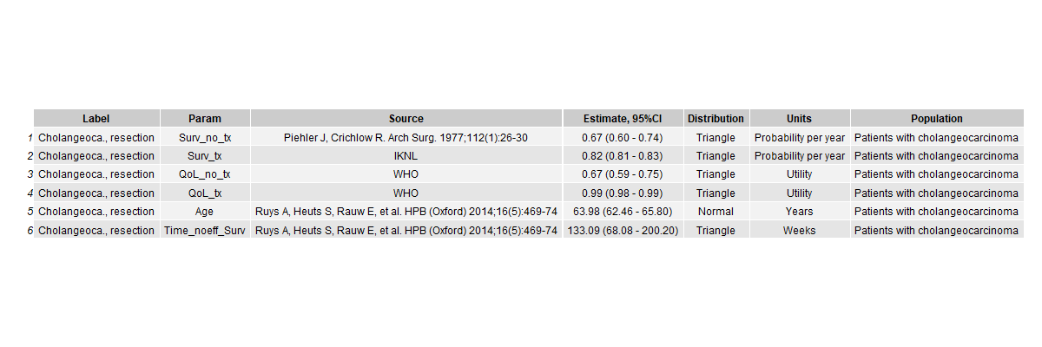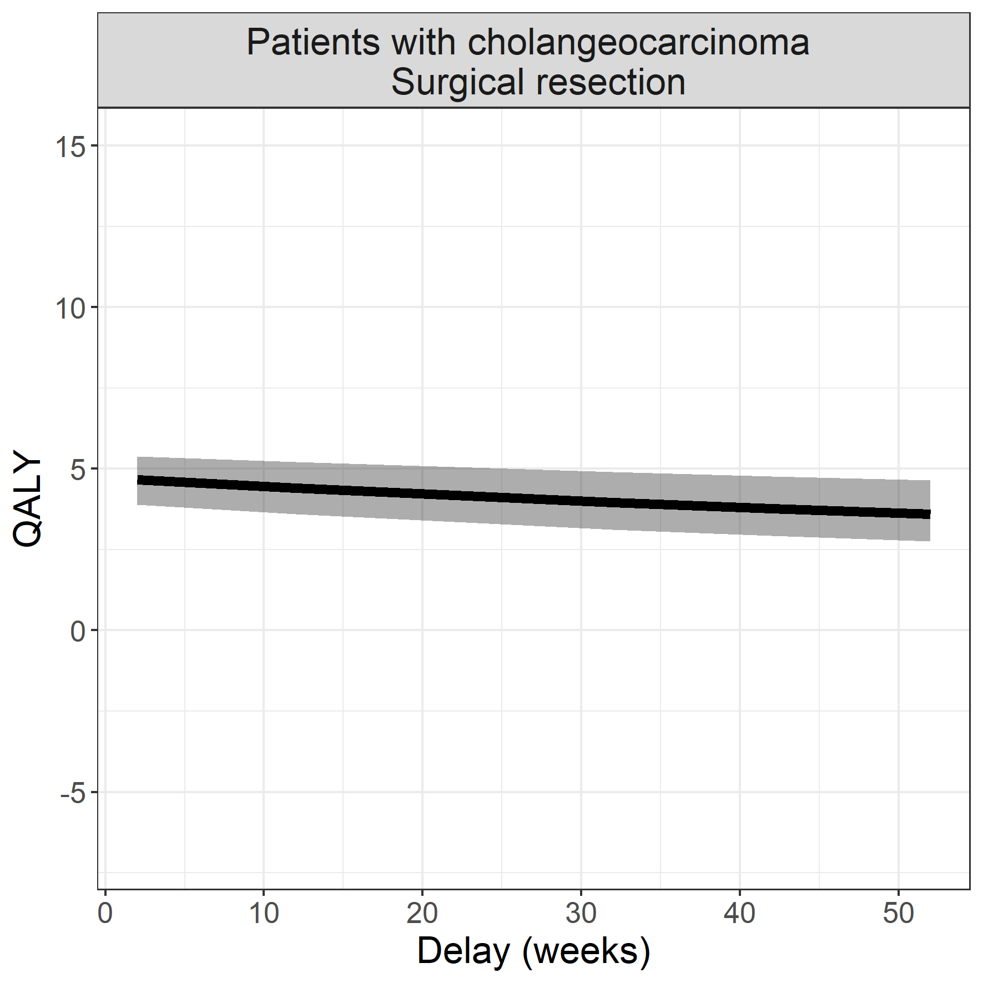

## End-stage renal disease

### Surgical procedure: living donor kidney transplant

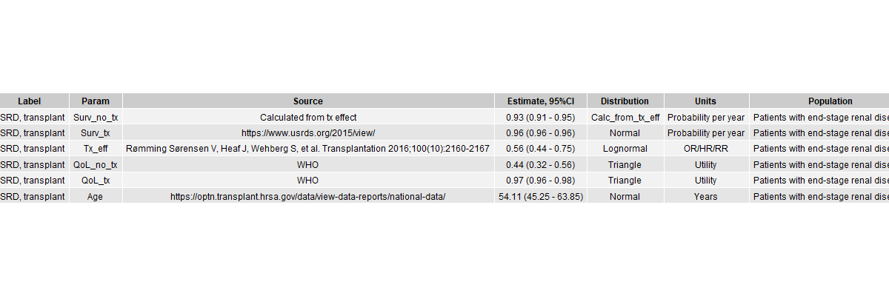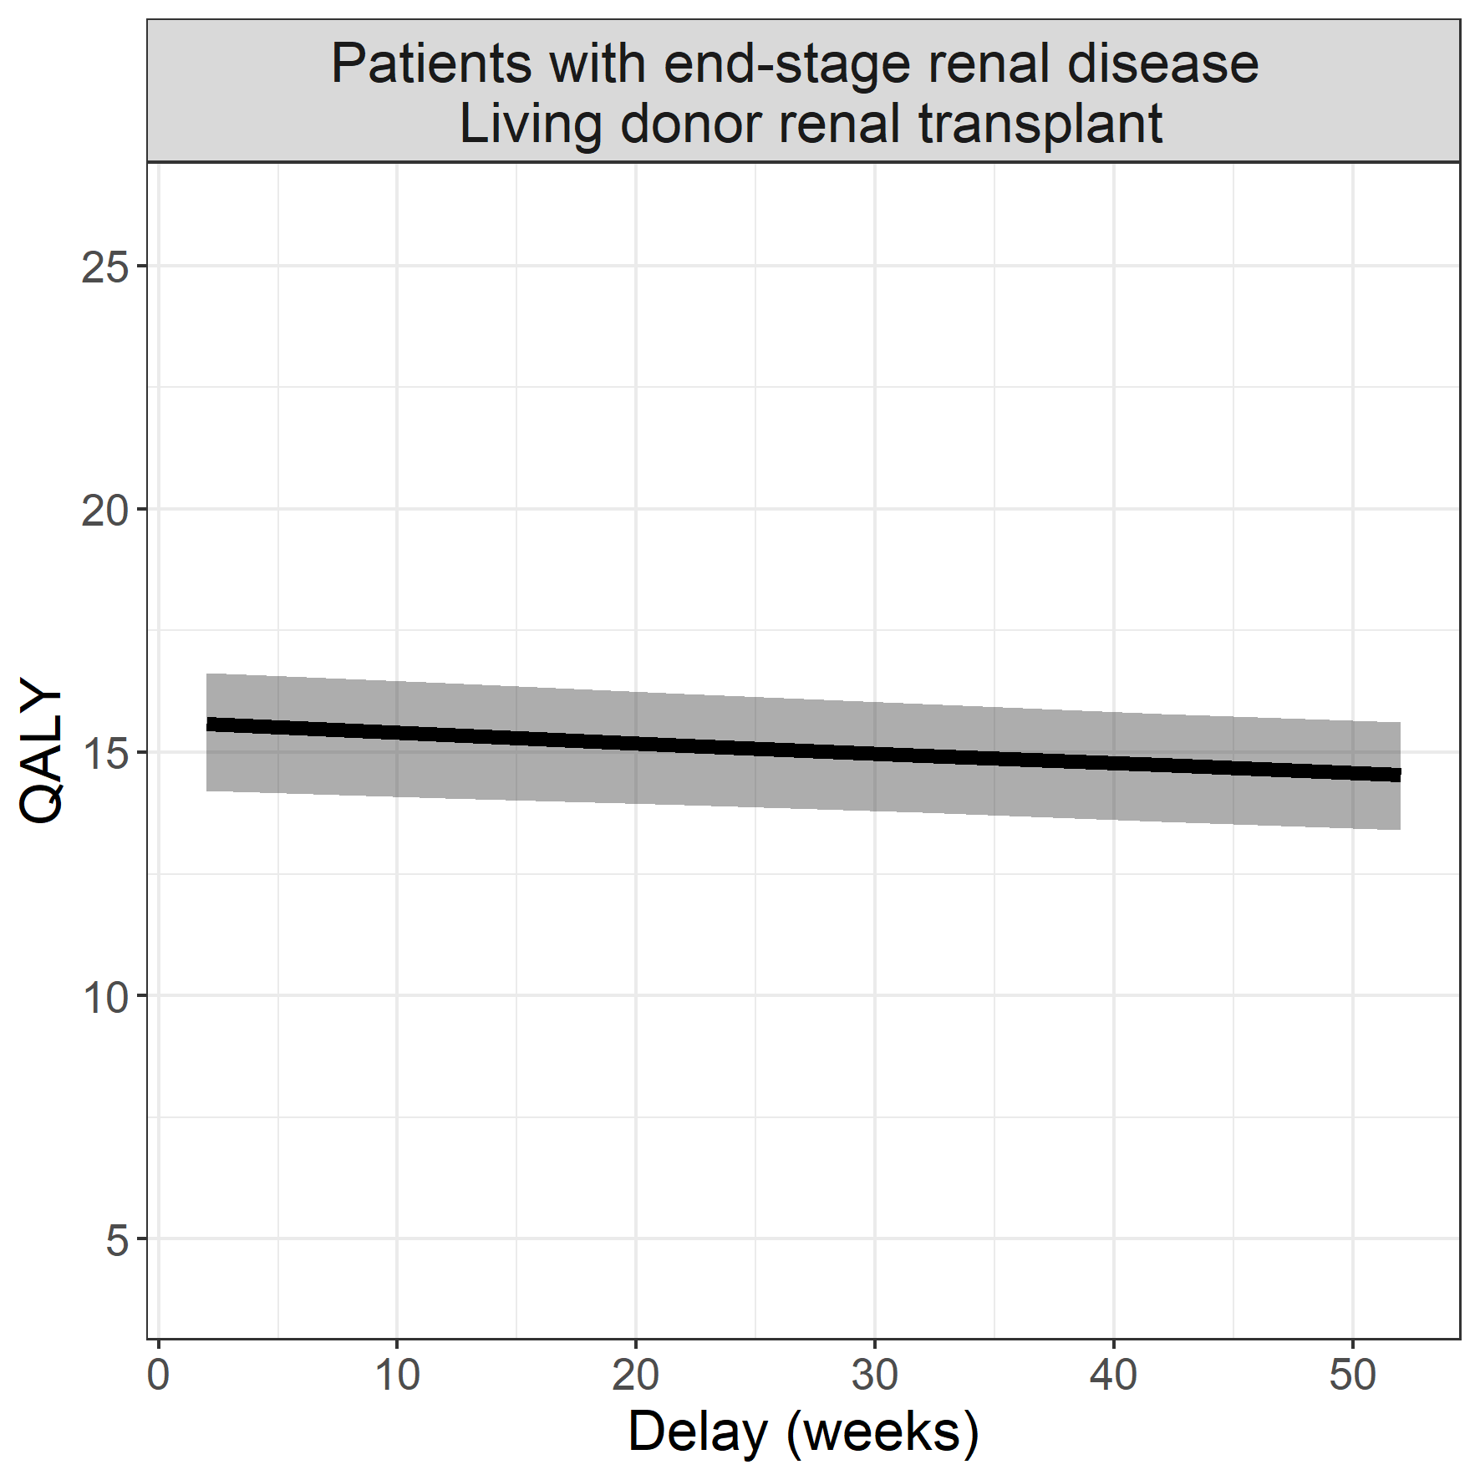

## Non-small cell lung carcinoma

### Surgical procedure: lobectomy

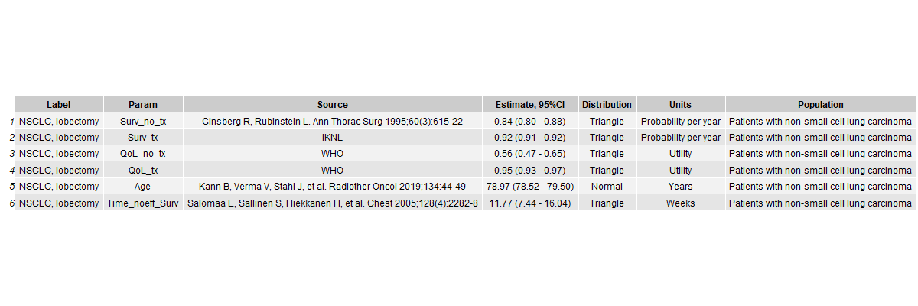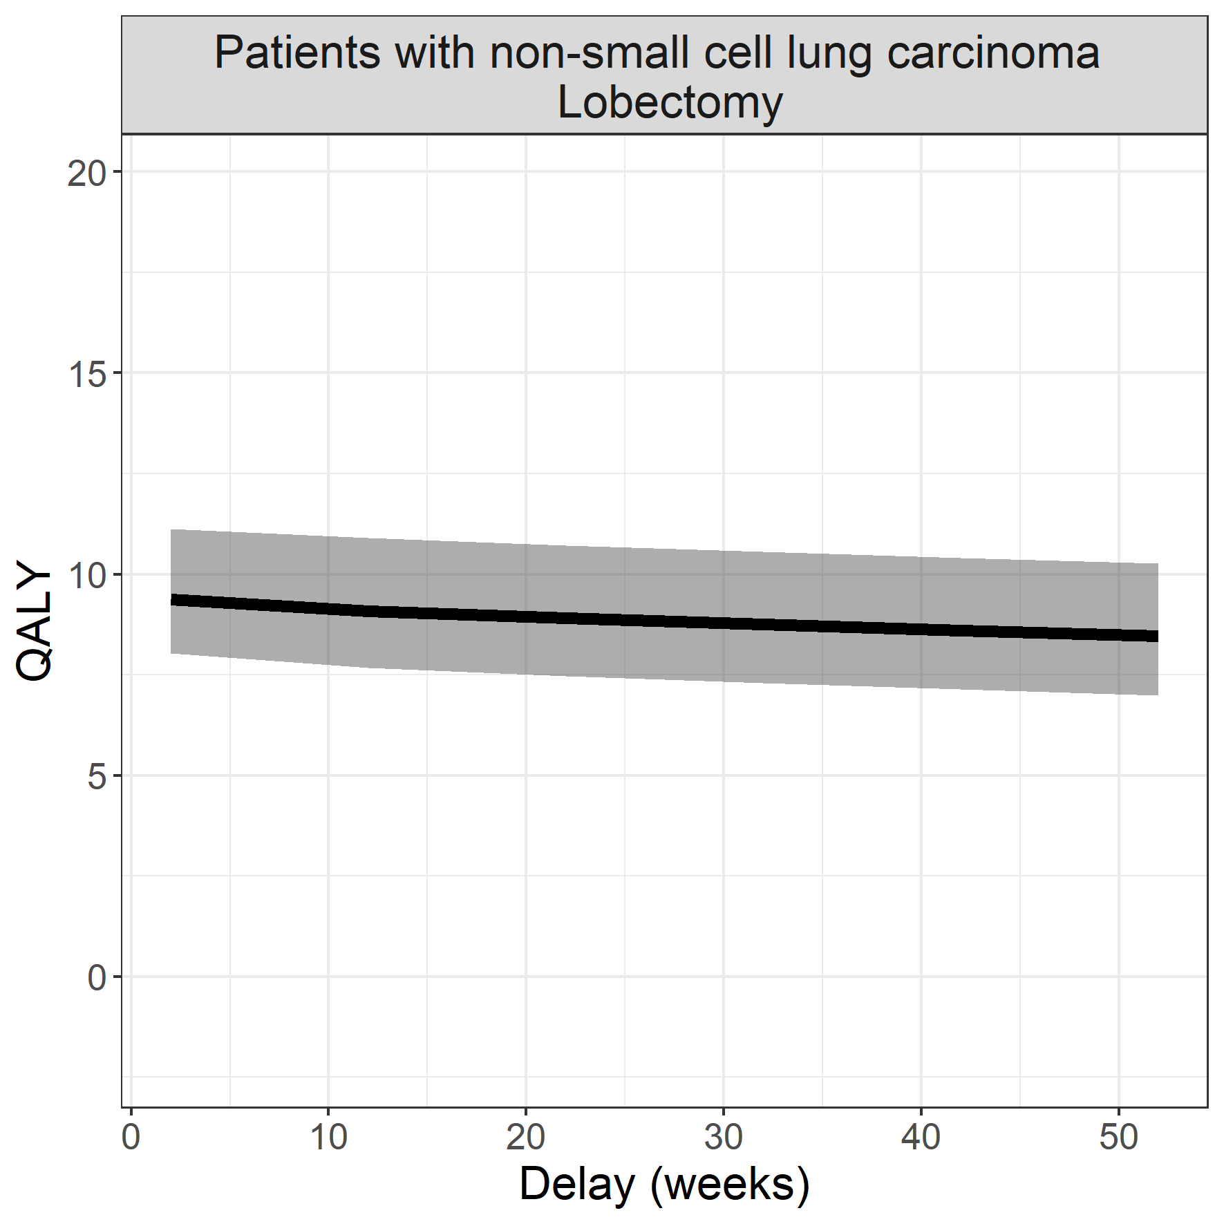

## Coloncarcinoma with liver metastases

### Surgical procedure: hepatectomy

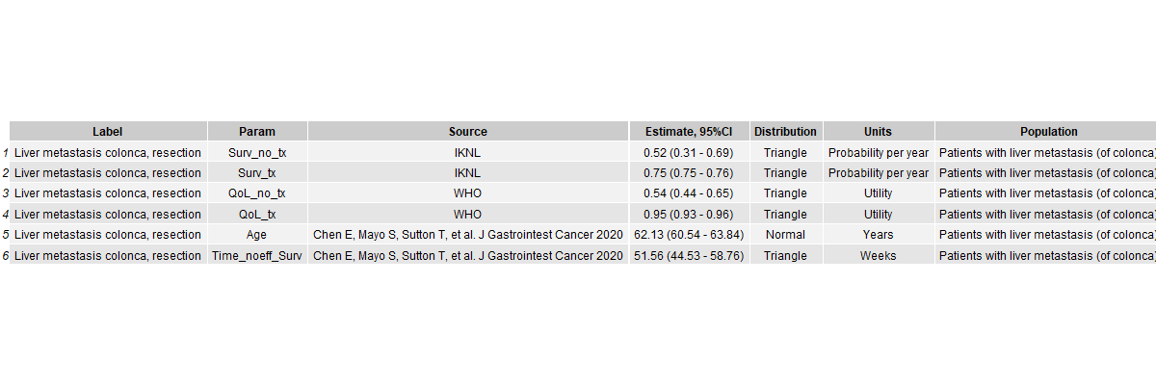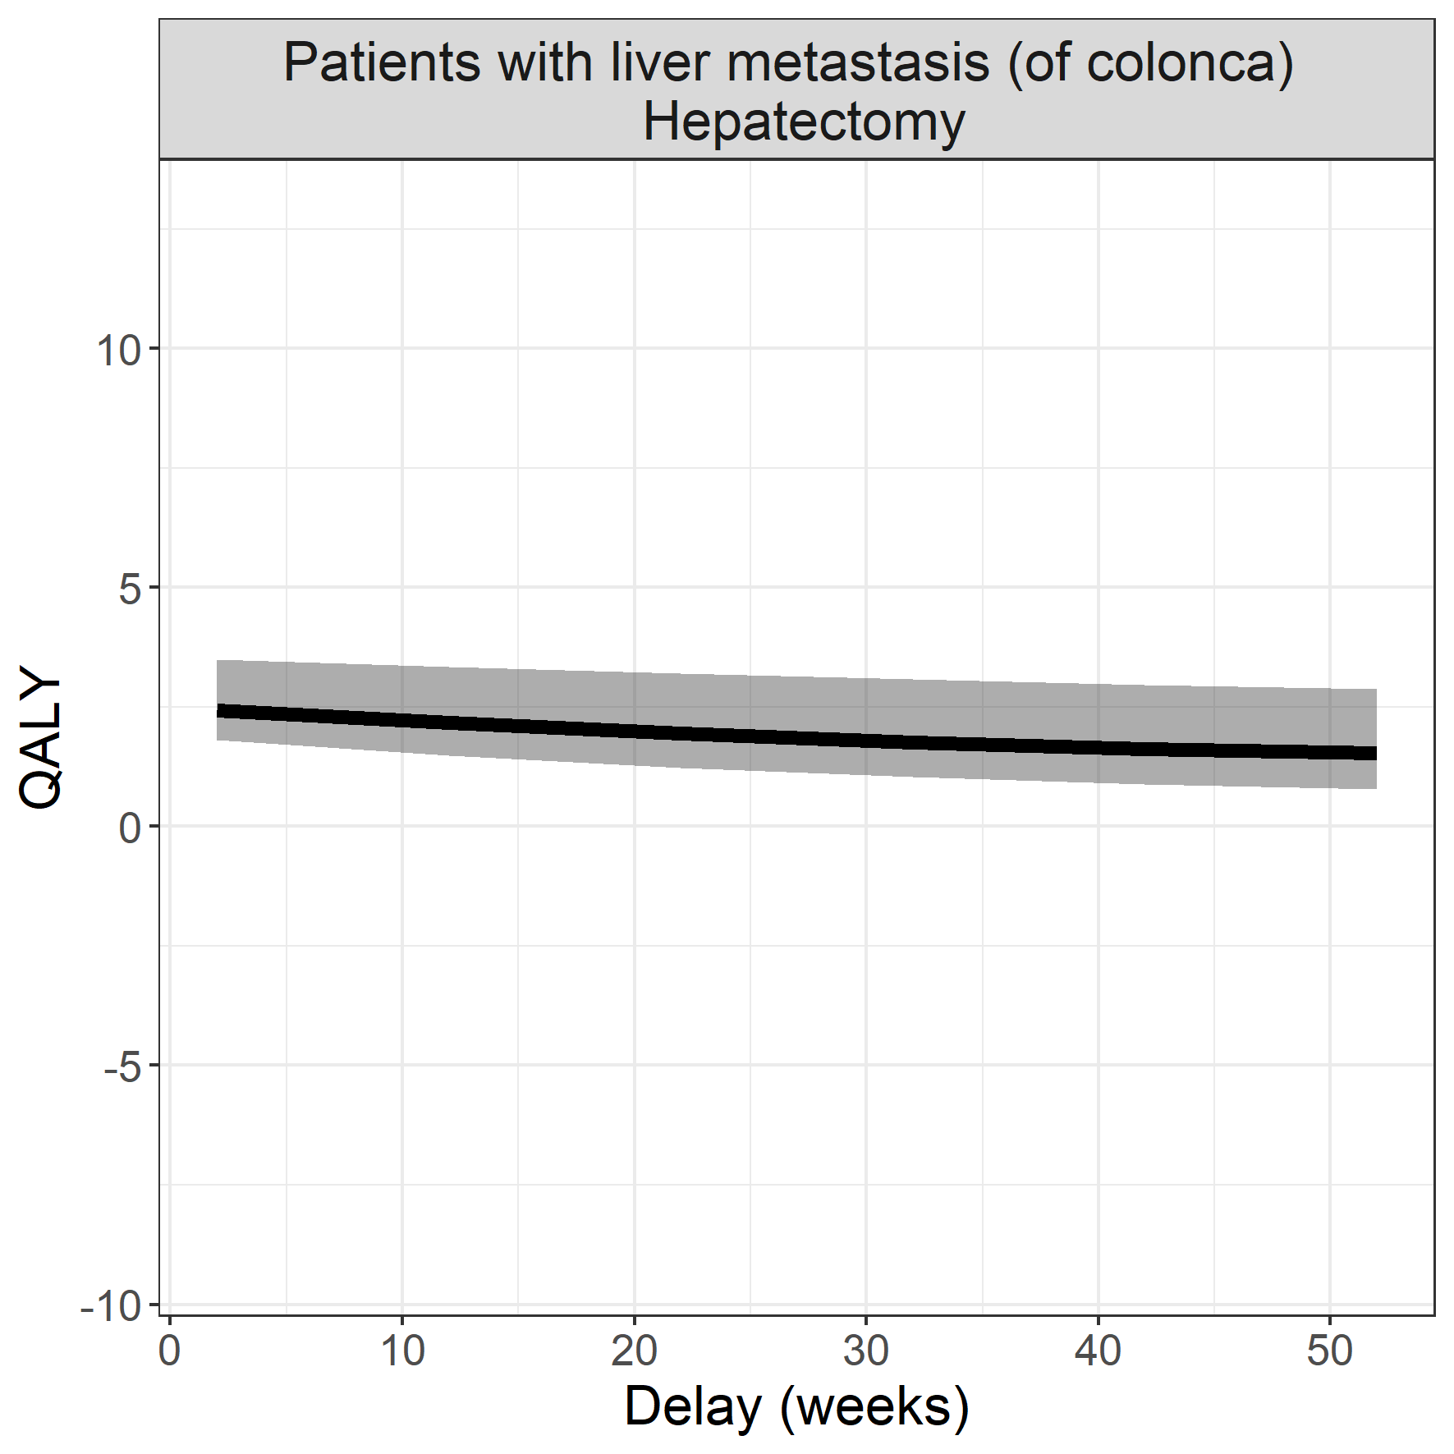

## Renal cell carcinoma, stage I

### Surgical procedure: partial nefrectomy

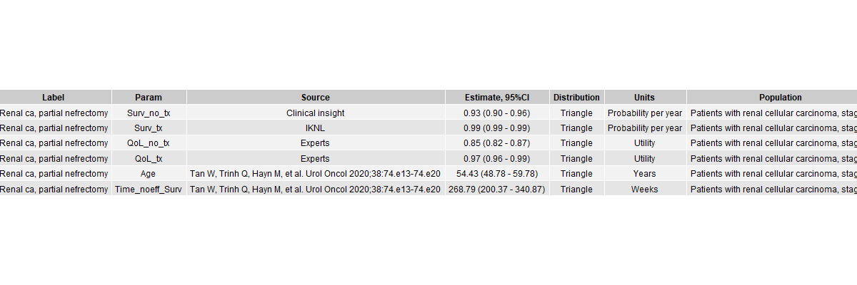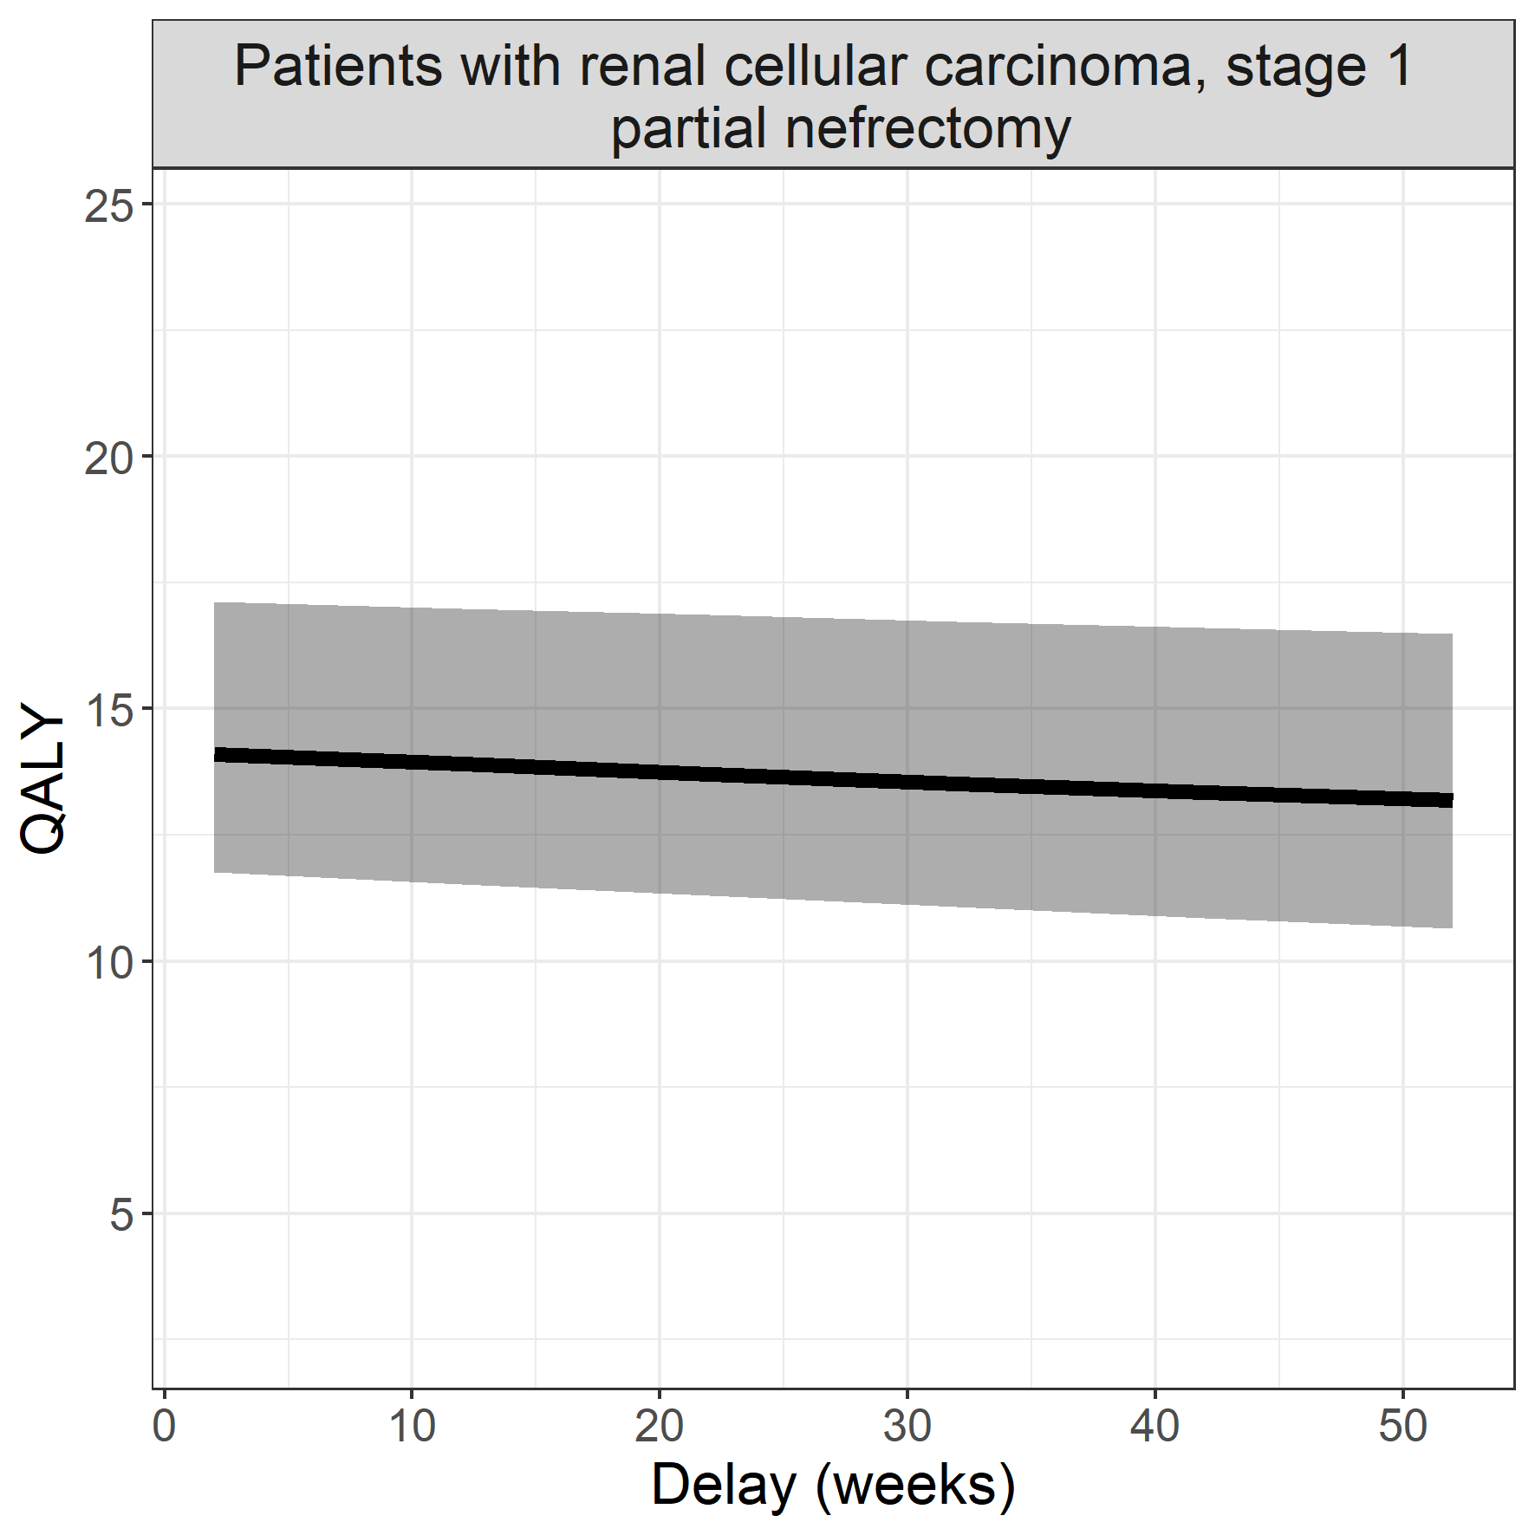

## End-stage liver disease

### Surgical procedure: living donor liver transplant

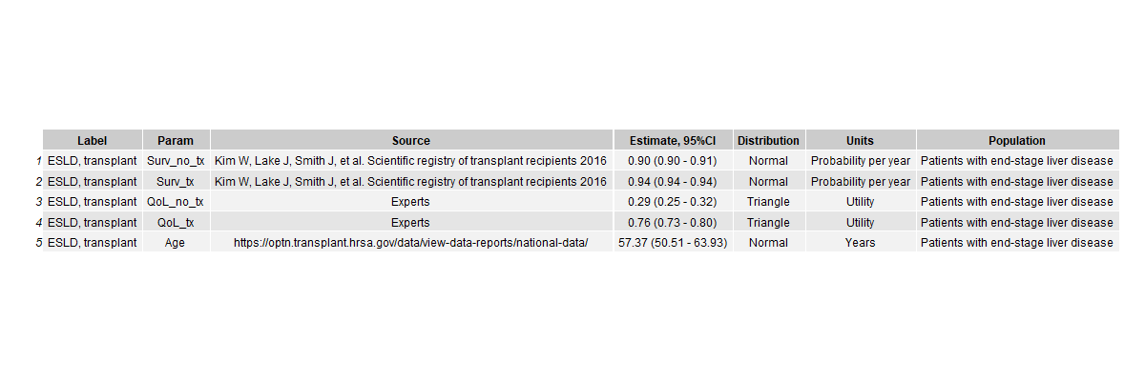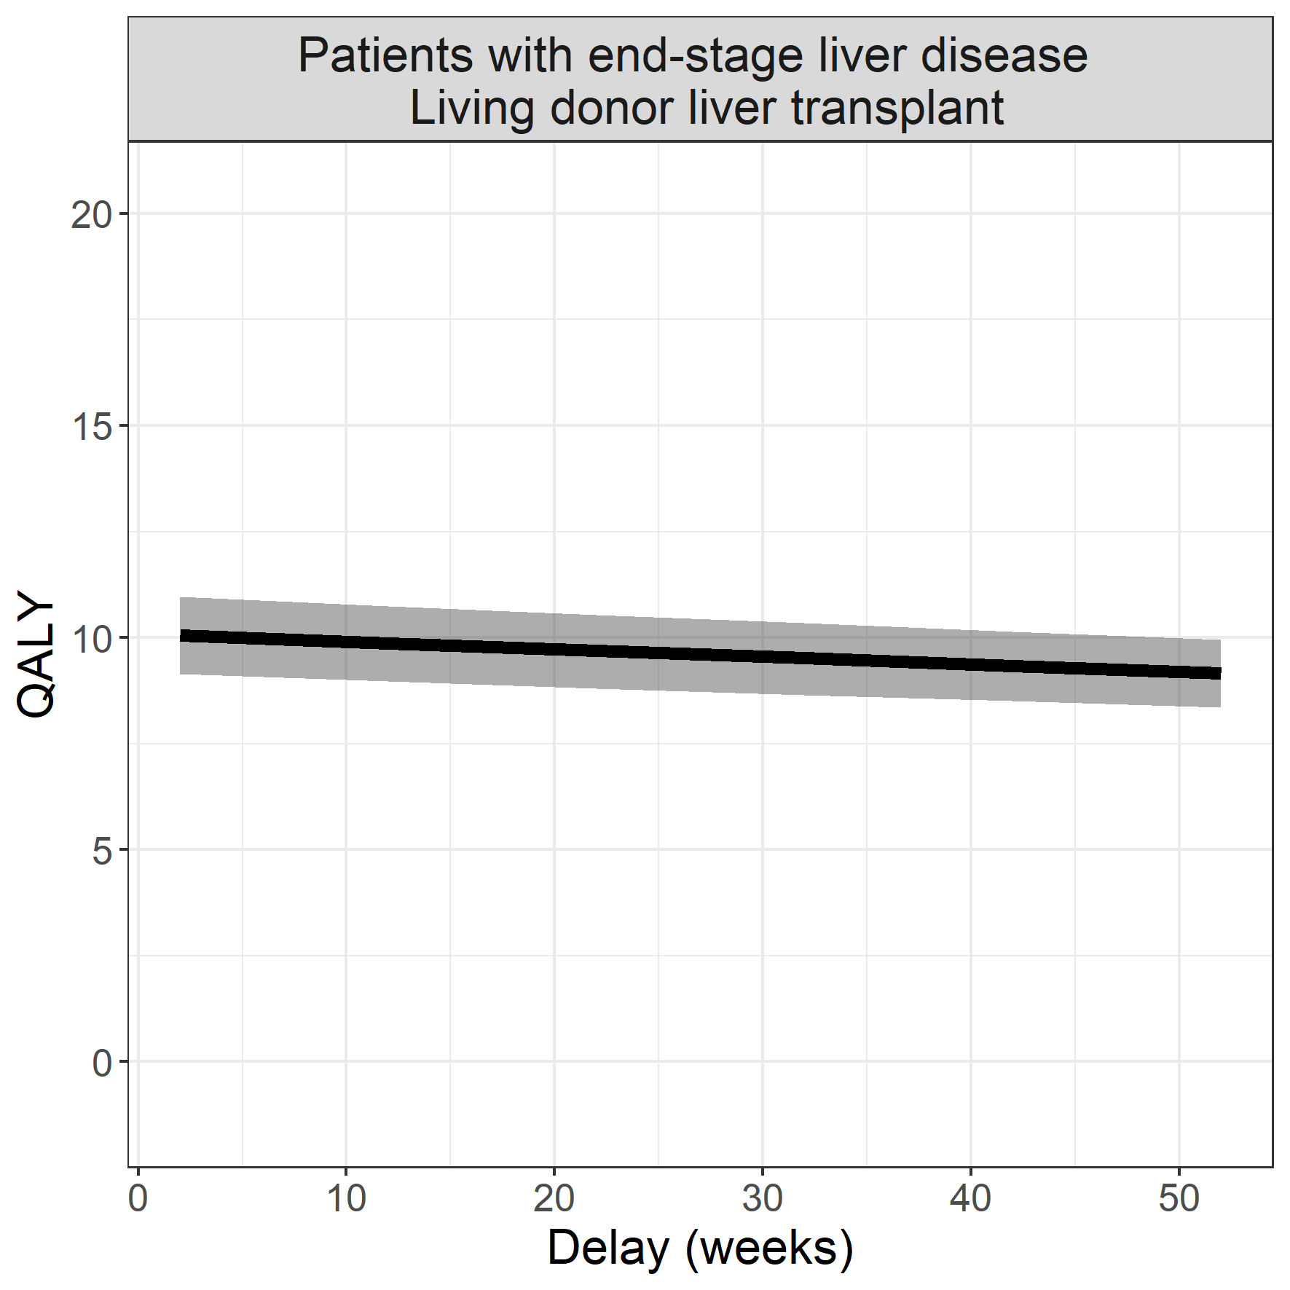

## End-stage heart failure

### Surgical procedure: implantation of a left ventricle assist device

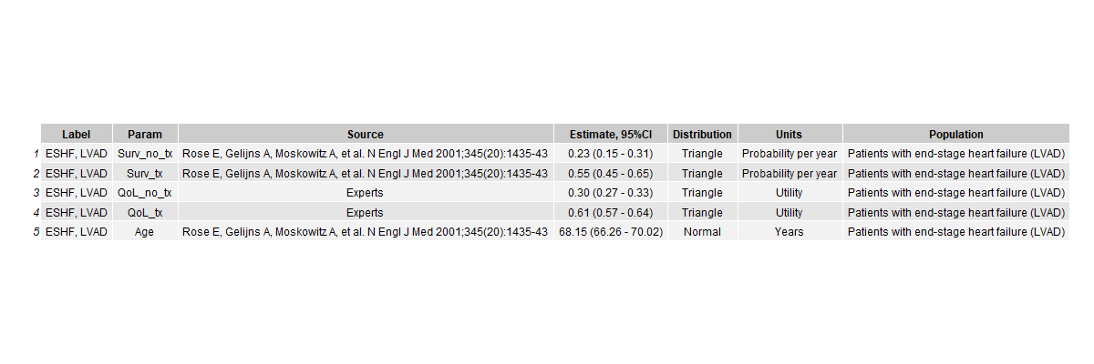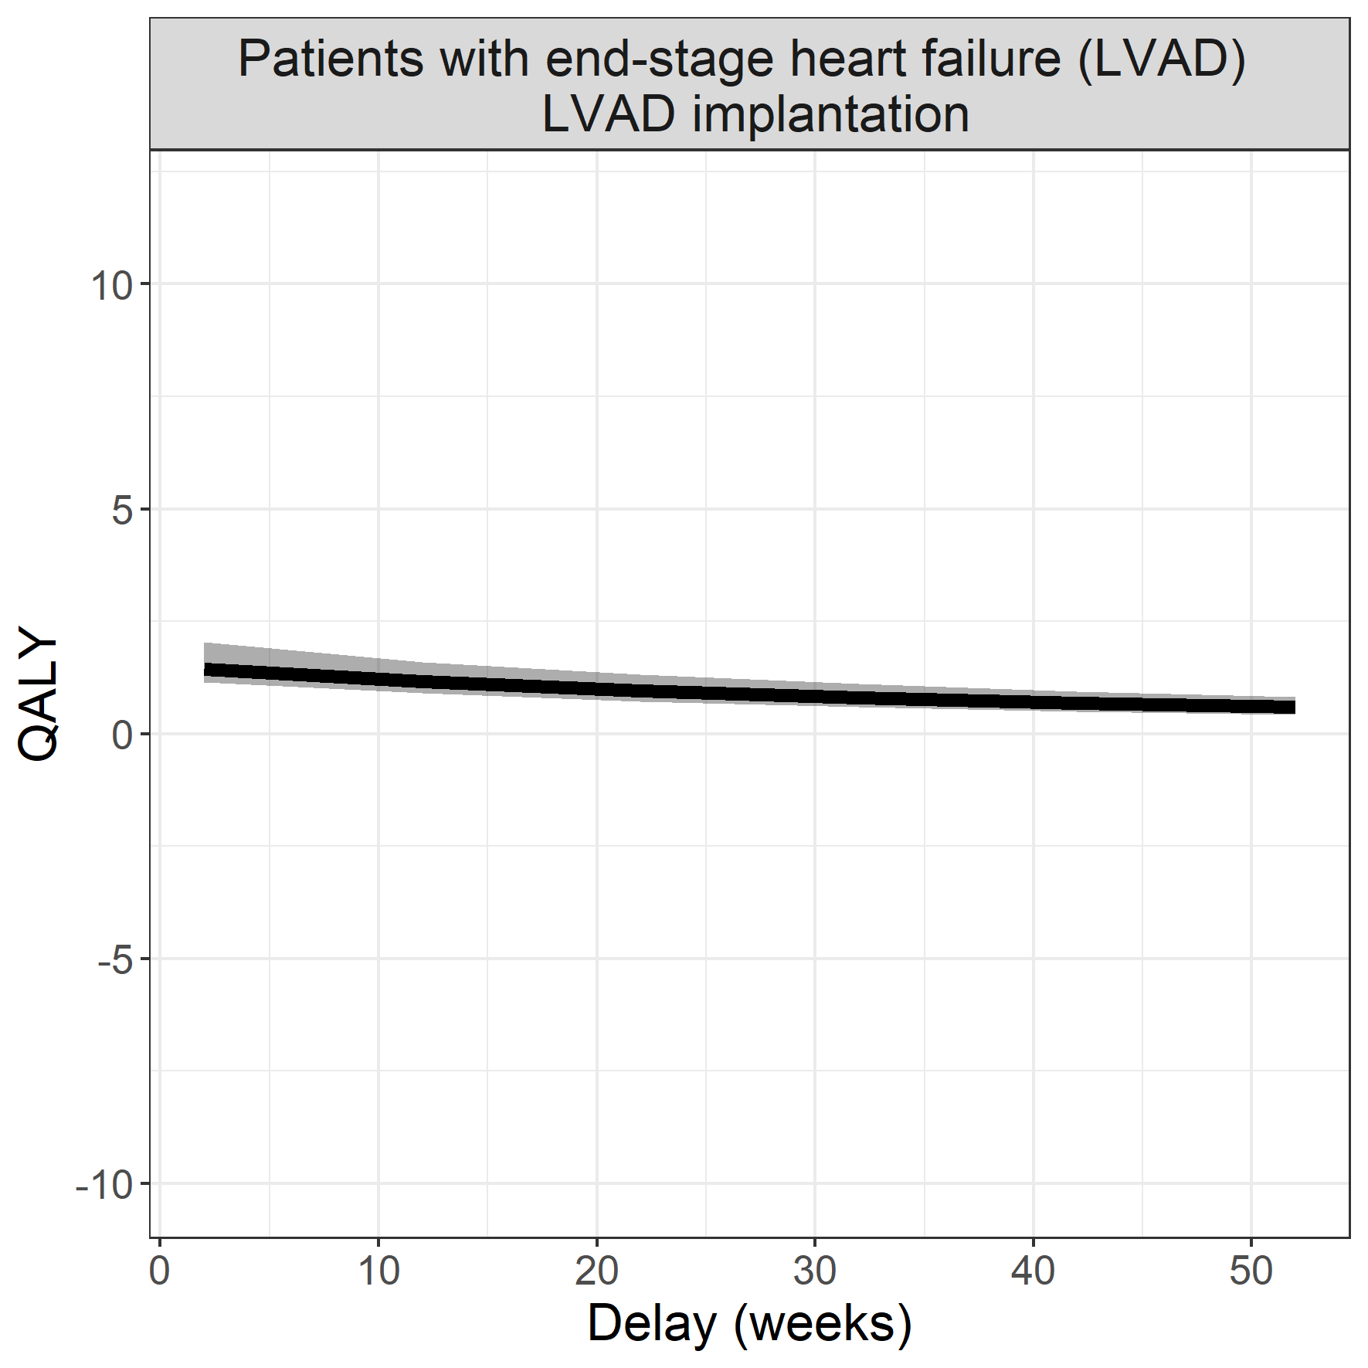

## Laryngeal carcinoma

### Surgical procedure: surgical resection

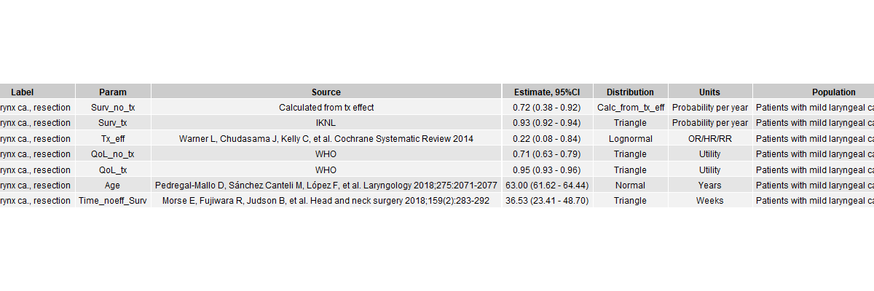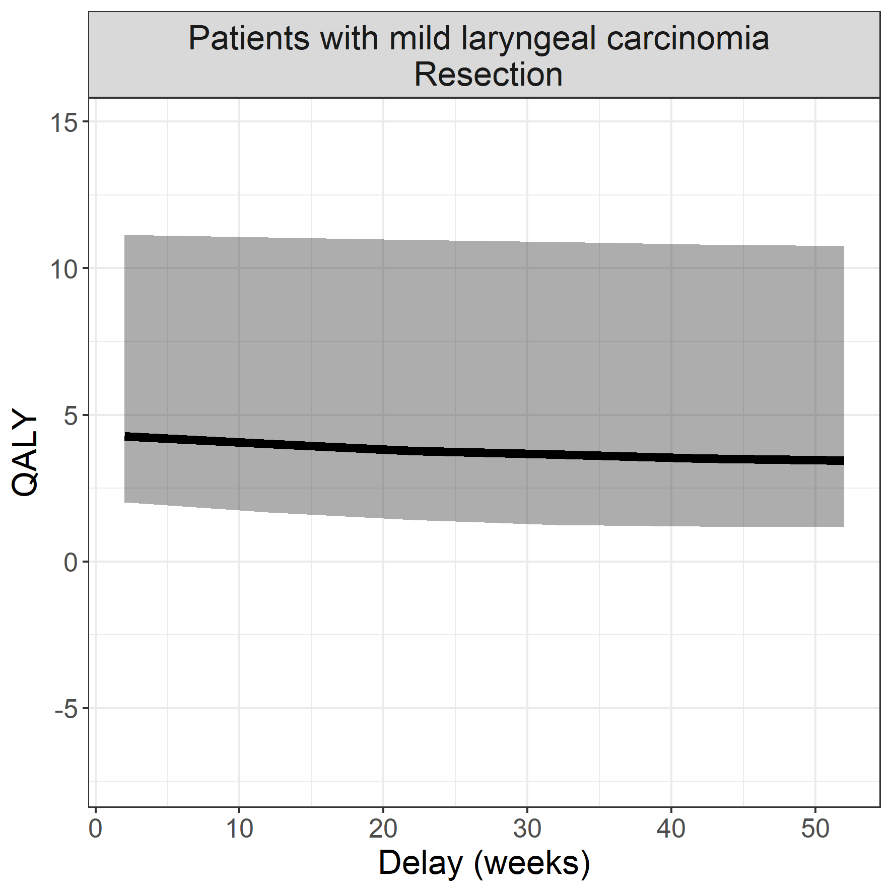

## Aortic valve insufficiency

**Surgical procedure: aortic valve replacement (thoracotomy)**

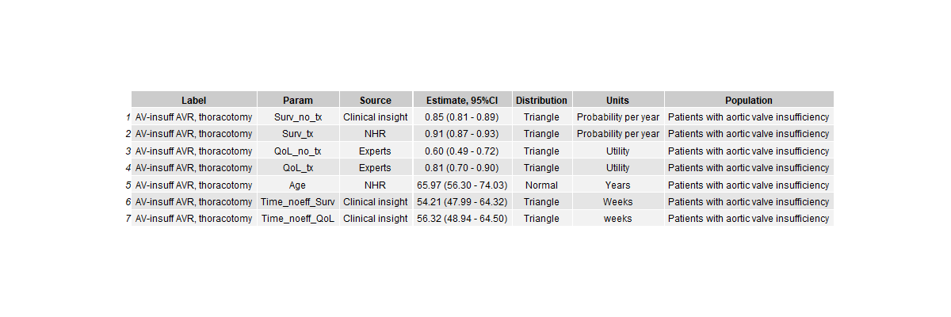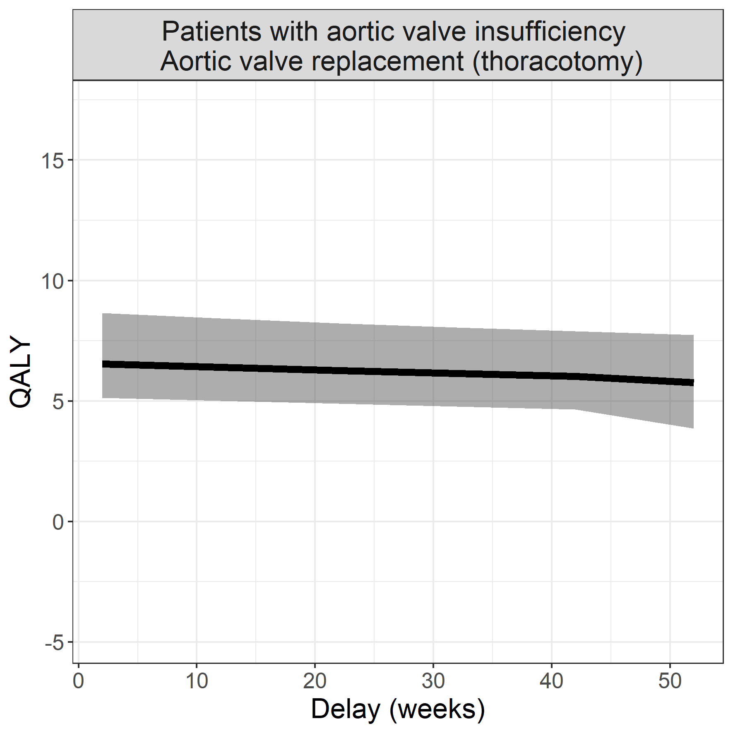

## Abdominal aneurysm of the aorta

**Surgical procedure: endovascular aorta repair**

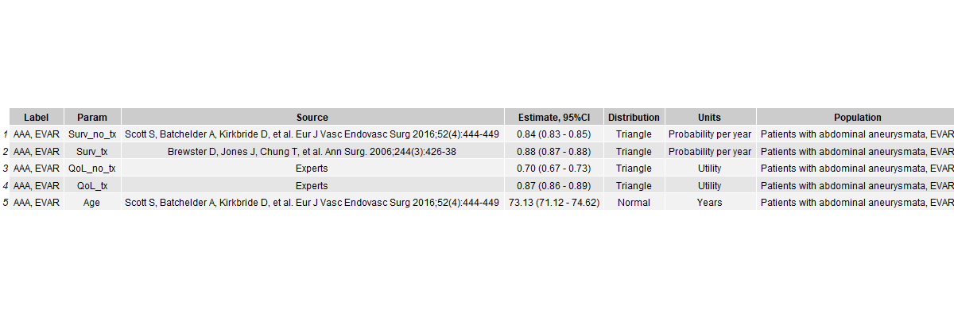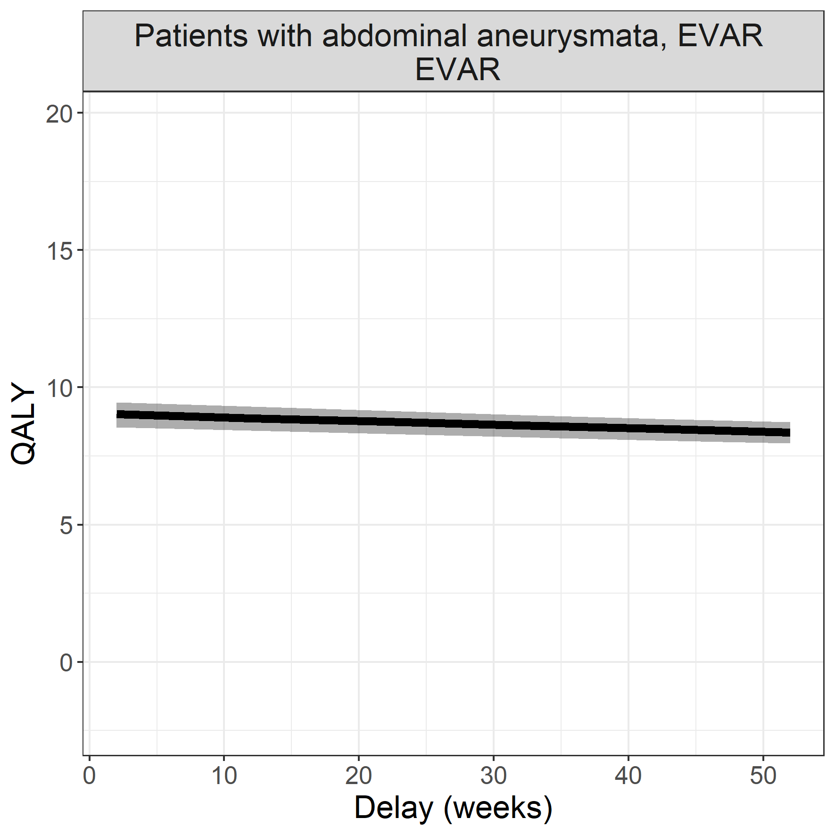

## Adults with untreated atrial septum defect

**Surgical procedure: surgical repair**

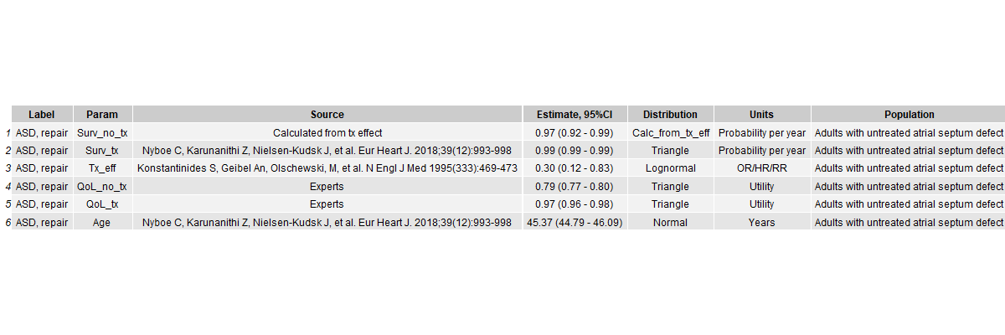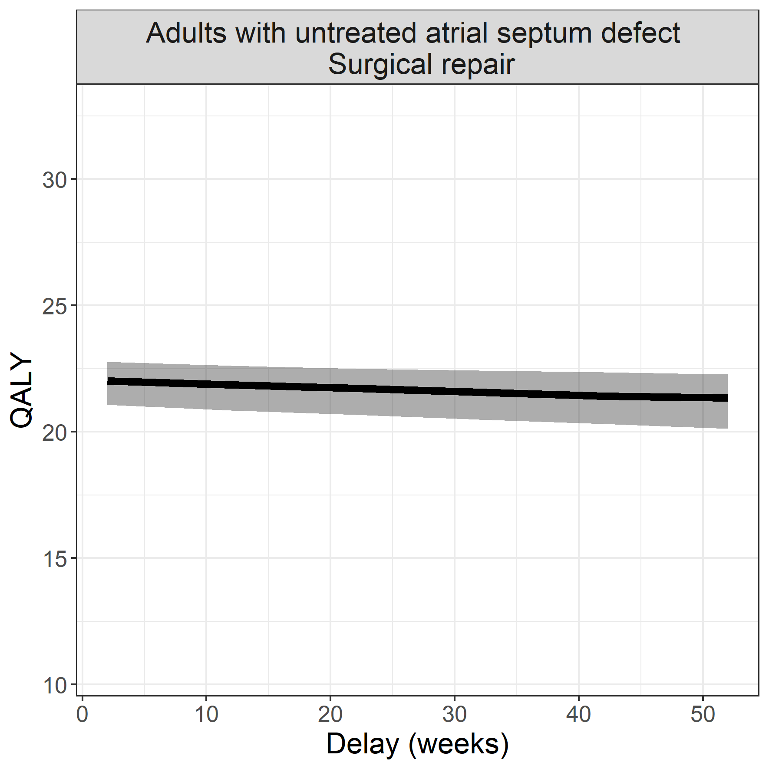

## Penis carcinoma

**Surgical procedure: surgical resection**

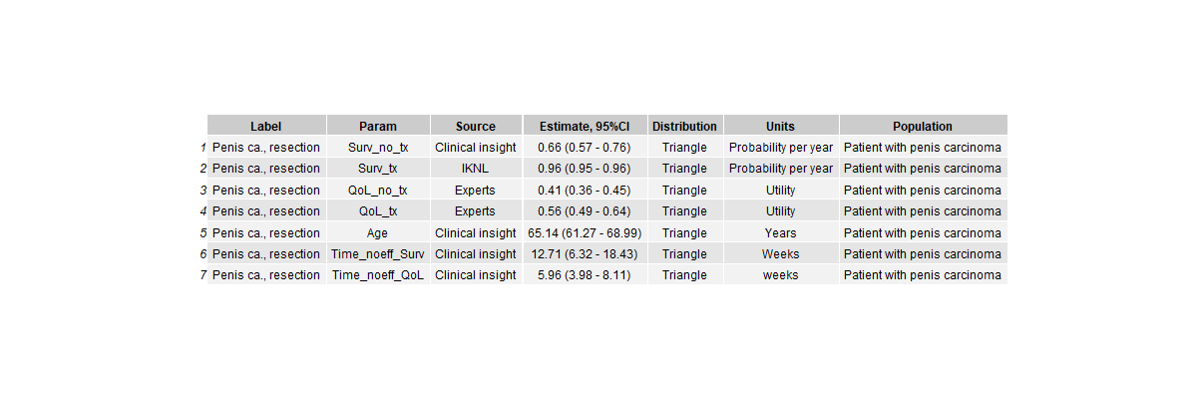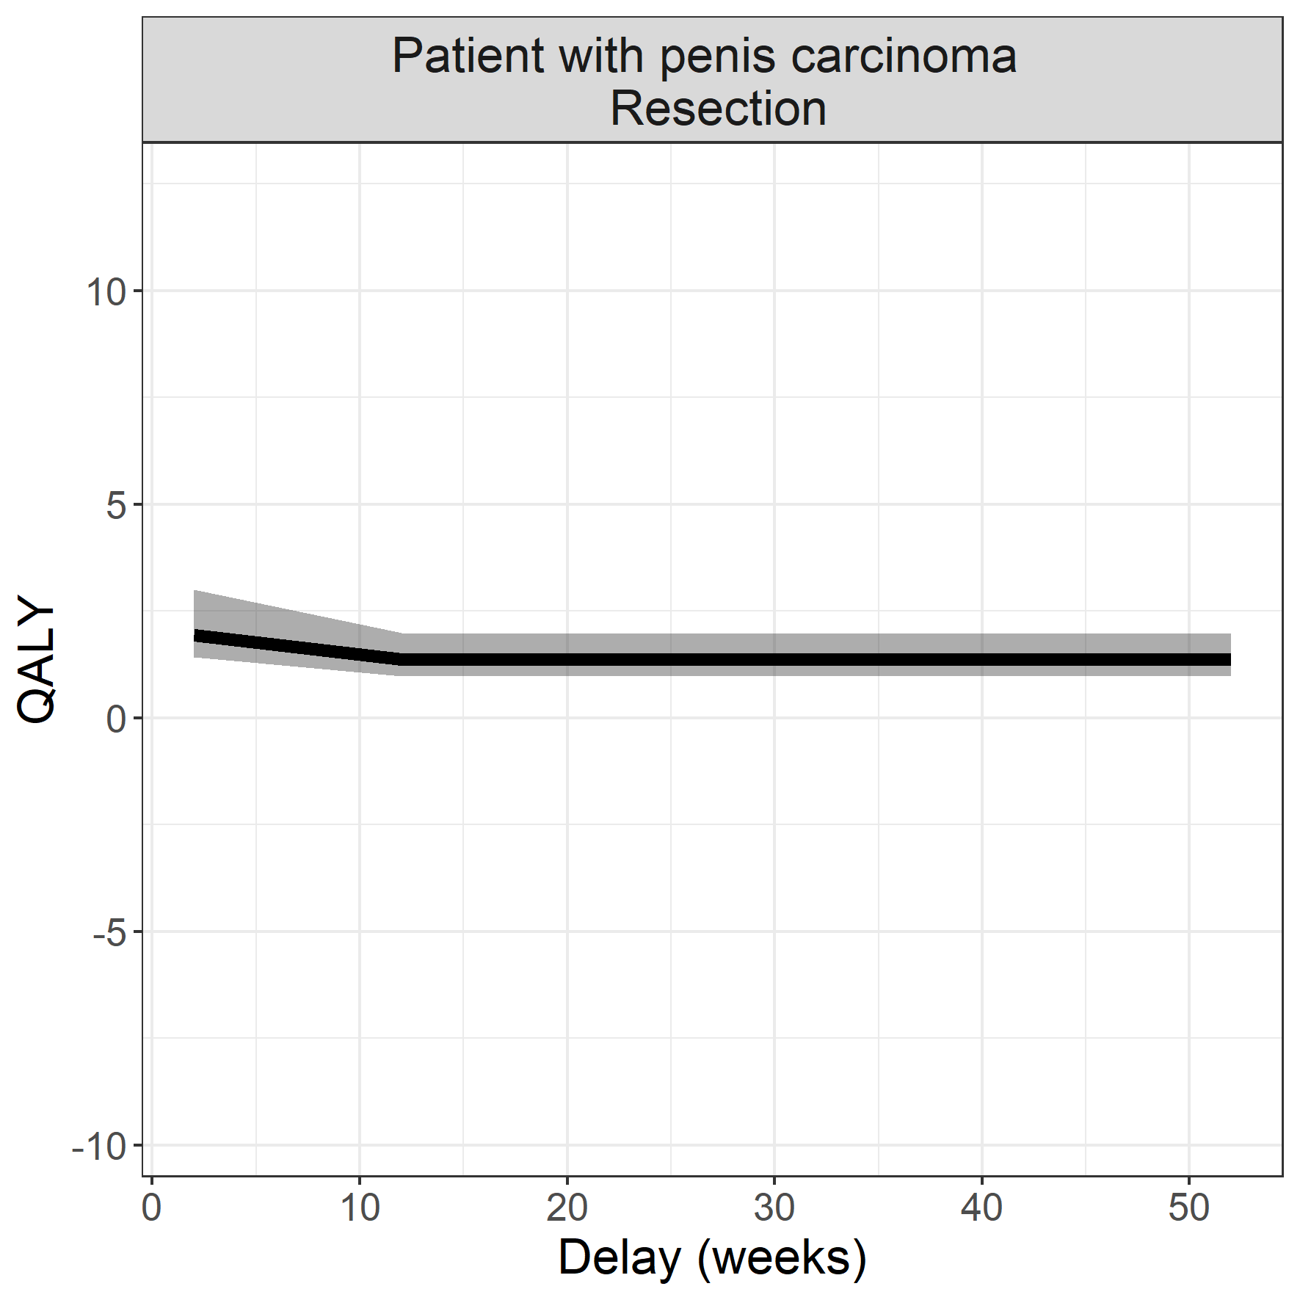

## Pancreas carcinoma

**Surgical procedure: whipple**

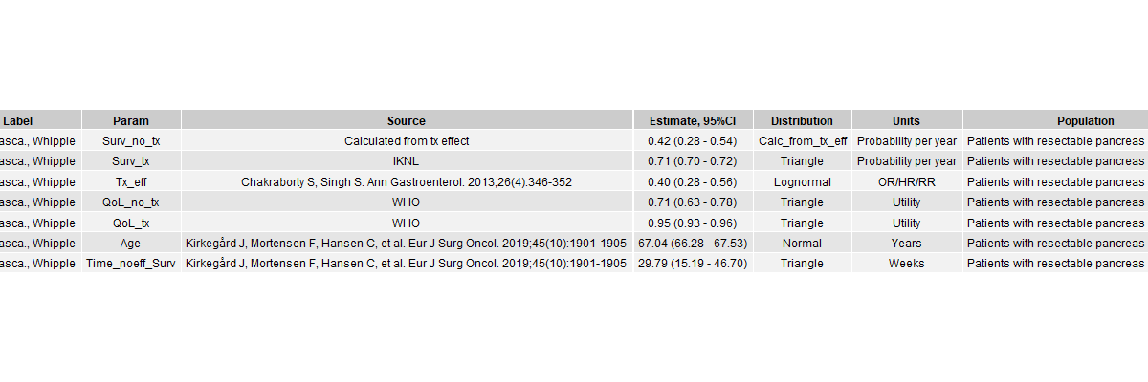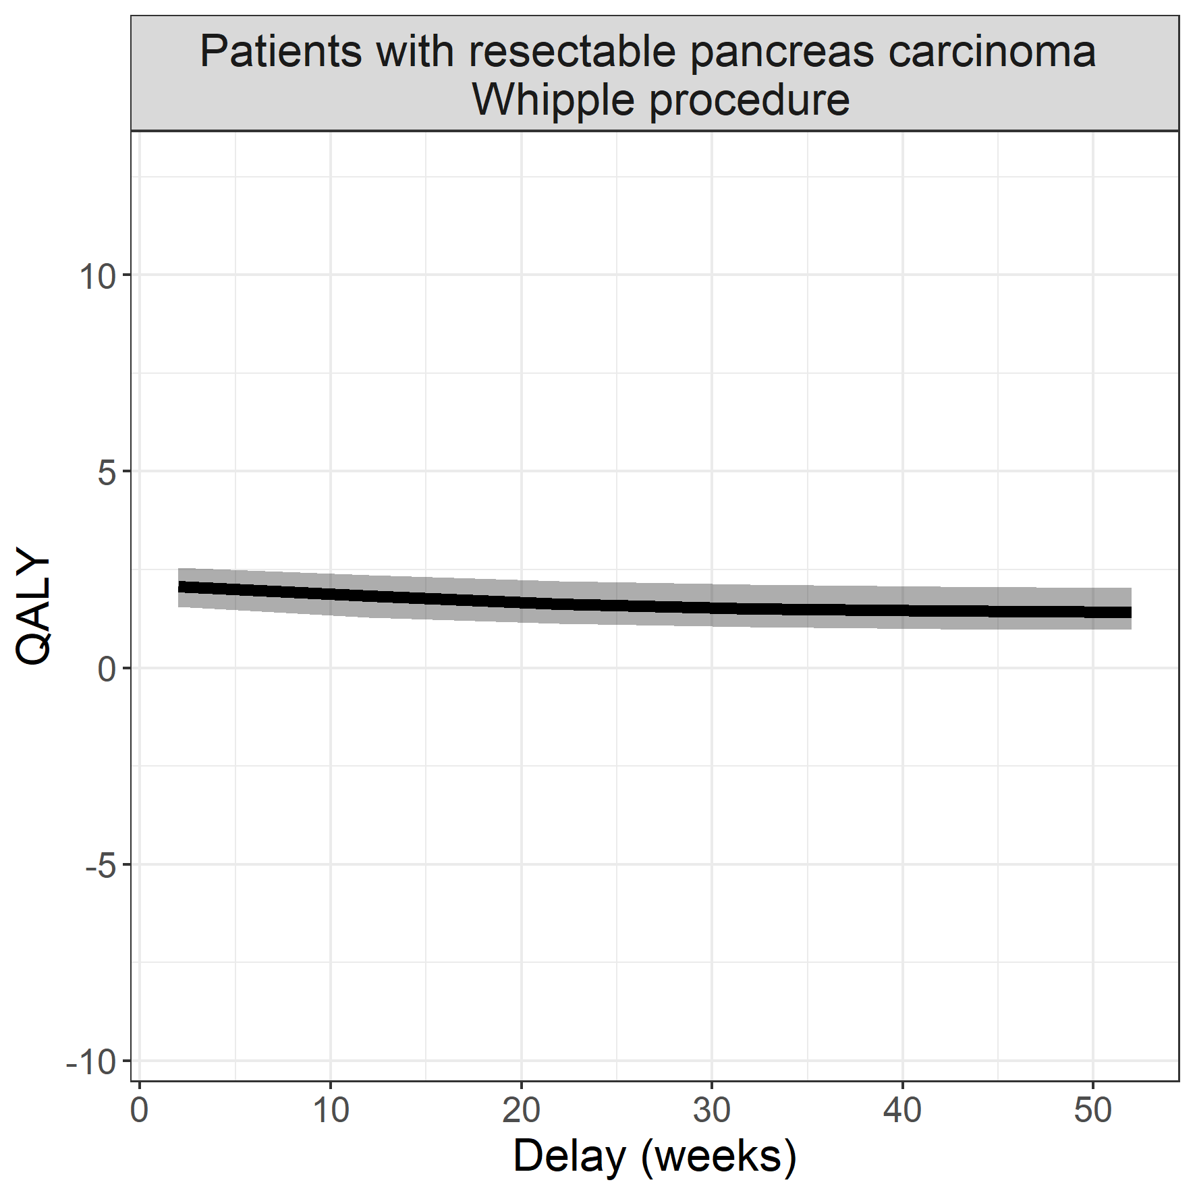

## Instable angina pectoris - CABG

**Surgical procedure: coronary bypass artery graft**

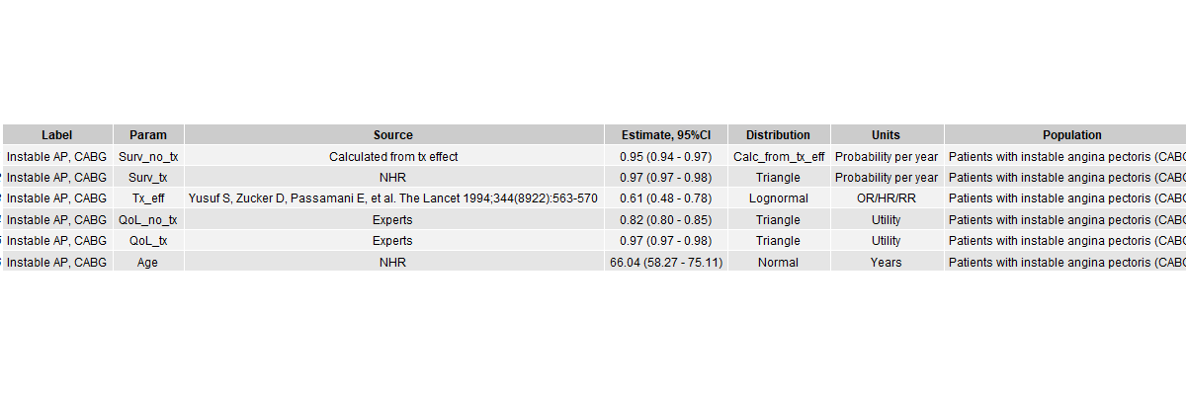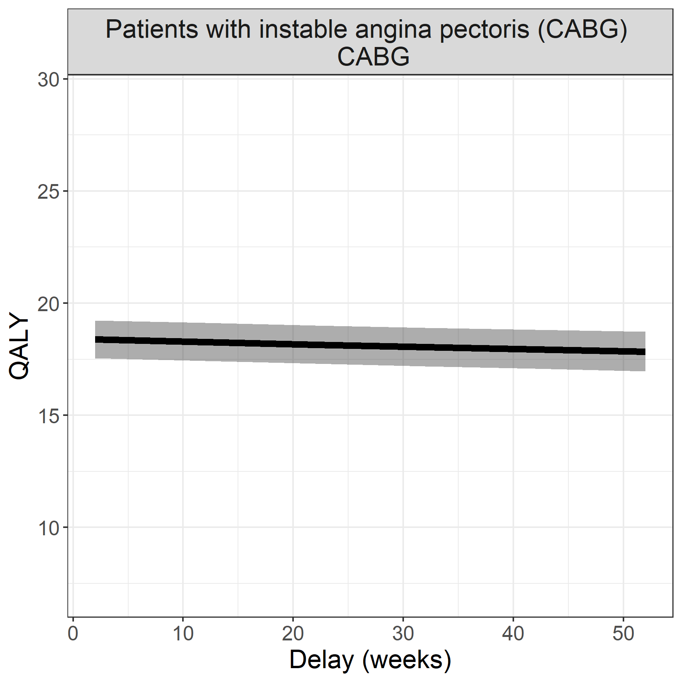

## Instable angina pectoris - PCI

**Surgical procedure: percutaneous coronary intervention**

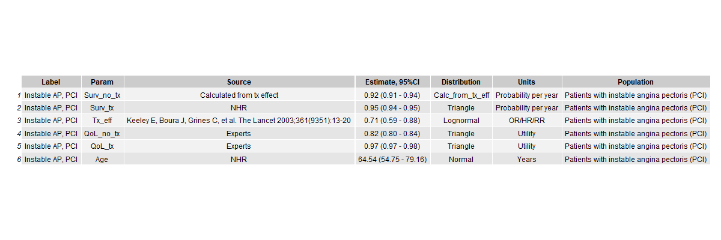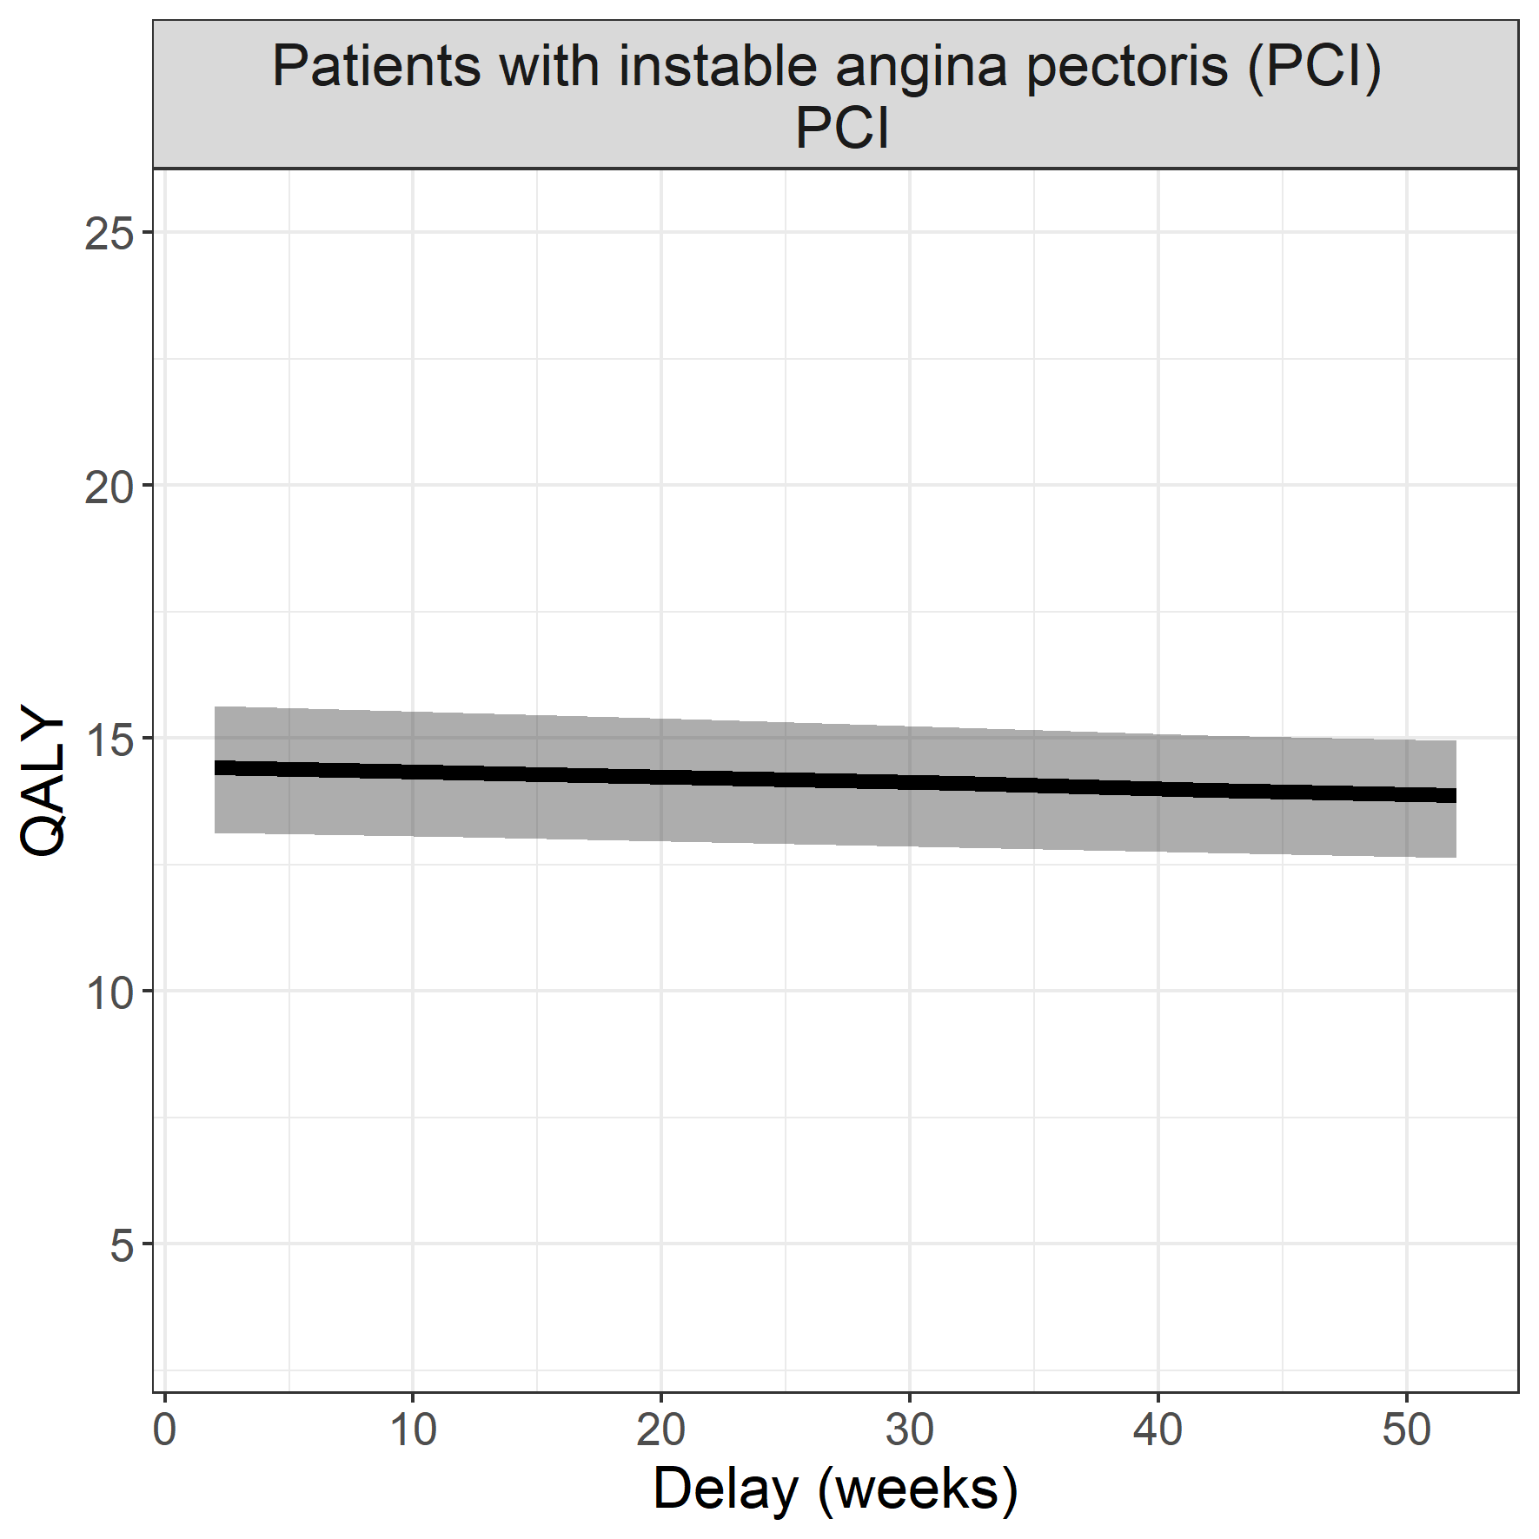

## Hepatocellular carcinoma

**Surgical procedure: surgical resection**

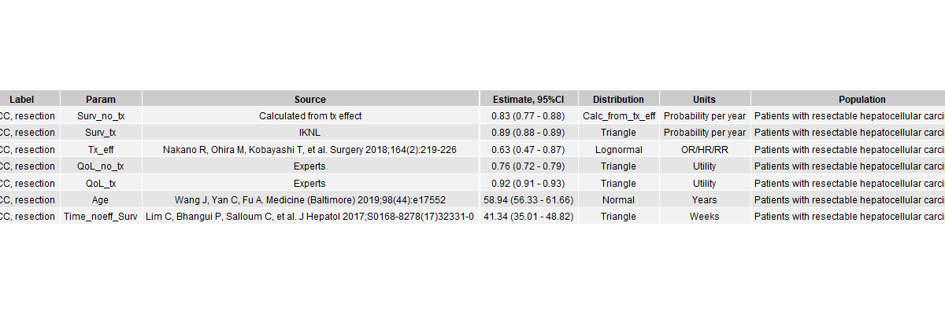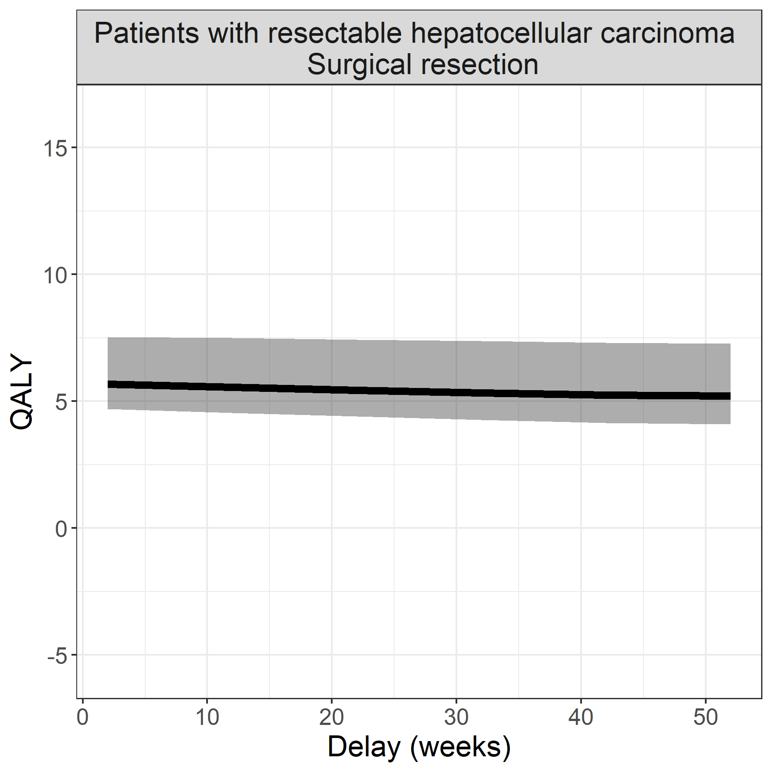

## Colon carcinoma with peritoneal metastases

**Surgical procedure: hyperthermic intraperitoneal chemotherapy**

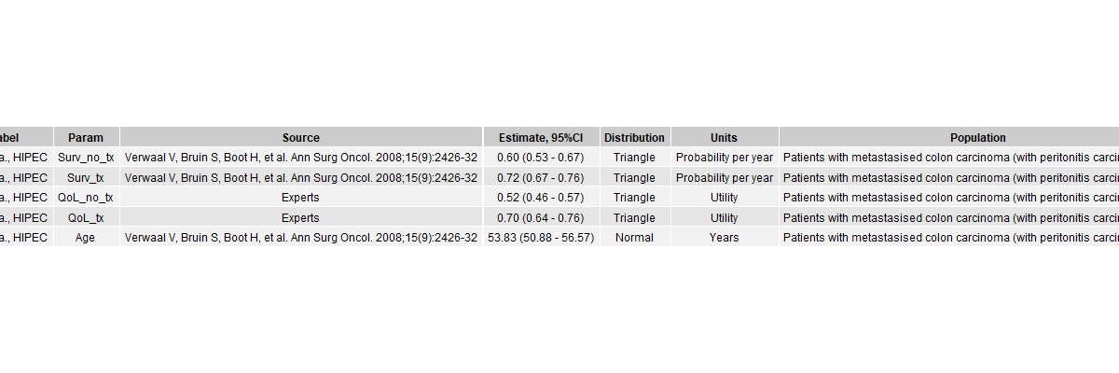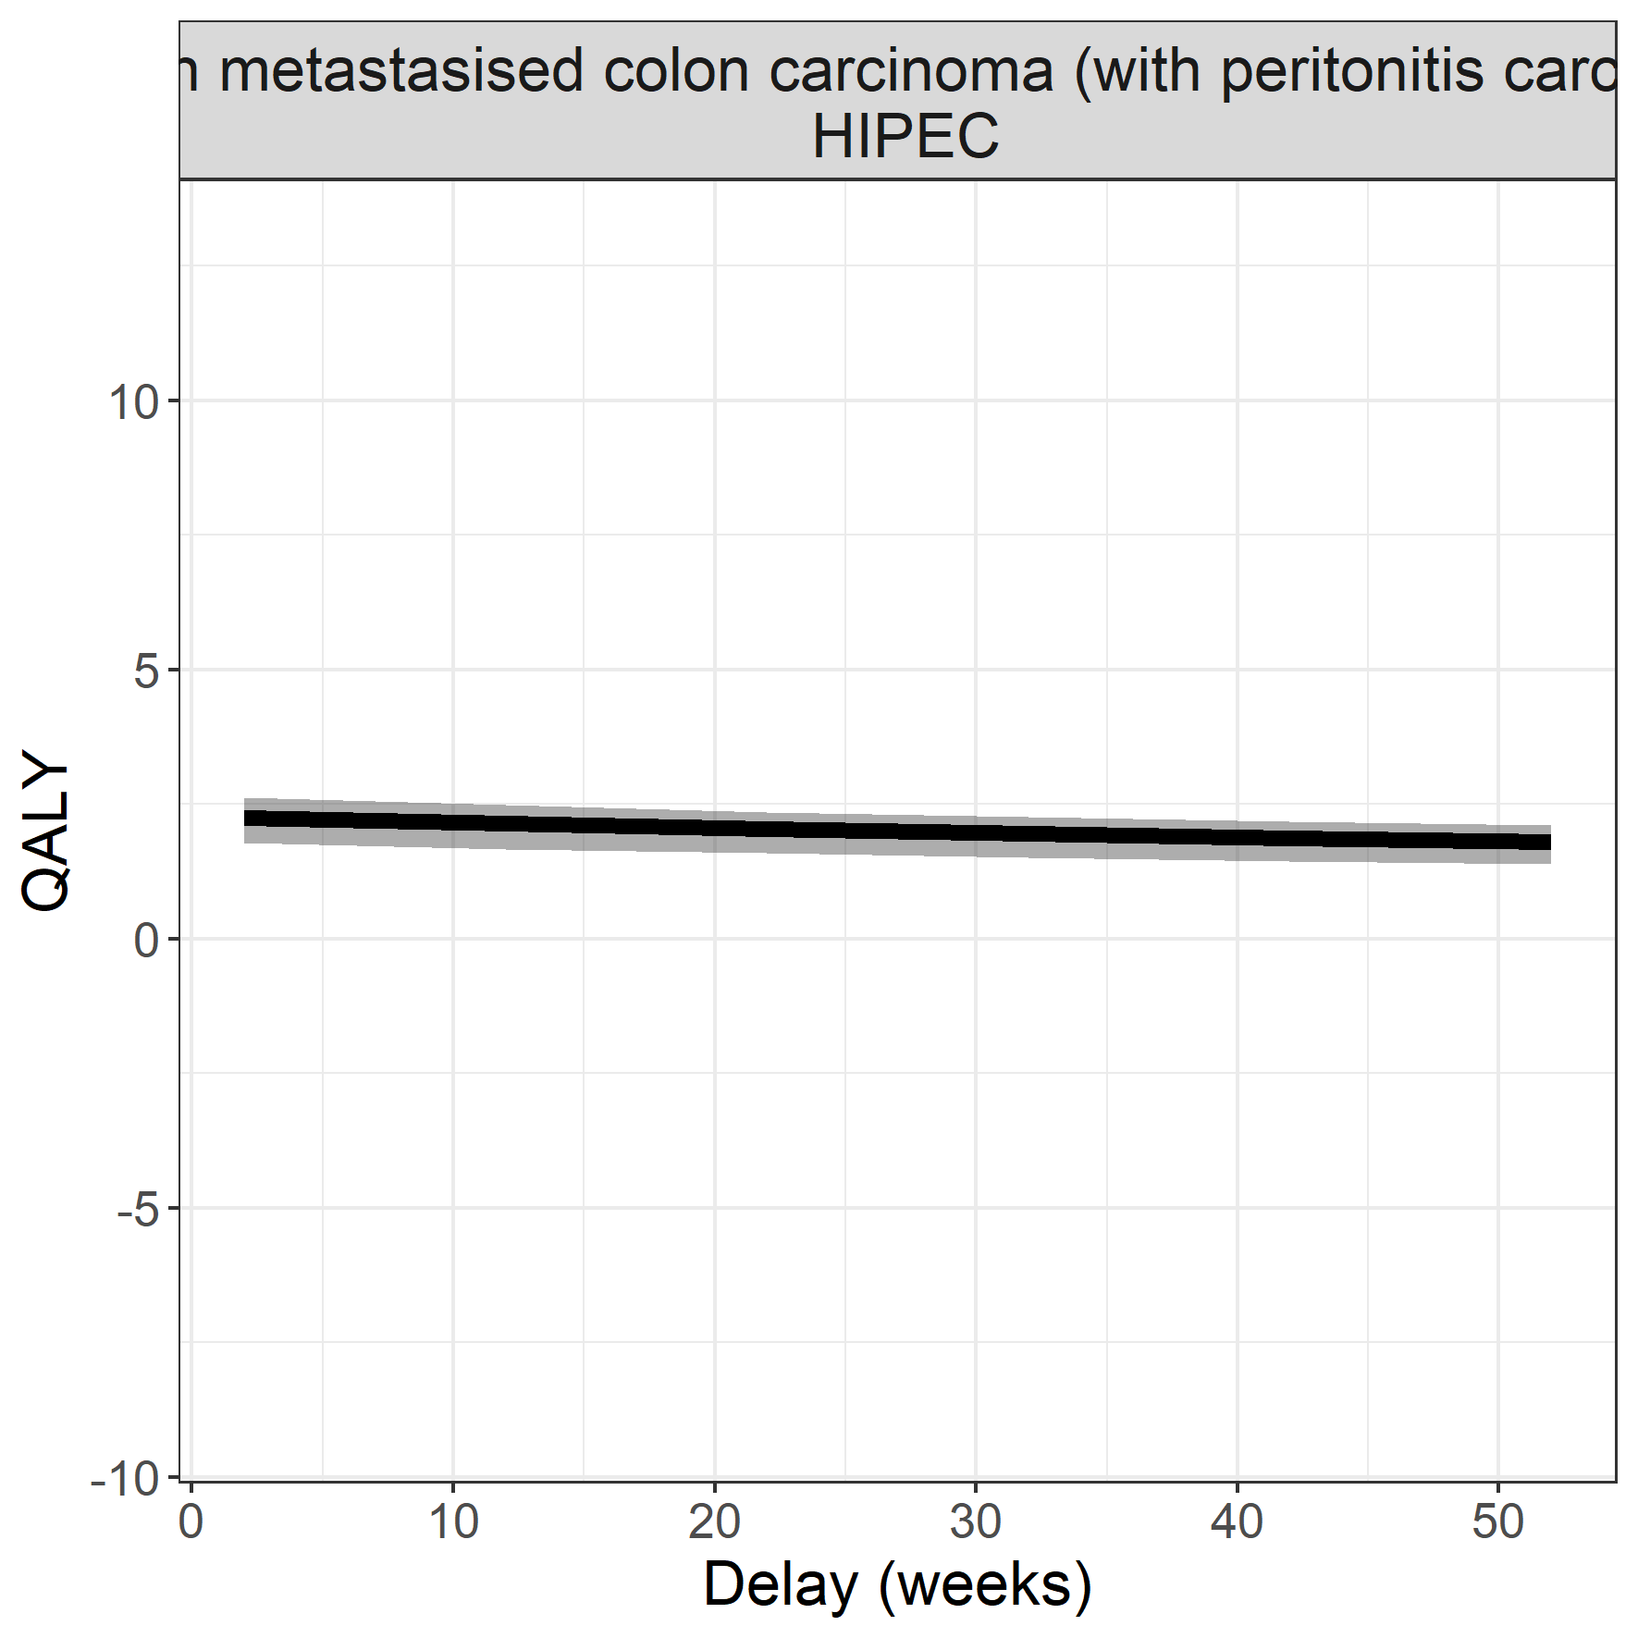

## Ovarium carcinoma

**Surgical procedure: debulking and hyperthermic intraperitoneal chemotherapy**

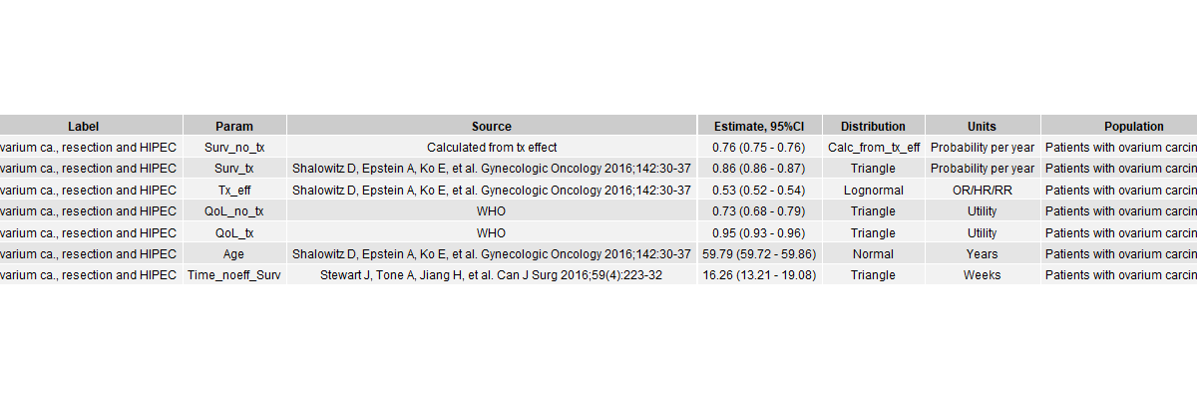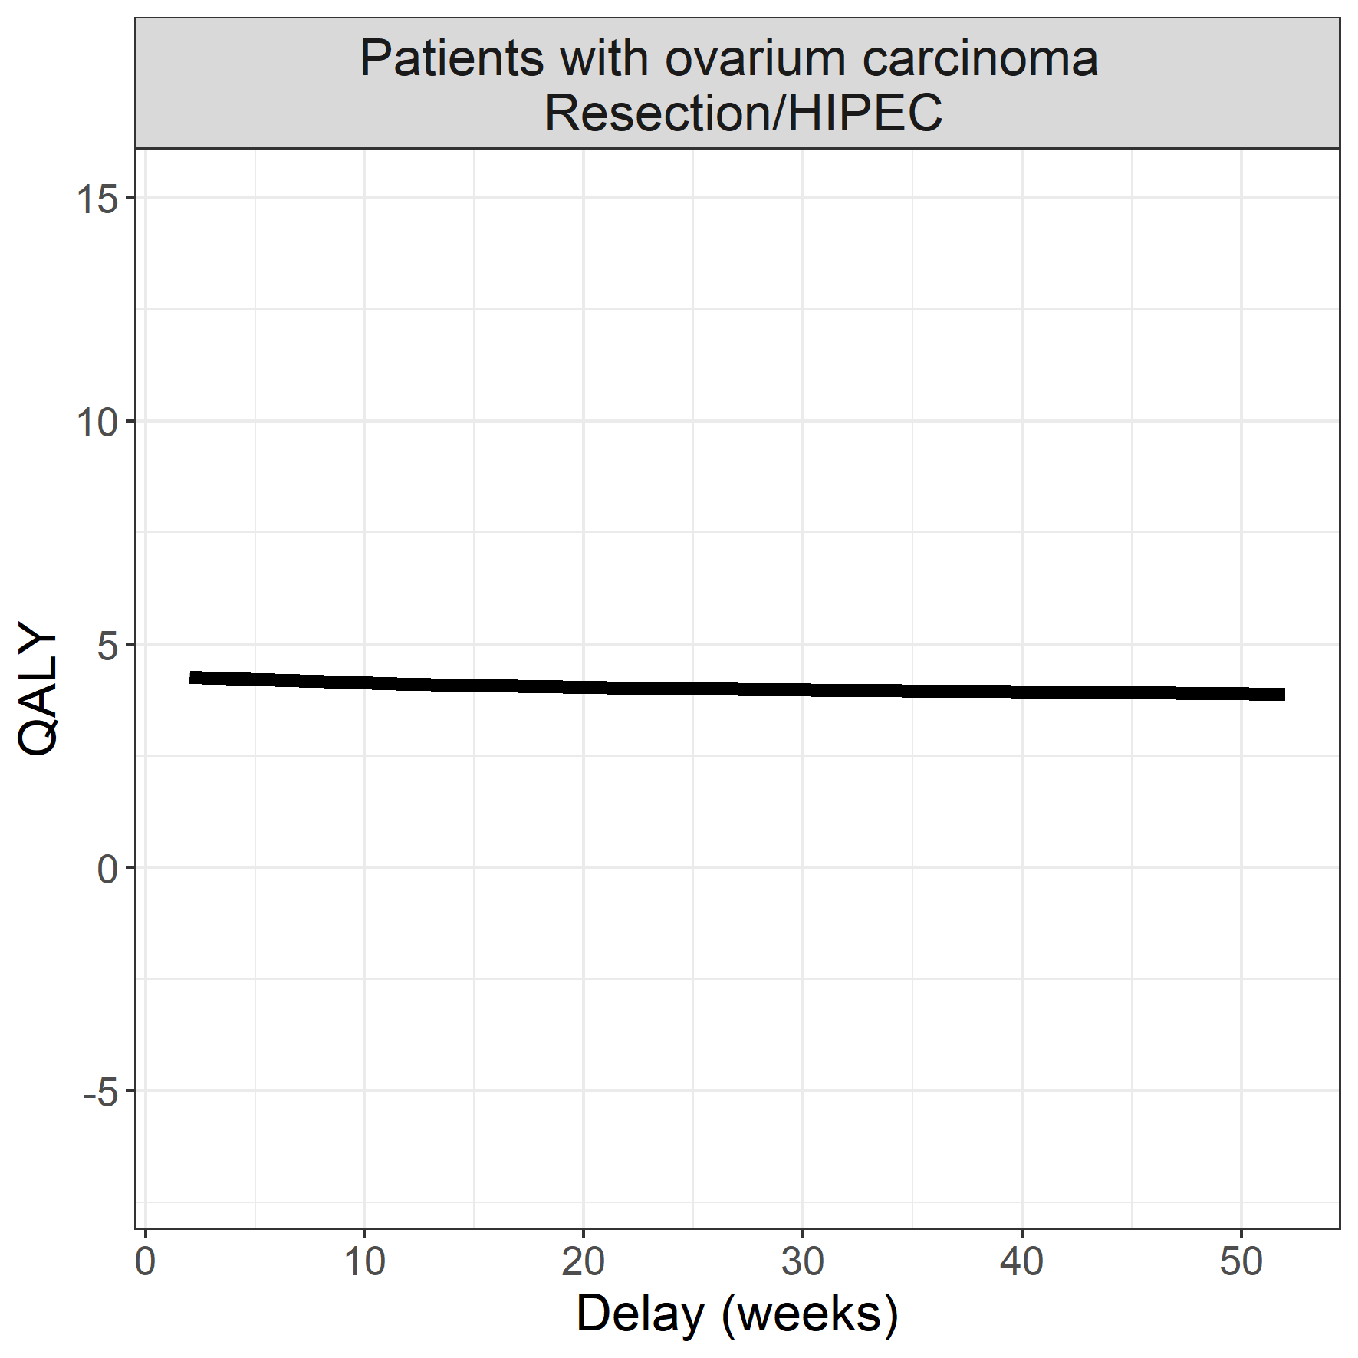

## Oral carcinoma

**Surgical procedure: surgical resection**

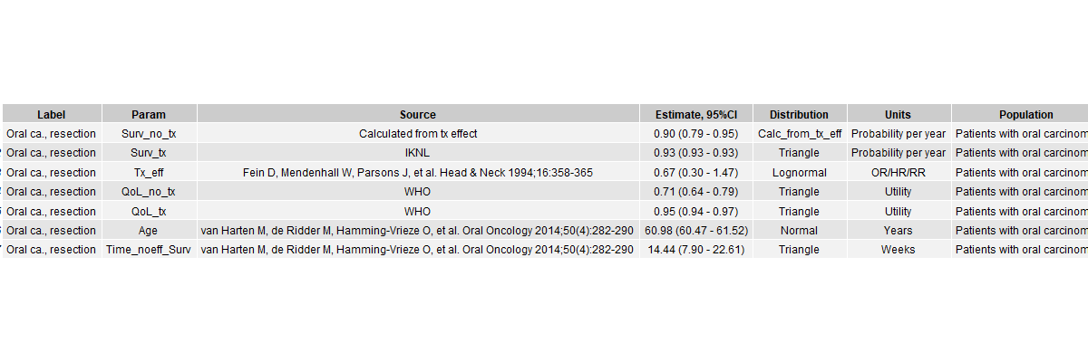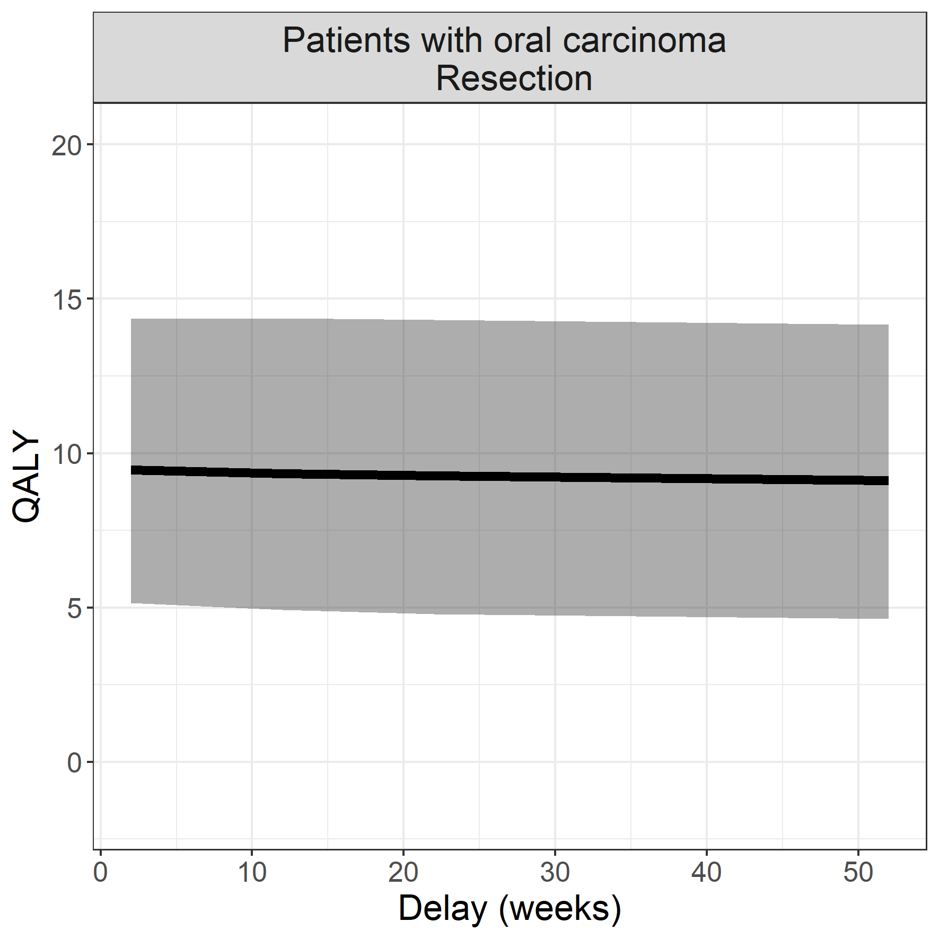

## High-risk endometrium carcinoma

**Surgical procedure: surgical resection**

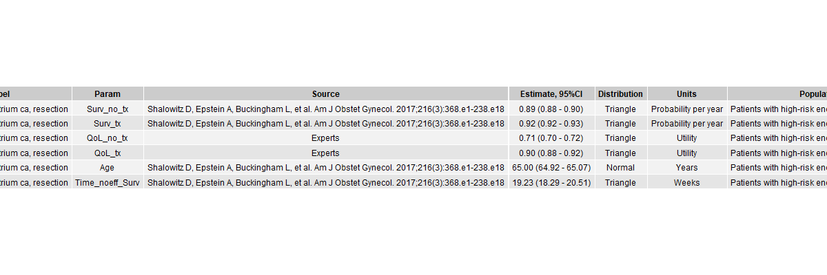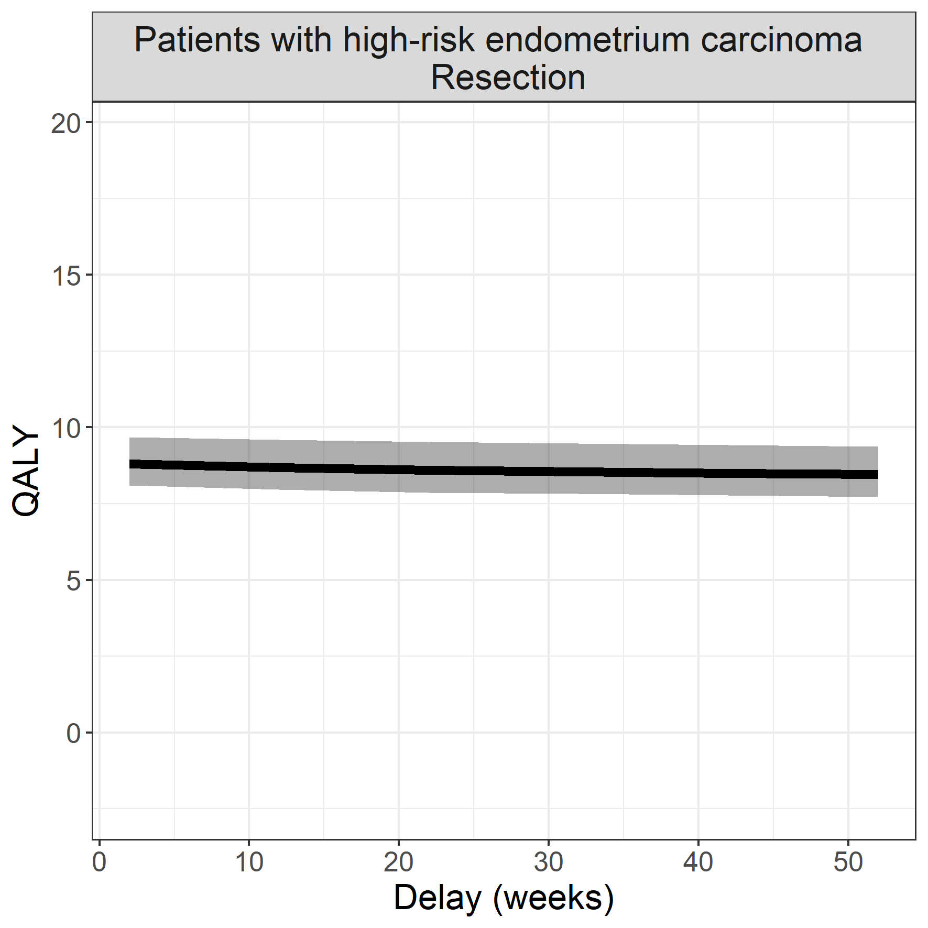

## Upper urinary tract carcinoma

**Surgical procedure: nefroureterectomy**

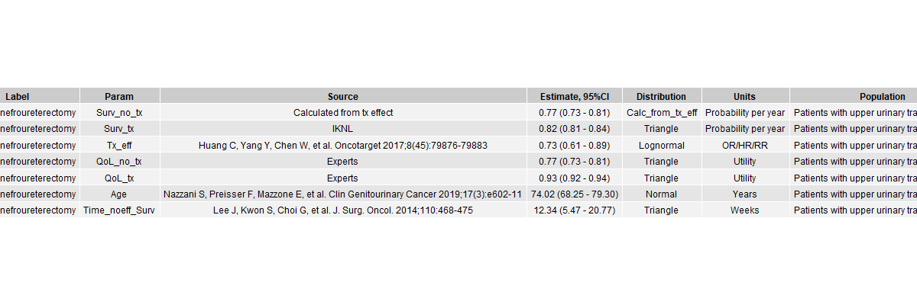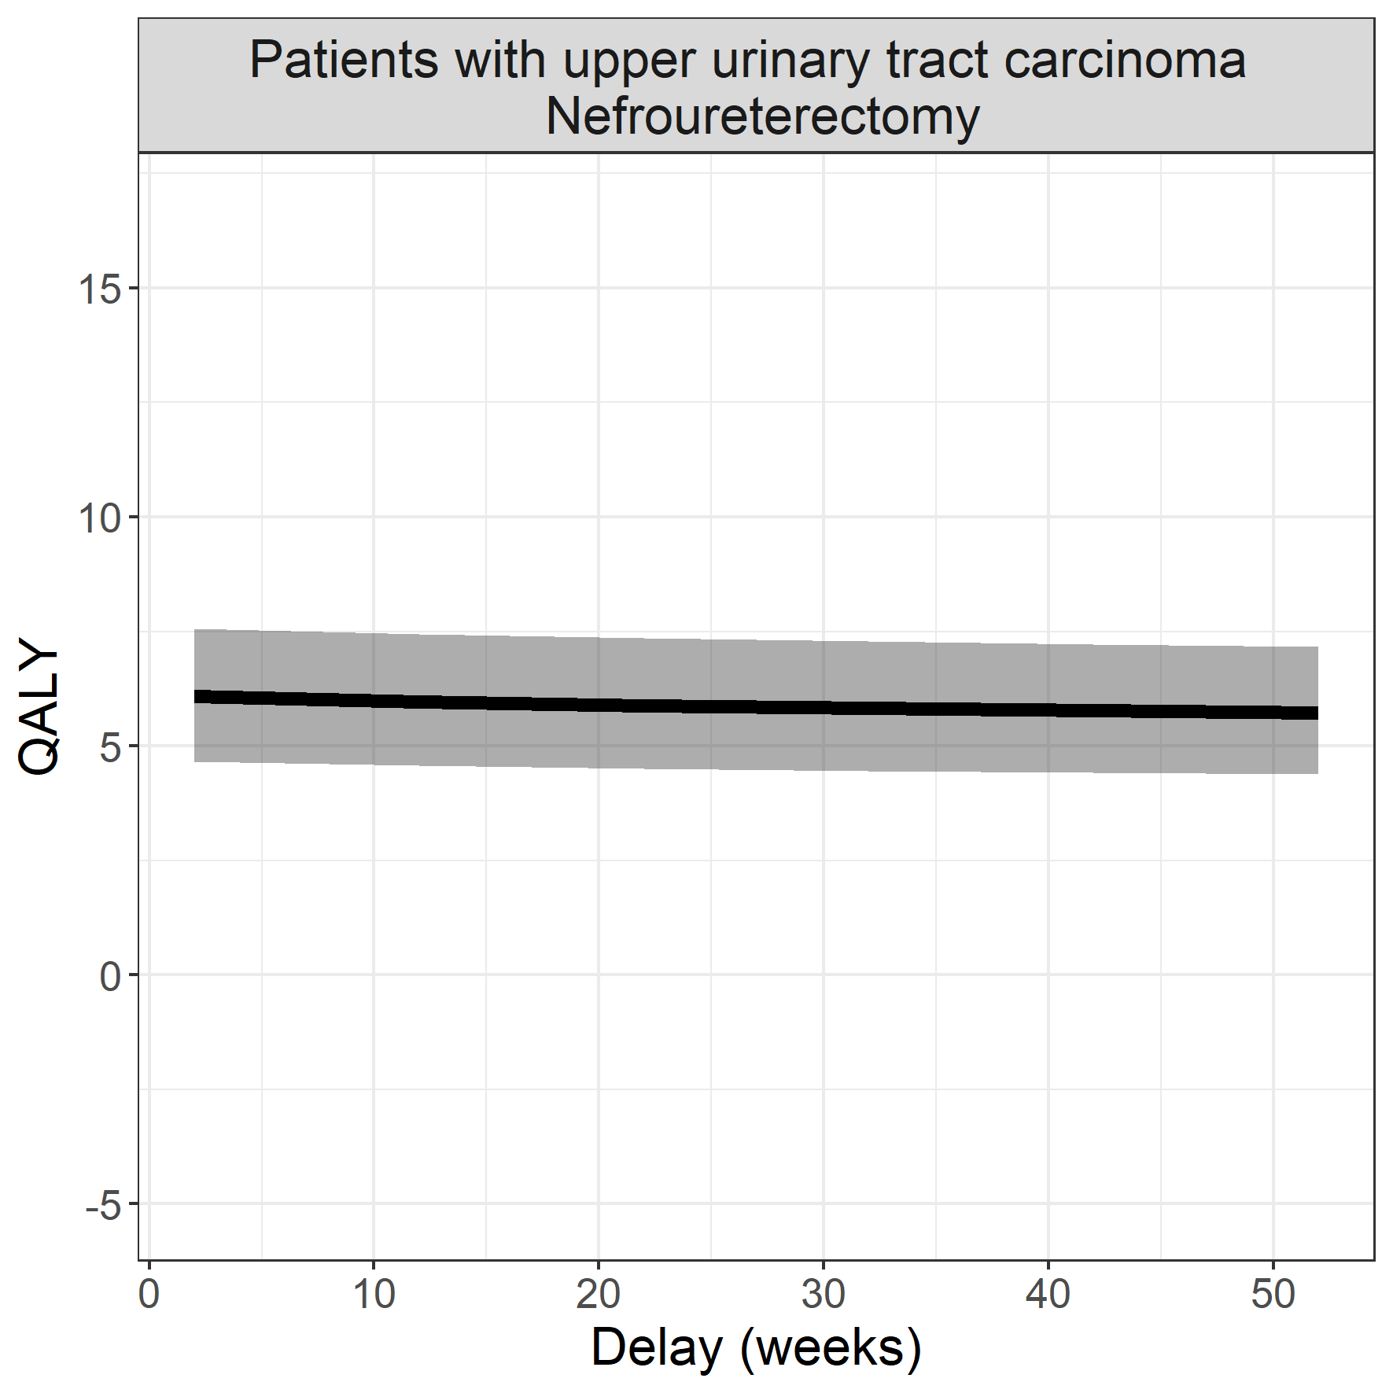

## Muscle invasive bladder cancer

**Surgical procedure: cystectomy**

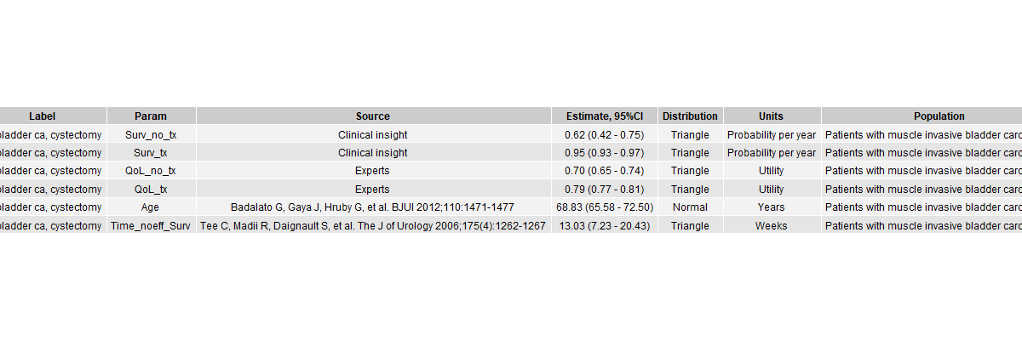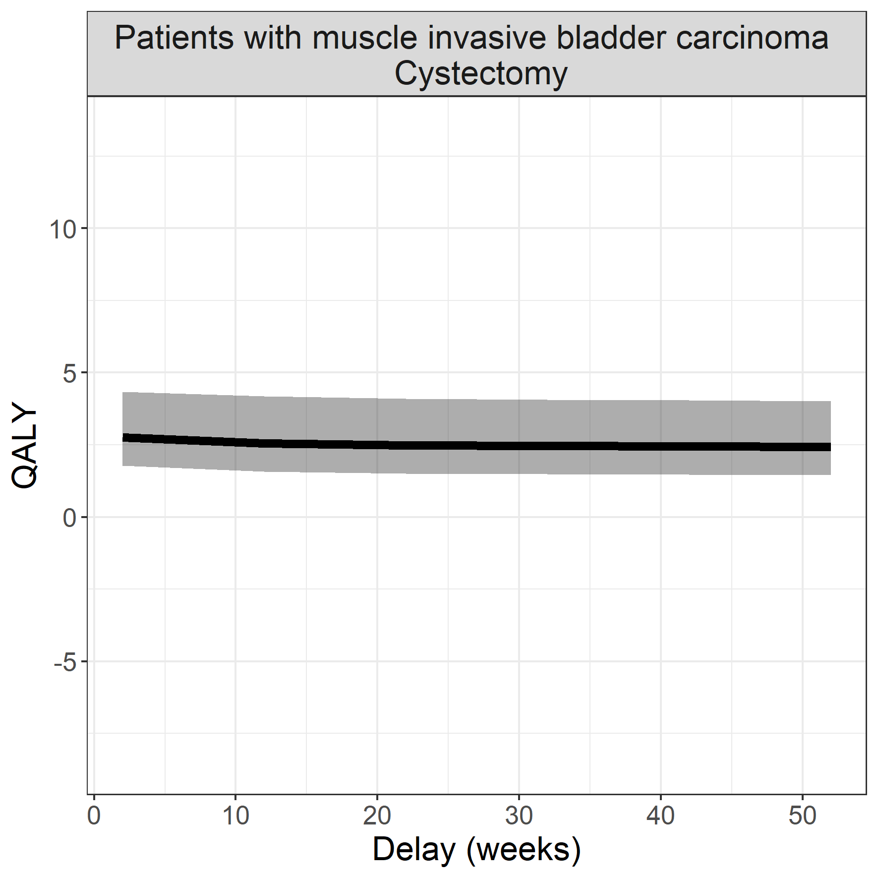

## Resectable mammacarcinoma

**Surgical procedure: surgical resection**

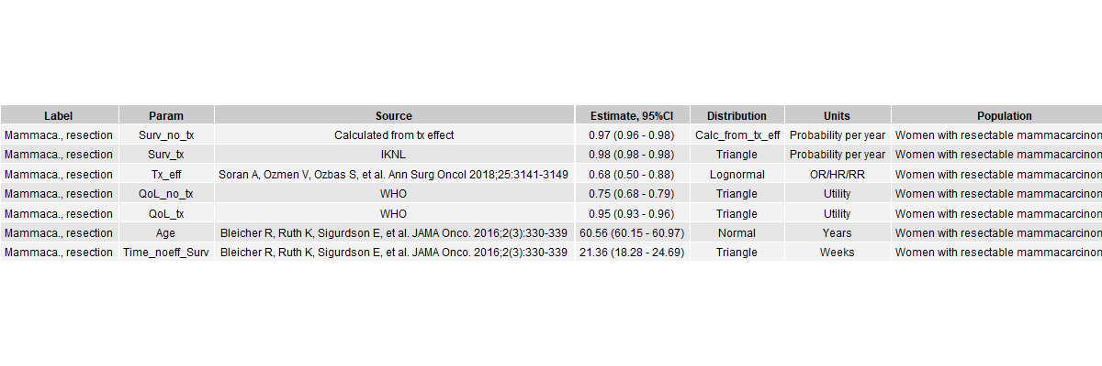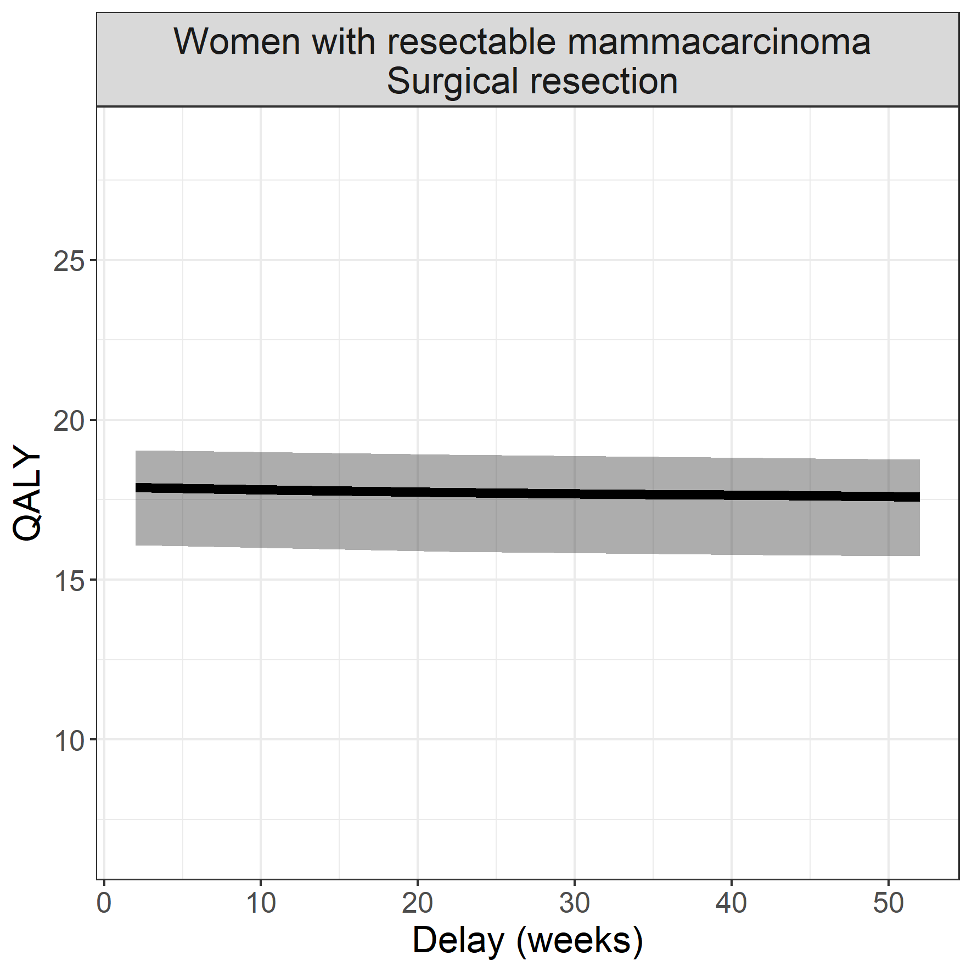

## Empyema

**Surgical procedure: video assisted thoracoscopy**

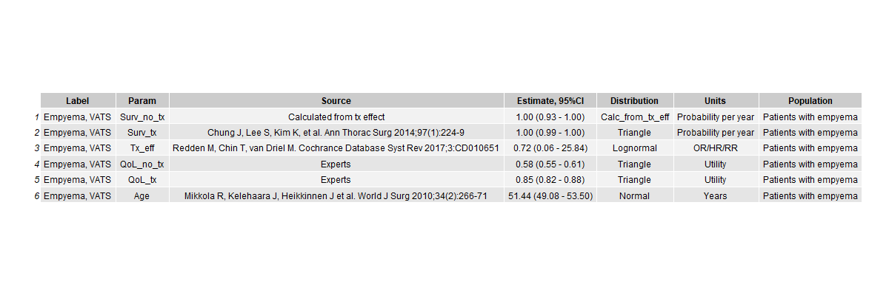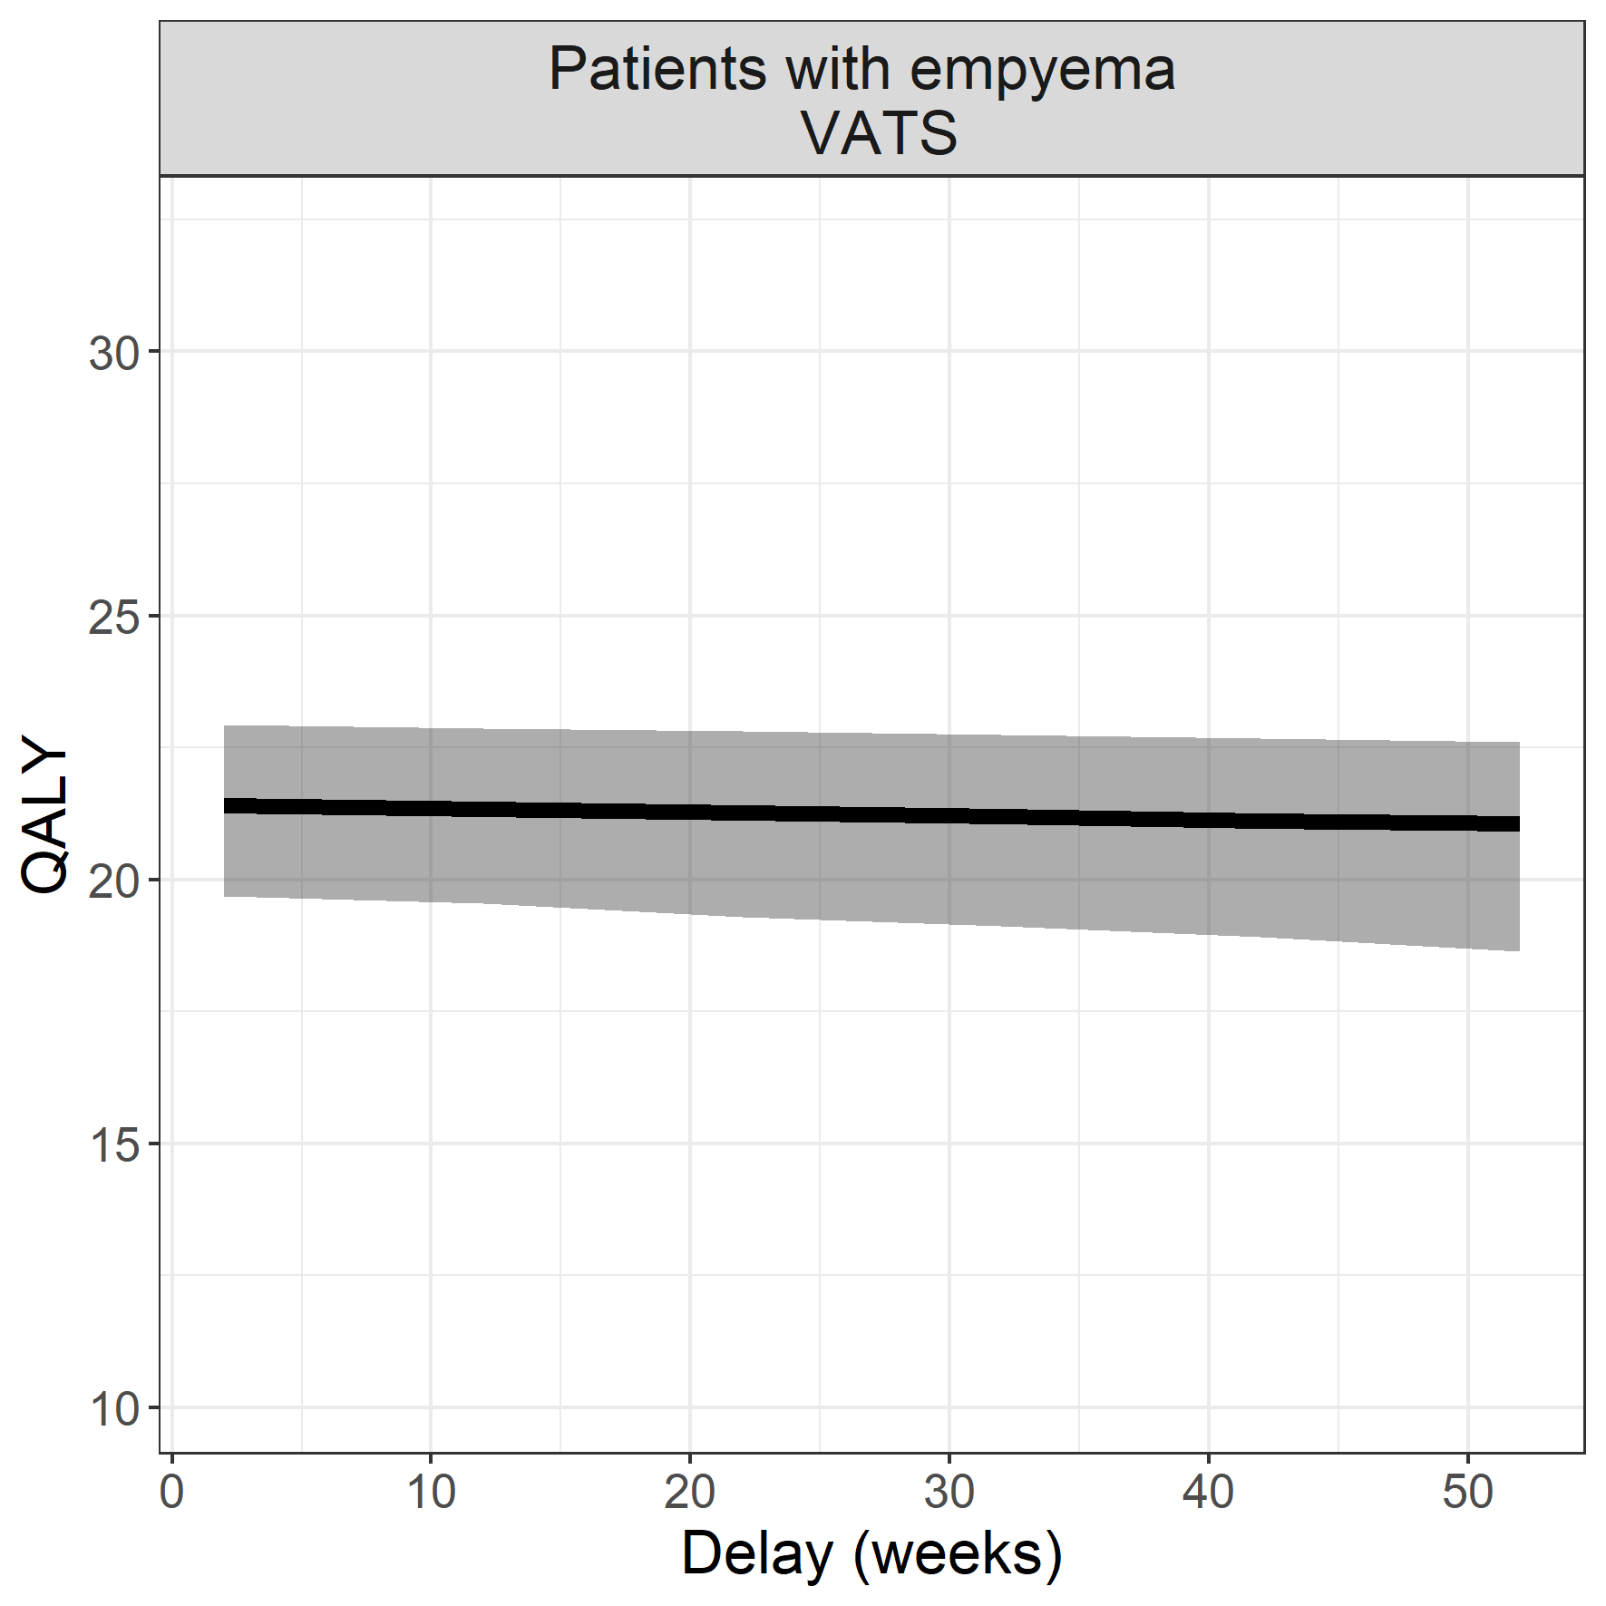

## High-grade glioma

**Surgical procedure: transcranial resection**

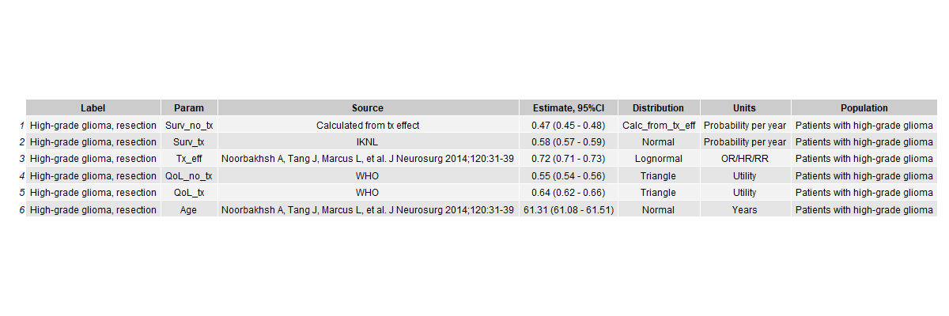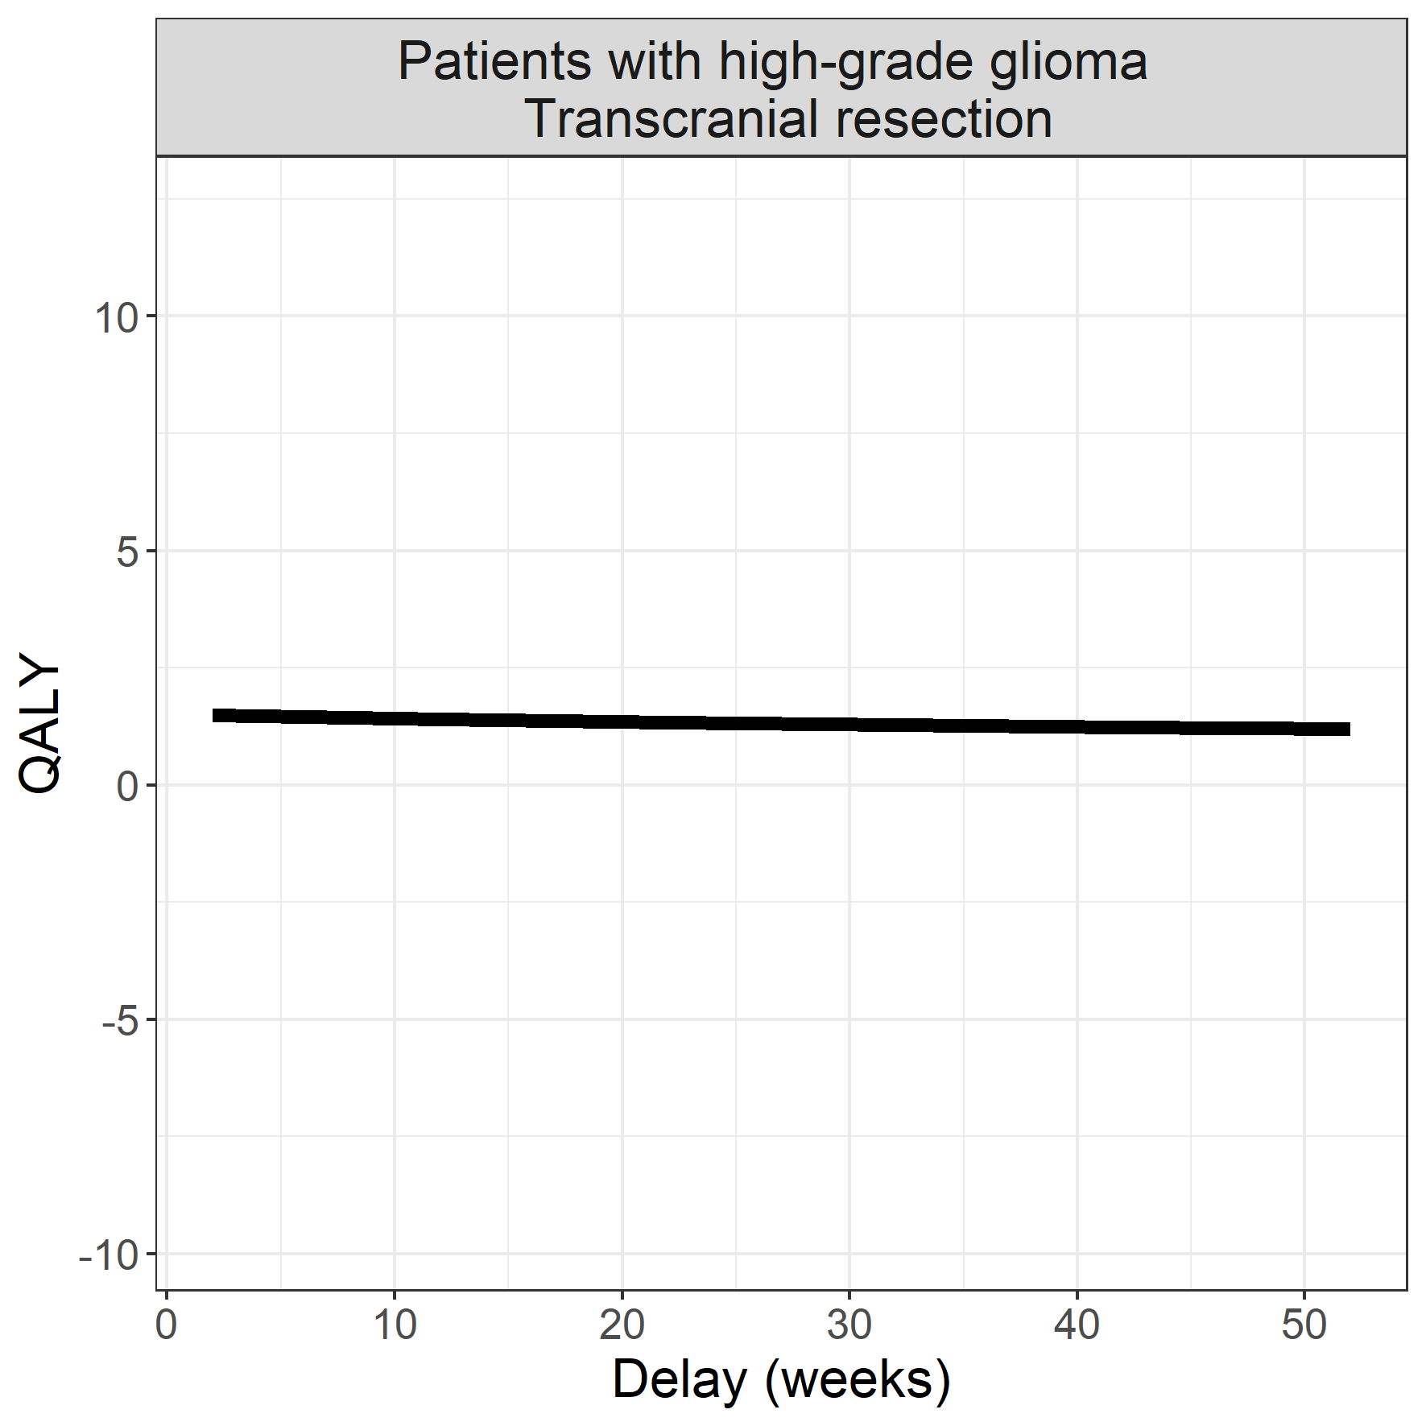

## Symptomatic carotid artery plaques

**Surgical procedure: endarterectomy**

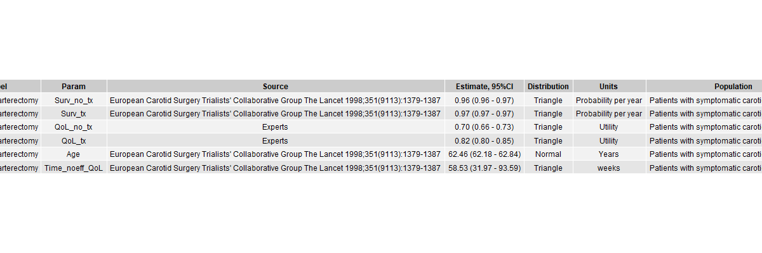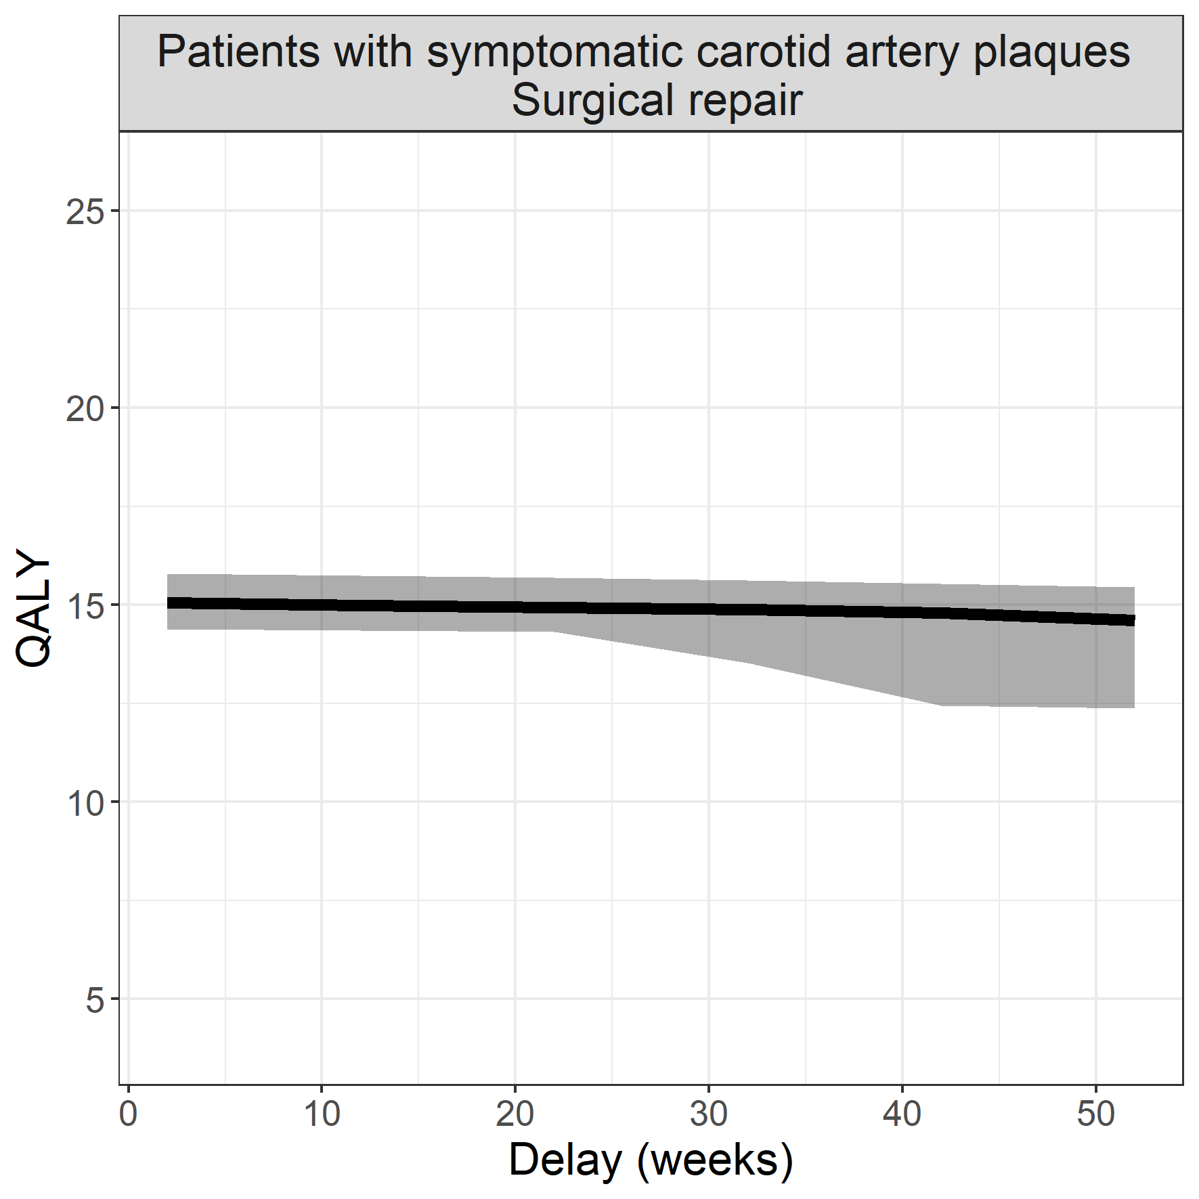

## Cervical cancer

**Surgical procedure: surgical resection**

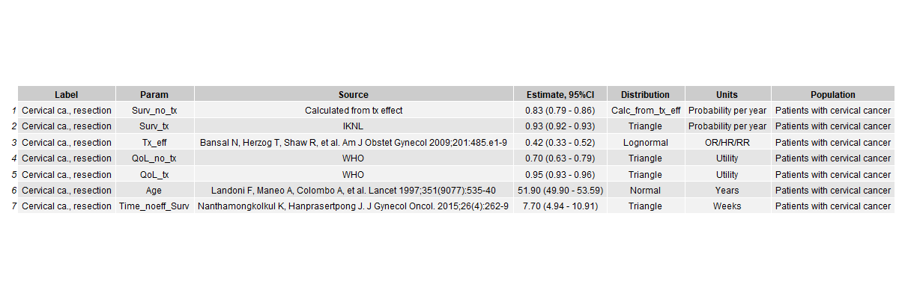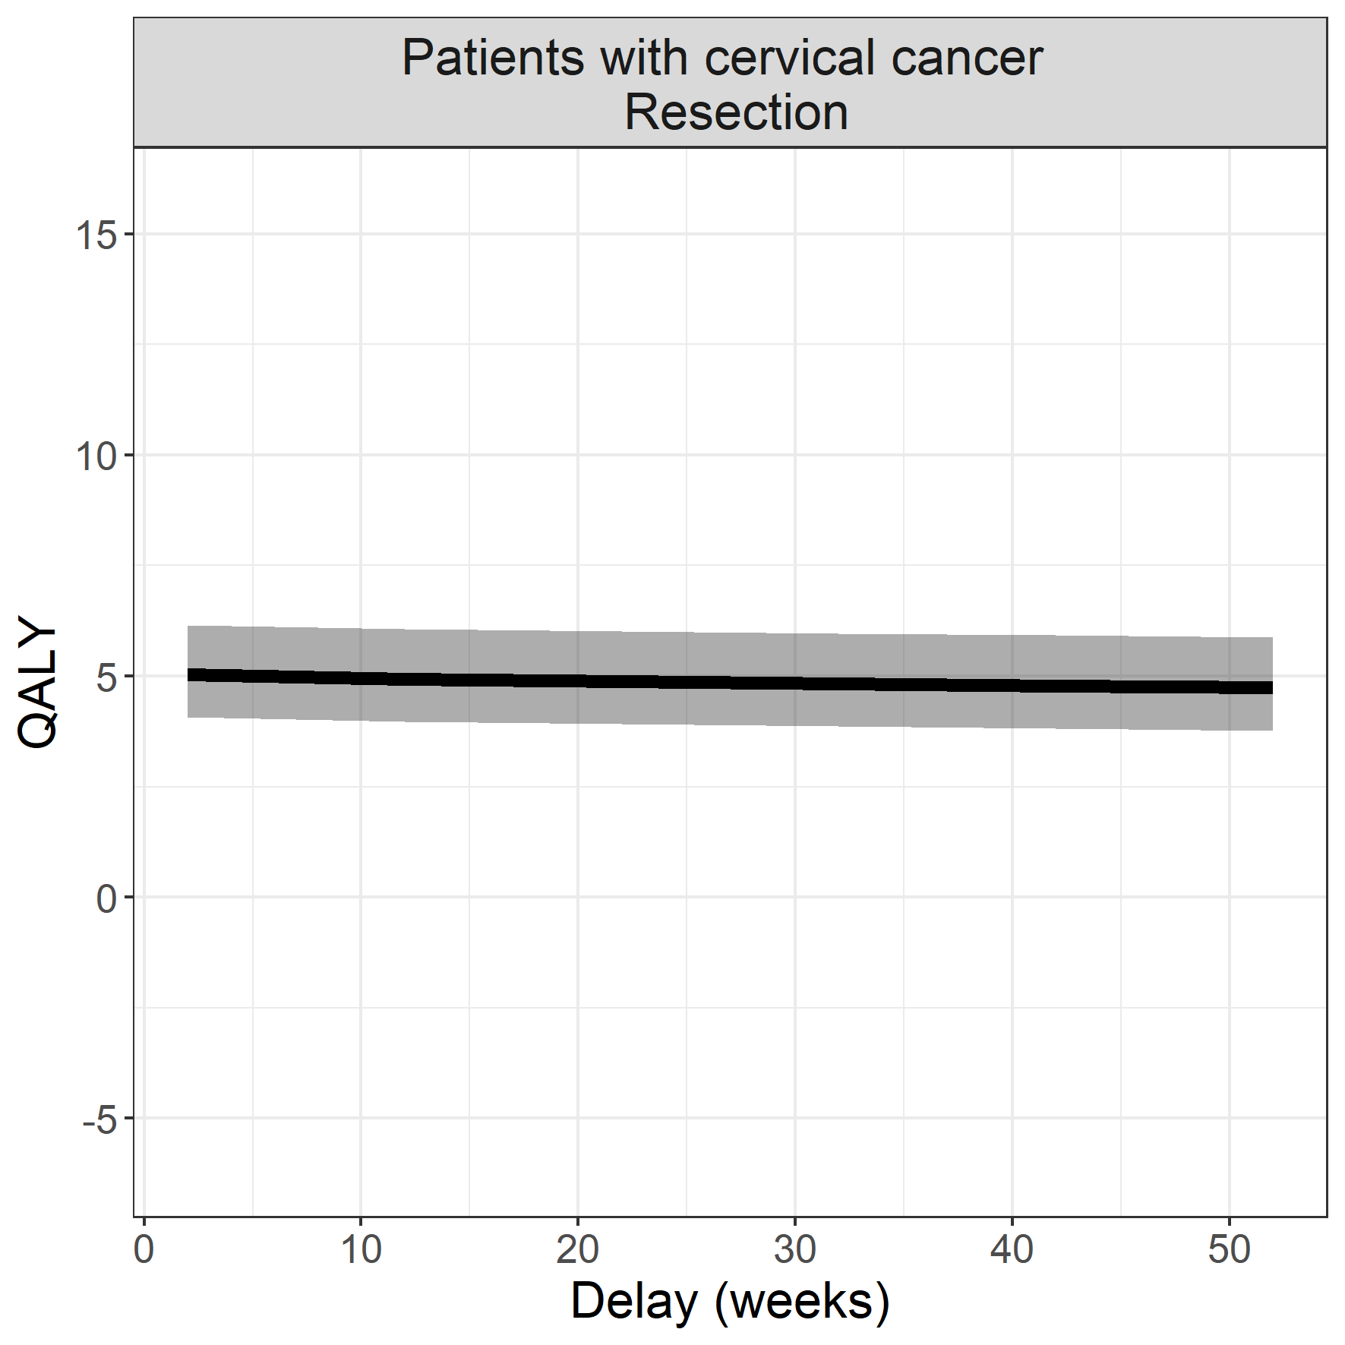

## Low-grade glioma

**Surgical procedure: transcranial resection**

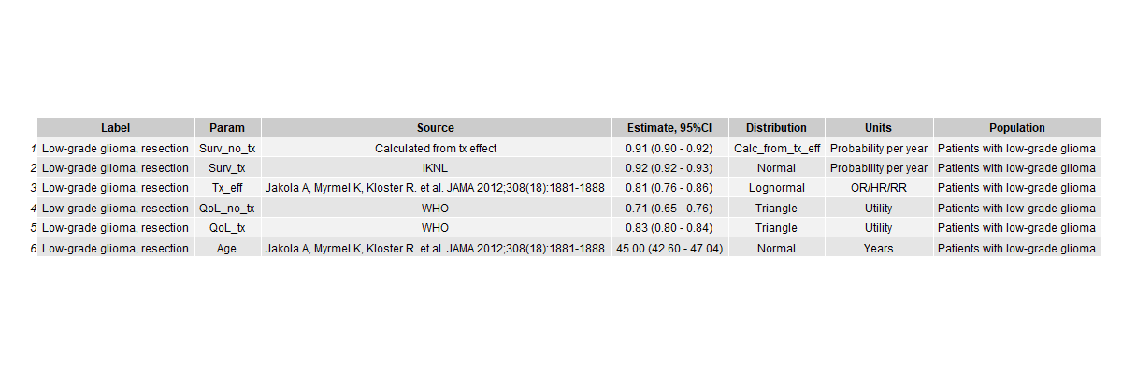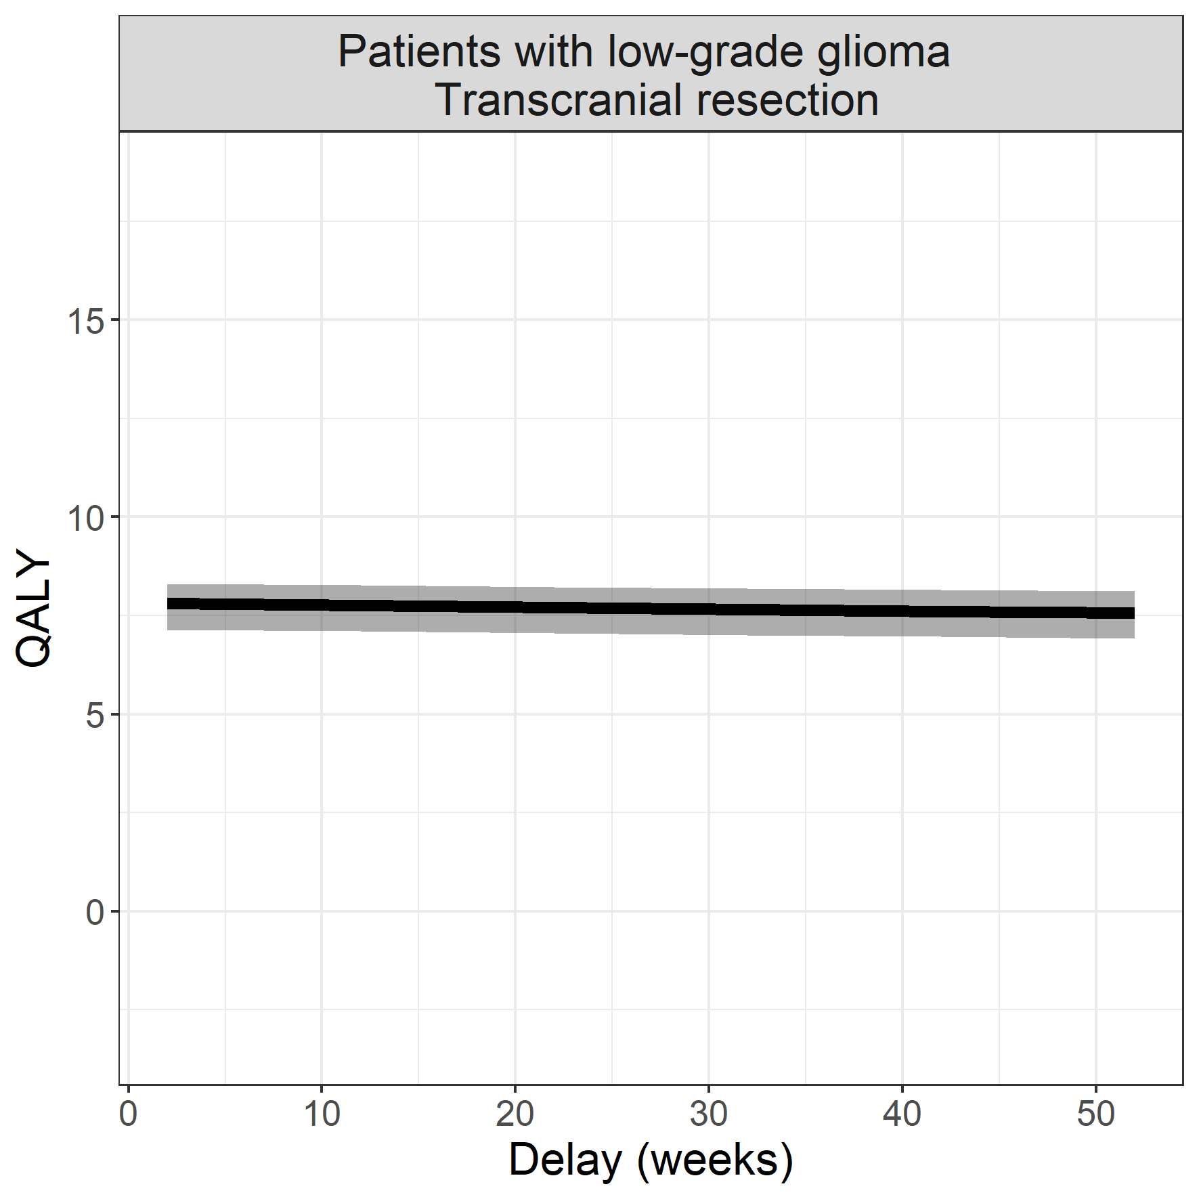

## Low-risk endometrium carcinoma

**Surgical procedure: surgical resection**

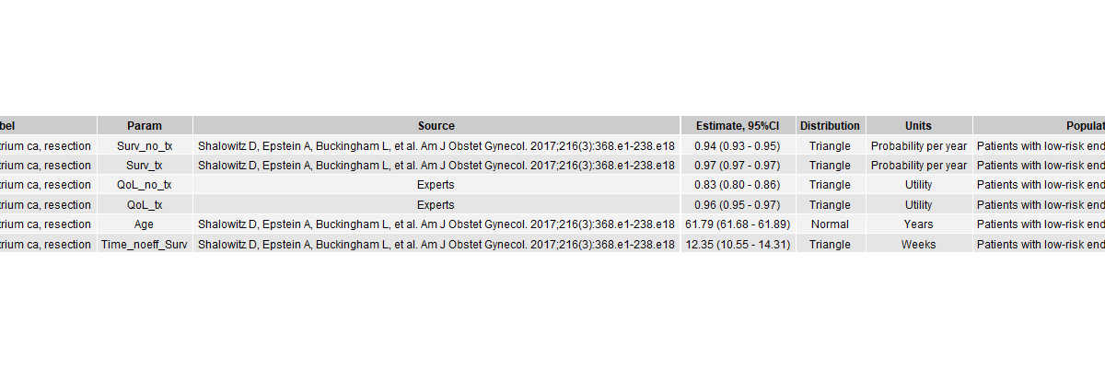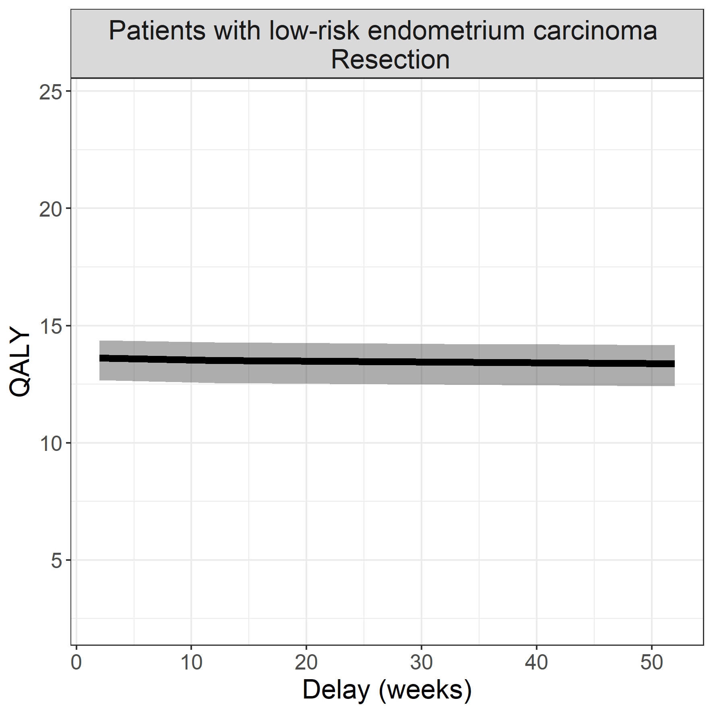

## Fontaine II peripheral artery disease

**Surgical procedure: bypass surgery**

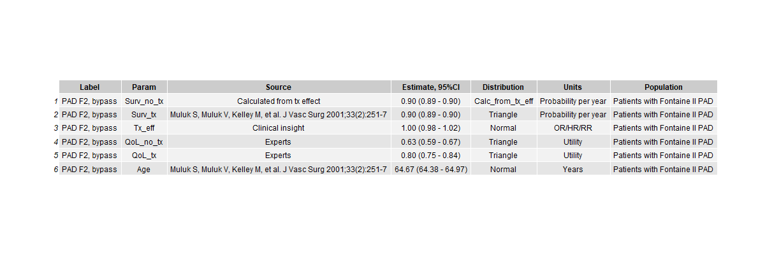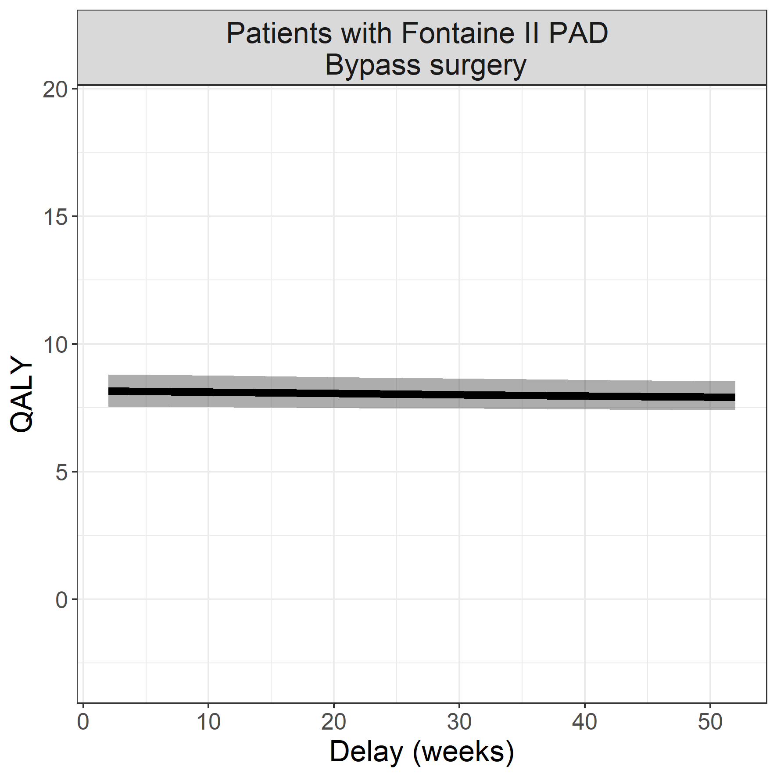

## Resectable mammacarcinoma

**Surgical procedure: mammectomy**

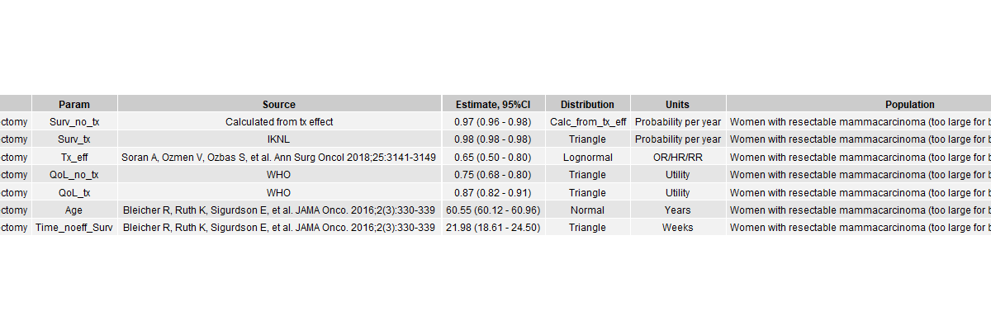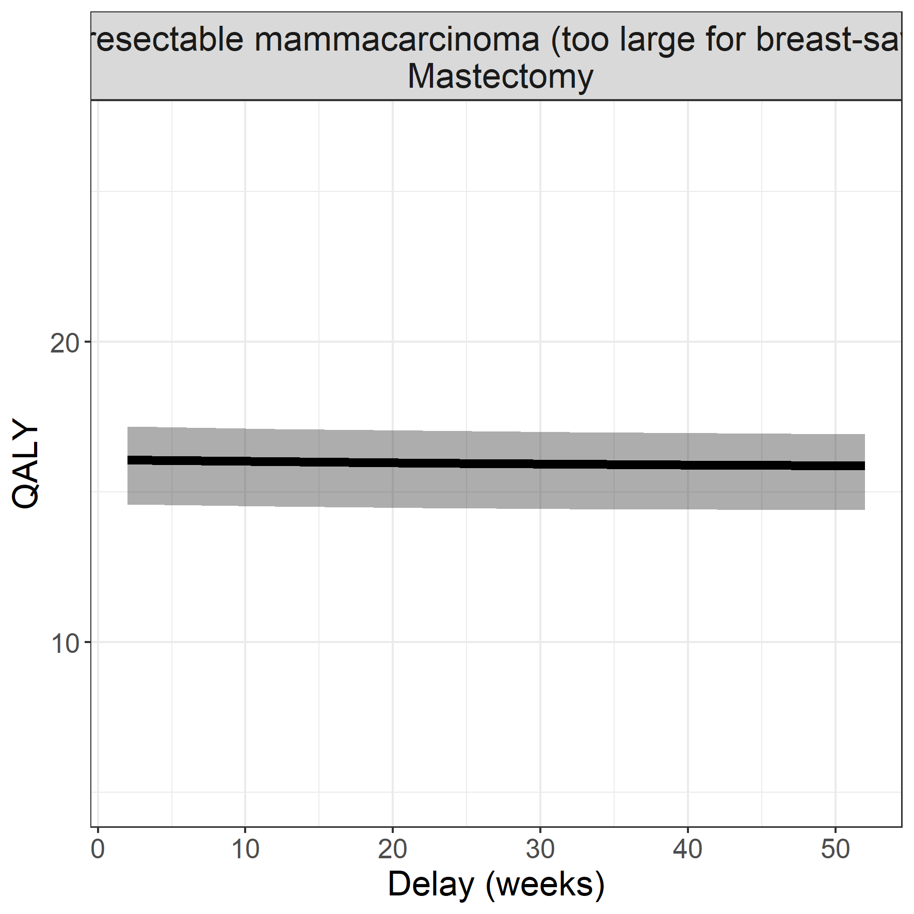

## COPD with substantial emphysema

**Surgical procedure: bullectomy**

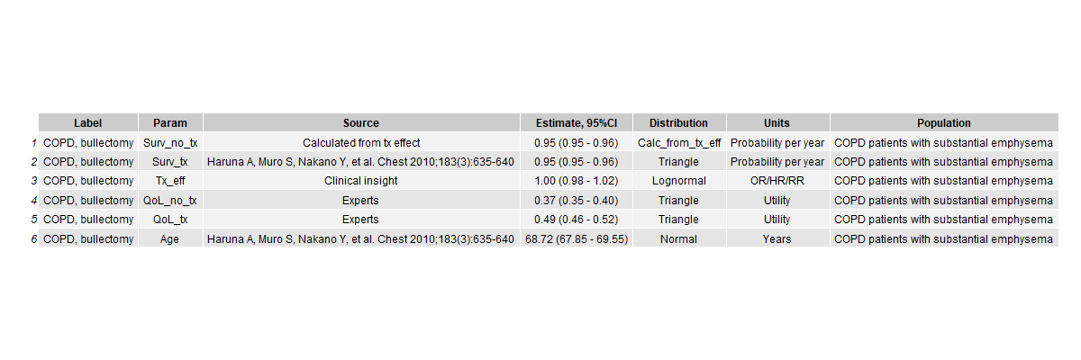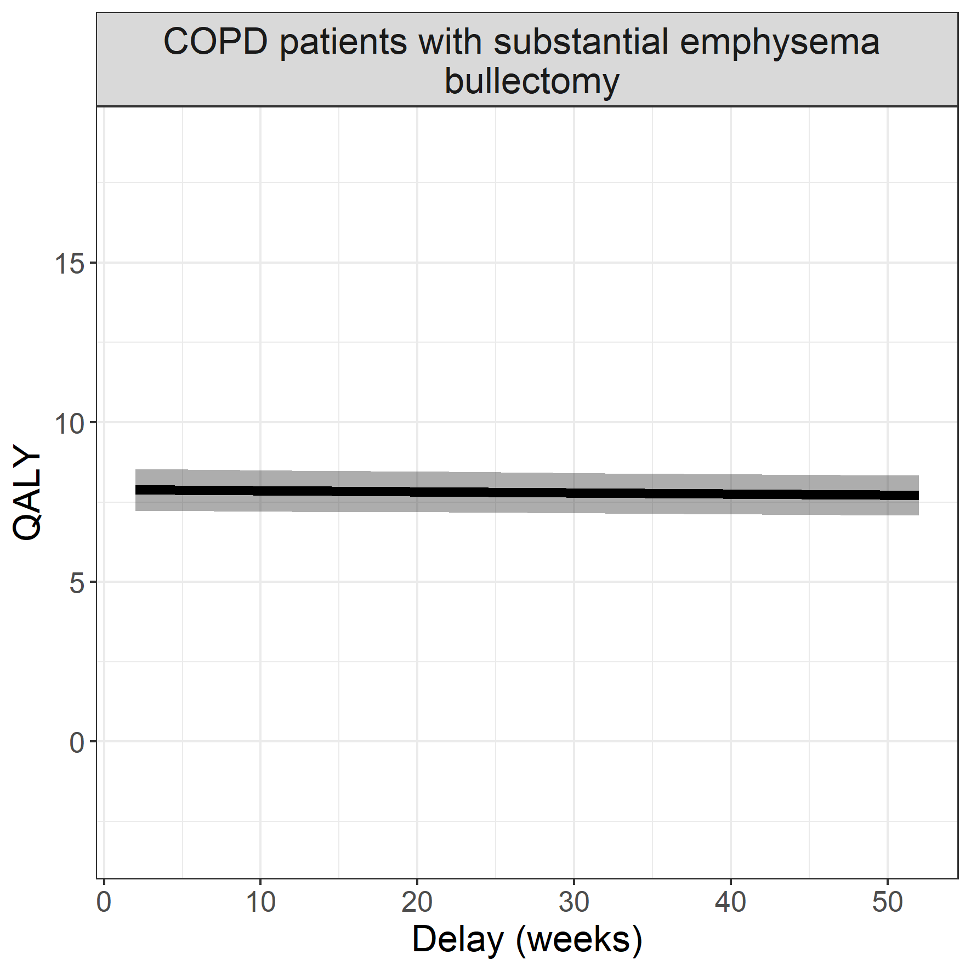

## Recurrent pneumothorax

**Surgical procedure: pleurodesis**

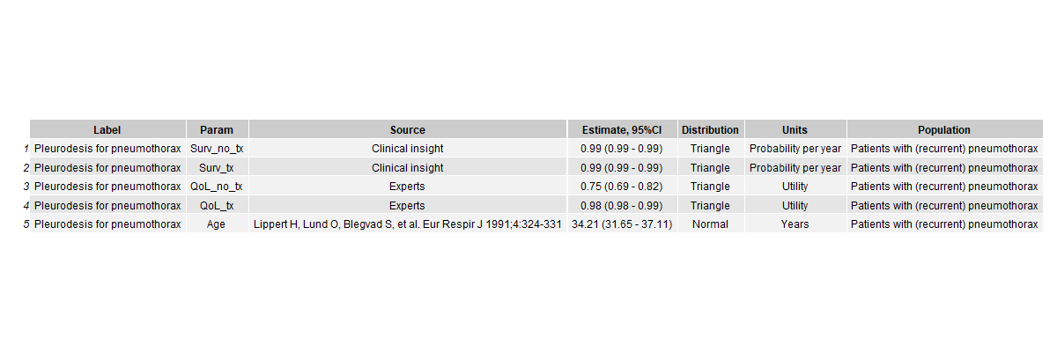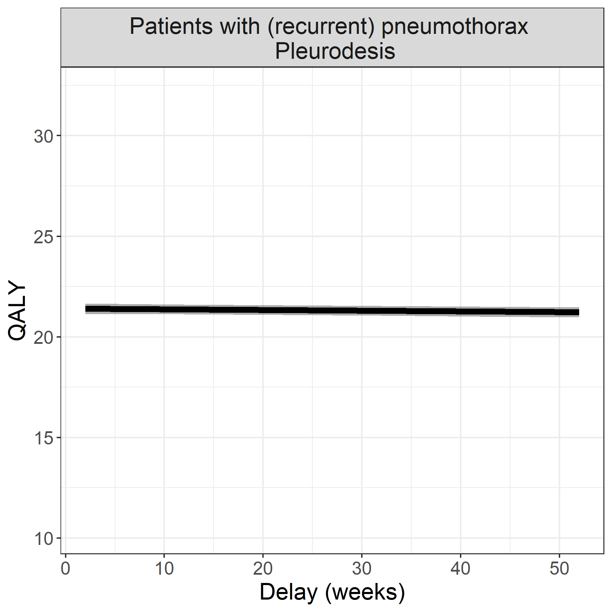

## Mild salivary gland carcinoma

**Surgical procedure: surgical resection**

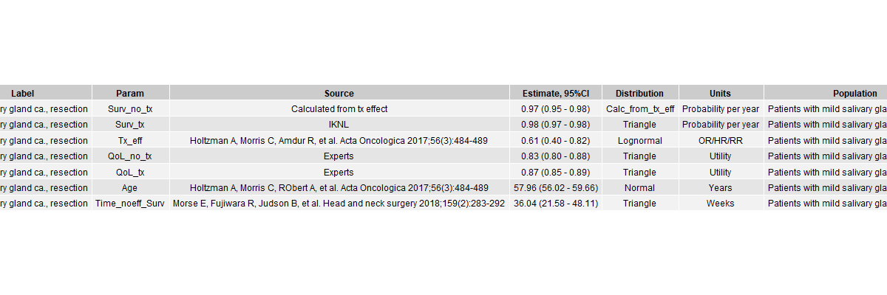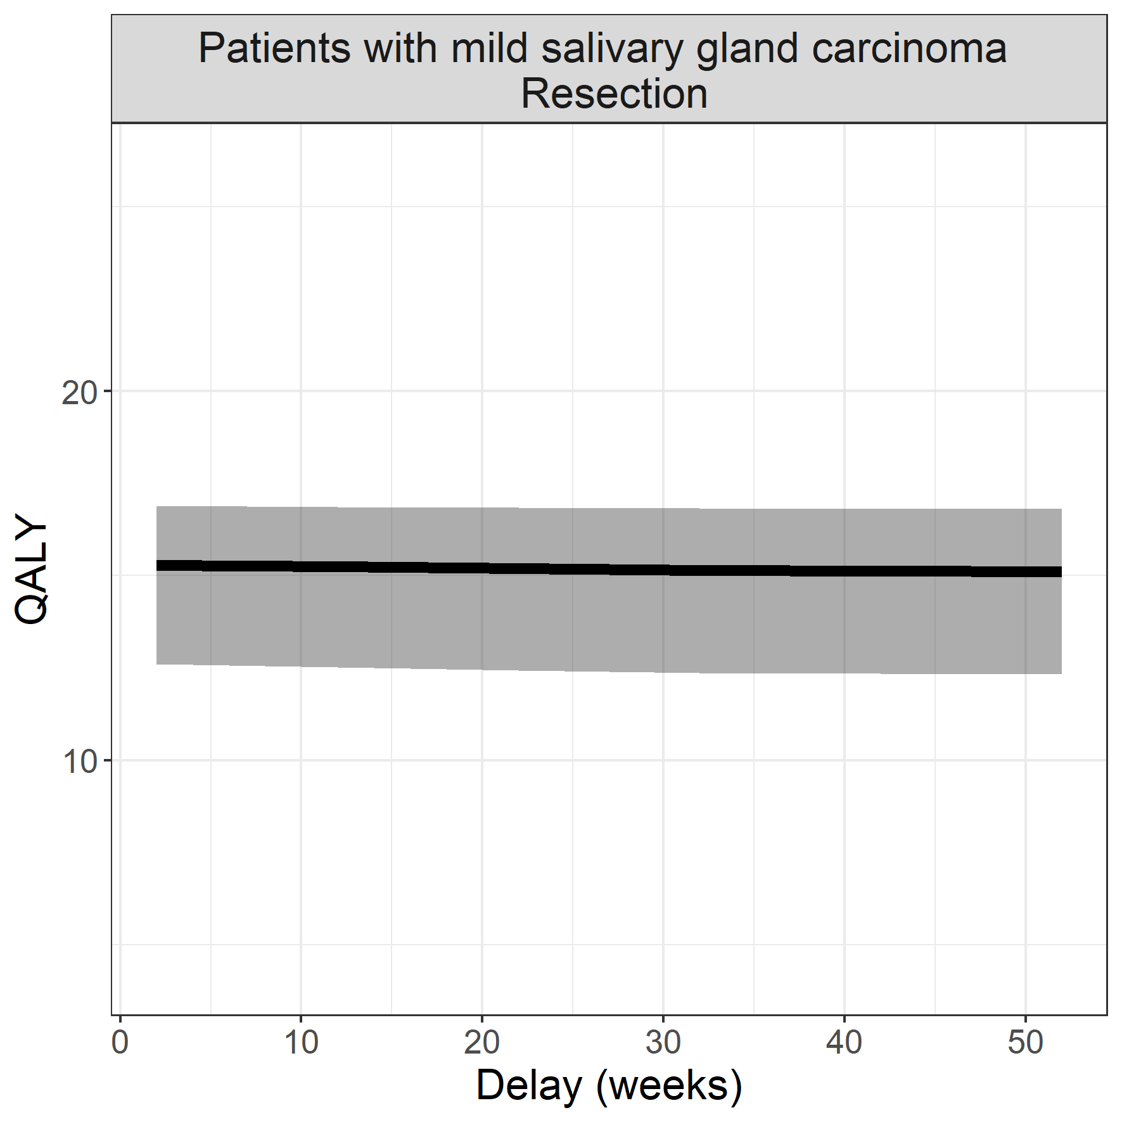

## Thyriod carcinoma

**Surgical procedure: surgical resection**

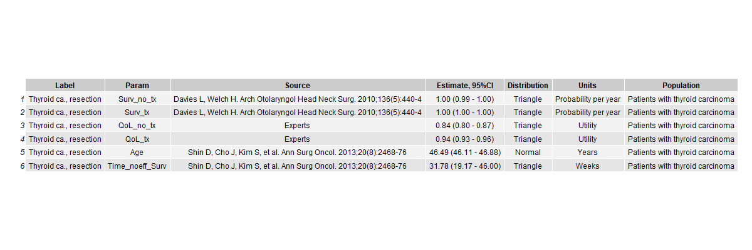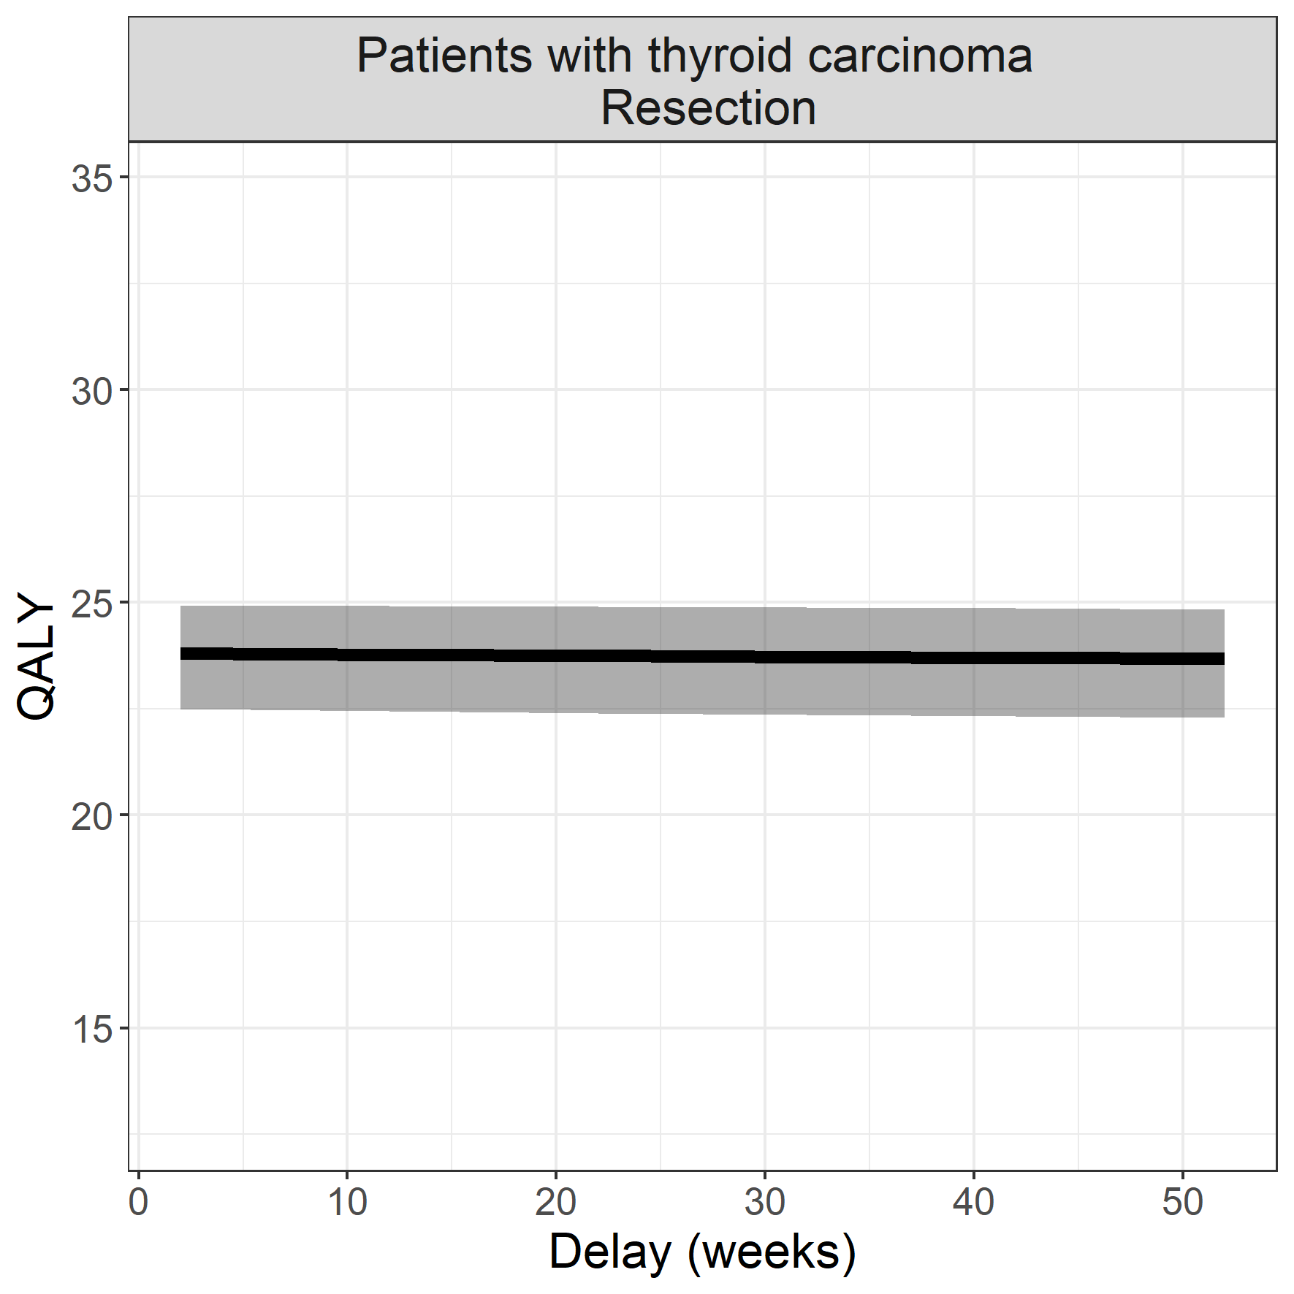

## End-stage renal disease

**Surgical procedure: installment of shunt for hemodialysis**

